Health Protection in Knowsley

JSNA Report

This version published in June 2026

To be reviewed in June 2028

Authorised for publication by Dr Sarah McNulty, Director of Public Health

Further Information

For a PDF copy of this report, and other research intelligence products, visit Knowsley Knowledge – the website of Knowsley’s JSNA.

Reader Information

Title | ‘Health Protection JSNA Report’
Authorisation for publication | Dr Sarah McNulty – Director of Public Health
Reviewers | Consultation with:
Contributors | Valerie Decraene, Matthew Grace, Beth Milton
Pages | 62
Date of Release | XX
Review Date | June 2028
Description | One of a number of topic-based reports contained within the Lifestyles theme of the Joint Strategic Needs Assessment. The report contains the latest intelligence about health protection, the policy context (local and national), evidence of what works and local engagement.
Superseded Documents | ‘Joint Strategic Needs Assessment, 2020’
Contact Details | matthew.grace@knowsley.gov.uk
Website | http://knowsleyknowledge.org.uk/key_documents/health-protection/
Related Information

Glossary of acronyms / abbreviations contained within the JSNA:-
AMR | Antimicrobial Resistance
C. diff/C. difficile | Clostridioides difficile
CCG | Clinical Commissioning Groups
COMAH | Control of Major Accident Hazards
COPD | Chronic Obstructive Pulmonary Disease
CPE | Carbapenemase-producing Enterobacterales
DTaP/IPV | Diphtheria, tetanus, pertussis and polio
DTaP/IPV/Hib/Hep B | Diphtheria, tetanus, whooping cough, polio, haemophilus influenza (type b) and hepatitis B
E. coli | Escherichia coli
EWD | Excess Winter Deaths
EWM | Excess Winter mortality
HBV | Hepatitis B Virus
HCAI | Healthcare-associated infections
Hib | Haemophilus Influenza (type B)
HPV | Human Papillomavirus
HTM | Health Technical Memorandum
ICB | Integrated Care Board
IPC | Infection Prevention and Control
JCVI | Joint Committee on Vaccination and Immunisation
JSNA | Joint Strategic Needs Assessment
LHRP | Local Health Resilience Partnership
LRF | Local Resilience Forum
LSOA | Lower-layer Super Output Area
MenACWY | Meningococcal groups A, C, W and Y disease
MenB | Meningococcal group B
MenC | Meningococcal group C
MMR | Measles, mumps and rubella (German measles)
MRF | Merseyside Resilience Forum
MRSA | Methicillin-resistant Staphylococcus aureus
MSSA | Methicillin-sensitive Staphylococcus aureus
NAP | The National Action Plan: Confronting antimicrobial resistance 2024 to 2029
NHSE/I | NHS England and NHS Improvement
NICE | National Institute for Health and Care Excellence
NPSA | National specifications for cleanliness in the NHS and care homes
PCV | Pneumococcal Conjugate Vaccine
PHE | Public Health England
PHOF | Public Health Outcomes Framework
PIR | Post Infection Review
RSV | Respiratory Syncytial Virus
SARS-CoV-2 | Severe Acute Respiratory Syndrome Coronavirus 2
STAR-PU | Specific Therapeutic Group Age-Sex Related Prescribing Units
TB | Tuberculosis
TD/IPV | Tetanus, Diphtheria and Polio
UKHSA | UK Health Security Agency
UTI | Urinary Tract Infection

Contents
EXECUTIVE SUMMARY 5
1 THE POPULATION OF KNOWSLEY 7
2 WHY HEALTH PROTECTION IS IMPORTANT 7
2.1 Health Protection Structures 8
2.2 Health Protection Outcomes 9
2.3 The Public Health Outcomes Framework (PHOF 9
2.4 Other related JSNA chapters 9
3 NATIONAL POLICY DRIVERS 10
3.1 NHS Vaccination Strategy 10
3.2 National Annual Flu Immunisation Plan 10
3.3 Measles and Rubella Elimination UK Strategy 11
3.4 WHO Global Health Sector Strategy on Viral Hepatitis, 2022-2030 11
3.5 UK second 5-Year National Action Plan for Antimicrobial Resistance, 2024-2029 12
3.6 Tuberculosis (TB): action plan for England, 2021 to 2026 13
3.7 Data sources and publicly available dashboards 13
3.7.1 Public Health Profiles (Fingertips) 13
3.7.2 Childhood Vaccination Coverage 2023-24 Interactive Dashboard 13
3.8 Infection Prevention and Control 14
3.9 UKHSA Strategic Plan 2023-2026 14
3.10 UKHSA Health Equity for Health Security Strategy 2023-2026 14
4 LOCAL PARTNERSHIPS 15
4.1 Champs Public Health Collaborative 15
4.2 Primary Care Networks 15
5 VACCINATION AND IMMUNISATION IN ADULTS AND CHILDREN 15
5.1 Childhood Immunisations 15
5.1.1. Dtap/IPV/Hib/Hep B Vaccine 16
5.1.2 Pneumococcal Conjugate Vaccine (PCV) 17
5.1.3 Rotavirus 18
5.1.4 Meningococcal B (MenB) 19
5.1.5 Hib/MenC booster 20
5.1.6 Measles, Mumps and Rubella (MMR) 22
5.1.7 DTaP/IPV 24
5.1.8 Seasonal Flu 25
5.1.9 HPV Vaccination 27
5.1.10 Td/IPV 28
5.1.11 MenACWY 29
5.2 Adult immunisations 30
5.2.1 Influenza vaccinations 30
5.2.3 Shingles Vaccination 33
5.2.4 Pneumococcal Polysaccharide Vaccine (PPV) 35
5.2.5 Pertussis vaccination in pregnancy 36
5.2.6 RSV vaccination in pregnancy 36
6 COMMUNICABLE DISEASES 36
6.1 Healthcare Associated Infections (HCAI) 37
6.1.1 C. difficile 38
6.1.2 MRSA 38
6.1.3 MSSA 39
6.1.4 E. coli 40
6.1.5 Klebsiella spp. 40
6.1.6 Pseudomonas aeruginosa 41
6.2 Antimicrobial resistance 41
6.3 Gastrointestinal Infections 42
6.3.1 Overview of Gastrointestinal infections 42
6.3.2 Campylobacter Infections 43
6.3.3 Salmonella 44
6.4 Vaccine preventable diseases 45
6.5 Hepatitis B and C 46
6.5.1 Hepatitis B 46
6.5.2 Hepatitis C 46
6.6 Tuberculosis 48
6.7 Respiratory infections 49
6.7.1 Emergency hospital admissions 49
6.7.2 Mortality from influenza and pneumonia 50
7 EXCESS WINTER DEATHS 51
8 ANTIMICROBIAL PRESCRIBING TRENDS 54
9 EMERGENCY PREPAREDNESS RESILIENCE AND RESPONSE 57
10 FUTURE OPPORTUNITIES AND CHALLENGES 58
11 RECOMMENDATIONS 60

EXECUTIVE SUMMARY

Knowsley faces significant health protection challenges that require coordinated action between the local authority, health and social care providers, and system partners. The borough’s population is among the most deprived in England, with nearly half of its neighbourhoods in the most deprived decile nationally. This deprivation exacerbates health inequalities, particularly in relation to infectious diseases and vaccination uptake.

Vaccination coverage in Knowsley is consistently below national and regional averages across the life course. Childhood immunisation rates have declined sharply since 2013, with MMR (Measles, Mumps, Rubella vaccination) coverage for two doses by 5 years old standing at just 76.9% in 2024/25 (England: 83.7%). This shortfall contributed to a measles outbreak in Knowsley in June 2025, highlighting the urgent need to improve uptake. Seasonal flu vaccination rates are also low: only 66% of residents aged 65+ were vaccinated in 2024/25, below the 75% national target, and uptake among pregnant women was just 24.9%.

Healthcare-associated infections remain a concern, with Knowsley reporting higher rates of Methicillin-sensitive Staphylococcus aureus and Escherichia coli bacteraemia than regional and national averages. Antimicrobial resistance compounds this challenge; Cheshire and Merseyside Integrated Care Board has one of the highest rates of resistant bloodstream infections in England, disproportionately affecting deprived communities. While antimicrobial prescribing, particularly in primary care, has improved in Knowsley over the 12 months to October 2024, further improvements are still required in order to reach the national target for prescribing.

Respiratory infections exert a heavy burden, with emergency admissions for lower respiratory tract infections in children aged 0-4 years at 284.4 per 10,000 in 2023/24, well above England’s rate of 207.7 per 10,000. Mortality from influenza and pneumonia is also significantly higher than national averages.

Knowsley’s health protection system operates within a complex governance landscape, with responsibilities shared across local authorities, UKHSA, and Integrated Care Boards (ICBs). The forthcoming transition of vaccination commissioning to the regional offices for pan-ICB commissioning (OPICs) in 2027 offers opportunities for tailored local strategies but poses risks given financial constraints and workforce reductions.

Recommendations

- Improve vaccination uptake across the life course: work with partners to develop and implement targeted, community-based interventions to address barriers to childhood and adult immunisation.

- Strengthen infection prevention and control and antimicrobial stewardship: work with IPC and health protection colleagues to strengthen IPC measures across care and educational settings. Develop local plans to tackle AMR which build on existing work underway in primary care, including on existing initiatives to reduce inappropriate prescribing of antimicrobials, and the successful roll out of TARGET training.

- Improve intelligence on health inequalities in health protection: work with partners to ensure data used in local health protection reports is broken down by key population characteristics, such as deprivation and ethnicity, where these data are available. Optimising the availability and use of demographic data in health protection surveillance reports will enable identification of inequalities at local level, inform proportionate allocation of resources, and design interventions that effectively reduce inequalities across the local population.

Delivering effective health protection in Knowsley depends on strong partnership working and clear governance. The Health Protection Forum, reporting to the Health and Wellbeing Board, provides strategic oversight, while collaboration between all health and social care partners remains key to achieving improvements in Health Protection in Knowsley. Continued joint planning, data sharing, and coordinated response mechanisms will be critical to addressing current challenges and safeguarding the health of Knowsley’s population.

1 THE POPULATION OF KNOWSLEY
The population of Knowsley was estimated at 162,565 in 2024 (ONS mid-2024 estimates), reflecting a 7.1% increase since 2019. Knowsley is classified as a metropolitan district and is overwhelmingly urban, with around 99% of residents living in urban areas and only 1% in rural zones. The borough was among the top 35% most densely populated English local authority areas at the last census (2021)². Knowsley ranks as the eighth most deprived local authority in England, with 40% of Lower-layer Super Output Areas (small geographies with 1,000 to 3,000 residents) in the most deprived 10% of areas nationally based on the Index of multiple deprivation, published in 2025.
The age profile of Knowsley (mid-2024) shows that 19.9% of the population are aged 0–15 years, 62.8% are 16–64 years old, and 17.3% are 65 years or older¹. The borough is predominantly White (95.3%), with small Asian (1.6%), Mixed (1.7%), Black (0.8%), and Other (0.6%) ethnic groups². Life expectancy in Knowsley remains below national averages: period life expectancy at birth in 2022 to 2024 was 77.2 years for men and 80.3 years for women compared to 79.5 years for males and 83.3 years for females for England overall. Likewise, Healthy Life Expectancy at birth, which is the average number of years a person can expect to live in self-reported good health, was 54.0 years for men in 2022-24 (compared to 60.9 years for England) and 53.7 years for women (compared to 61.3 years for England)⁴.

2 WHY HEALTH PROTECTION IS IMPORTANT
Health Protection is one of the three core elements of public health practice (along with Health Improvement and Health Care Public Health). Health protection seeks to protect the population from health threats, emergencies, and disasters by preventing or reducing the harm caused by infectious diseases and environmental hazards such as poor air quality, chemicals and radiation.

A robust health protection system requires multi-agency joint working to comprehensively understand the risks to health locally to ensure that plans are in place to reduce risks, and to respond to outbreaks and incidents.

2.1 Health Protection Structures

Under the Health and Social Care Act (2012), Local Authorities’ remit and responsibility for health protection was expanded. Key health protection activities include emergency planning and preparedness, monitoring and controlling outbreaks, ensuring food and water safety, managing environmental threats and supporting and promoting immunisation. The Local Authority Public Health team also directly commissions the community Infection Prevention and Control (IPC) service via an agreed specification. This service faces outwards to support community and social care settings by audit, training and ad-hoc advice. The community IPC service is also responsible for supporting the management of outbreaks and incidents and following up patients for specific infections, such as Hepatitis B.

The 2022 Health and Care Act led to the establishment of Integrated Care Systems (ICSs) which are partnerships that bring providers and commissioners of NHS services across a geographical area together with local authorities and other local partners to collectively plan health and care services to meet the needs of their local population. Each ICS is made up of an Integrated Care Board (ICB) which oversees commissioning of most NHS services, and an Integrated Care Partnership (ICP) which brings together a wider range of partners and addresses the broader health, public health and social care needs of the population. From April 2027, responsibility for vaccination commissioning will transition to the regional offices for pan-ICB commissioning (OPICs).

The UK Health Security Agency (UKHSA, previously Public Health England) provides support to organisations to fulfil these responsibilities and work as a system with local public health to lead responses to outbreaks and incidents. UKHSA is responsible for the surveillance of infectious diseases and provides expertise on health threats including chemical, biological, radiological and nuclear agents. UKHSA also provides specialist laboratory diagnostics and public health microbiology expertise via its network of regional and national specialist and reference microbiology services. UKHSA Health Protection Teams support the wider public health system by delivering effective and equitable health protection services; activities include conducting disease surveillance and maintaining alert systems, undertaking risk assessments and case and contact management, investigating and managing health protection incidents.

Local authorities work alongside UKHSA, health and social care provider organisations, and other relevant partner agencies to plan and respond to emergencies and major incidents. Existing structures such as the Local Resilience Forum (LRF), hold responsibilities for emergency preparedness, resilience and response, which incorporate health emergencies. New structures also emerged under the Health and Social Care Act, such as the Local Health Resilience Partnership (LHRP) which leads in health-related emergency planning.

Local Authority Environmental Health teams play a key role in protecting the health of the population through ensuring regulatory compliance for a diverse range of health issues including air quality, contaminated land, food safety, housing conditions and pest control. They have a key role in responding to local incidents and outbreaks of food poisoning.

Leadership and oversight for public health, including health protection and emergency planning, is provided by the Director of Public Health (DPH), who is the statutory chief officer within each upper-tier local authority. The Knowsley DPH is responsible for providing oversight of the health protection system and ensuring that the population is protected from threats to health, working closely with UKHSA, NHS partners, and ICSs. The Health Protection Forum provides strategic oversight of the health protection system and reports into the Knowsley Health and Wellbeing Board.

2.2 Health Protection Outcomes

Under the Health and Social Care Act (2012), delivering the health protection function is the responsibility of different partner organisations across the system and joint working is required on health protection issues. This is reflected in the health protection related indicators which are included within the Public Health Outcomes Framework.

2.3 The Public Health Outcomes Framework (PHOF):

D01 Fraction of mortality attributable to particulate air pollution
D02a Chlamydia detection rate 15-24 year olds
D03-D06 Population Vaccination coverage (all sub-indicators)
D07 HIV late diagnosis in people first diagnosed with HIV in the UK
D08a The proportion of drug sensitive TB cases who had completed a full course of treatment by 12 months
D08b: TB incidence (three year average) per 100,000 population
D09 NHS organisations with a board approved sustainable development management plan
D10 Adjusted antibiotic prescribing in primary care by the NHS
E08 Mortality from a range of specified communicable diseases, including influenza

2.4 Other related JSNA chapters

Health protection is a broad area, and a number of elements are contained in other chapters of the Knowsley JSNA which are referenced below:
- Drug Use Disorder JSNA – section on blood-borne viruses
- Live well JSNA - sections on COVID-19 infections, immunisations, and sexually transmitted infections
- Age well JSNA – section on winter vaccinations in older people
- Sexual Health JSNA – Sexually transmitted infections and HIV

3 NATIONAL POLICY DRIVERS

3.1 NHS Vaccination Strategy
The NHS Vaccination Strategy, published by NHS England in December 2023, brings together all vaccination programmes for the first time and aims to improve vaccination uptake and protect communities by making vaccinations more accessible and convenient, offering a holistic approach to prevention, and targeting underserved populations. The strategy sets out 9 key themes:
- simple, convenient and efficient front door to service
- target underserved populations through data-driven, focussed outreach
- integrated multi-disciplinary teams
- strong system leadership
- a new commissioning and financial framework
- an integrated and flexible vaccination workforce
- timely and accurate data
- efficient and responsive vaccine supply
- outbreak response capability

3.2 National Annual Flu Immunisation Plan
The national flu immunisation programme aims to provide direct protection to those who are at higher risk of flu associated morbidity and mortality. Groups eligible for flu vaccination are reviewed annually, based on the advice of the Joint Committee on Vaccination and Immunisation (JCVI). A national plan is produced each year and aims to successfully monitor flu activity, severity of the disease, vaccine uptake and impact on the NHS. Through adherence to NICE guidance the plan also activates guidance on prescribing of antiviral medicines in primary care for patients in at-risk groups and other eligible patients, ensures the NHS is well prepared and has appropriate surge and resilience arrangements in place during the flu season, and supports local action on outbreaks. The plan identifies those cohorts eligible, ambitions and recommended vaccines.

3.3 Measles and Rubella Elimination UK Strategy
The Measles and Rubella Elimination Strategy published in January 2019 maps out how the UK can achieve a future that is free of measles, rubella and congenital rubella syndrome. The WHO confirmed that the UK had eliminated rubella in 2015 and measles in 2016 but by 2018 measles transmission had been re-established in the UK. The interventions implemented to limit the spread of COVID-19 successfully interrupted measles transmission and allowed the UK to regain its measles elimination status in 2023, but this status was revoked in January 2026,, driven by a large outbreak in Birmingham and subsequent rises in measles activity across the country, especially in London but also in the North West. Knowsley has been directly affected, with an outbreak of measles occurring in June 2025, primarily among primary school aged children. To regain elimination status, countries must meet the WHO target of achieving 95% uptake with two doses of MMR by five years of age. In 2024 UK performance for the second dose was sitting well below this, at 84.4%¹¹, and in Knowsley it was 76.7% in 2023/24 (see Figure 11).

The strategy focuses on four core components, all of which are required to maintain elimination going forward:
- Achieve and sustain ≥ 95% coverage with two doses of MMR vaccine in the routine childhood programme (<five years old).
- Achieve ≥ 95% coverage with two doses of MMR vaccine in older age cohorts through opportunistic and targeted catch-up (>five years old).
- Strengthen measles and rubella surveillance through rigorous case investigation and testing ≥80% of all suspected cases with an Oral Fluid Test.
- Ensure easy access to high-quality, evidence-based information for health professionals and the public.

3.4 WHO Global Health Sector Strategy on Viral Hepatitis, 2022-2030
In 2016 the UK signed up to the first WHO global health sector strategy to eliminate viral hepatitis. The strategy addresses all five hepatitis viruses (hepatitis A, B, C, D and E) with a particular focus on hepatitis B and C, owing to the relative public health burden they represent.

The strategy sets out a number of impact targets, focussed on incidence and mortality targets:
- annual incidence less than or equal to 5 per 100,000 in all persons and less than or equal to 2 per 100 in people who inject drugs.
- mortality rate (combined for both hepatitis C and hepatitis B) less than or equal to 6 per 100,000

It also includes programmatic targets, focussed on diagnosis, treatment and prevention:
- at least 90% of people living with chronic hepatitis C to be diagnosed
- at least 80% of people who are diagnosed with hepatitis C to be treated
- at least 300 needles and syringes provided per person who injects drugs per year or at least 40% of people who inject drugs who are dependent on opioids to be receiving OAT
- 100% of healthcare facilities with safe injections or 90% of healthcare injection devices procured to be safety-engineered
- 100% of blood donations to be screened

3.5 UK second 5-Year National Action Plan for Antimicrobial Resistance, 2024-2029
This second national action plan (NAP), ‘Confronting antimicrobial resistance 2024 to 2029’, builds on the achievements and lessons of the first NAP, both working towards delivering the UK’s 20-year vision on antimicrobial resistance (AMR), in which resistance is effectively contained and controlled.

The 2024-2029 NAP has 9 strategic outcomes organised under four themes, with action being taken across all sectors (human health, animal health, agriculture and the environment):

Theme one: Reducing the need for, and unintentional exposure to, antimicrobials
- Infection prevention and control and infection management
- Public engagement and education
- Strengthened surveillance

Theme two: Optimising the use of antimicrobials
- Antimicrobial stewardship and disposal
- AMR workforce

Theme three: Investing in innovation, supply and access
- Innovation and influence
- Using information for action
- Health disparities and health inequalities

Theme four: Being a good global partner
- AMR diplomacy

3.6 Tuberculosis (TB): action plan for England, 2021 to 2026
The TB action plan for England, 2021 to 2026, includes actions linked to the Collaborative Tuberculosis Strategy for England 2015 to 2020 and focusses on the challenges and recommendations outlined in the TB strategy end of programme report⁴.

The TB action plan aims to improve the prevention, detection and control of TB in England while acknowledging the impact and learning from the COVID-19 pandemic. The plan will support the year-on-year reduction in TB incidence and in-UK transmission to enable the UK to meet its commitment to the World Health Organisation (WHO) End TB Strategy by 2035. Oversight of the TB action plan is being provided by UKHSA and NHSE through their governance structures.

The 5 priority areas of the TB action plan are:
- Recovery from COVID-19
- Prevent TB
- Detect TB
- Control TB disease
- Workforce

3.7 Data sources and publicly available dashboards

3.7.1 Public Health Profiles (Fingertips)

These Public Health profiles are a rich source of indicators across a range of health and wellbeing themes that have been designed to support JSNA and commissioning to improve health and wellbeing and reduce inequalities. The specific health protection sections cover a range of issues with information on various infections and interventions to reduce infections – for example, immunisation. There are health protection profiles for individual local authorities.
https://fingertips.phe.org.uk/profile/health-protection

3.7.2 Childhood Vaccination Coverage 2023-24 Interactive Dashboard
NHS Digital and UKHSA have published Childhood Vaccination Coverage Statistics: England 2023-24 which covers routine immunisations offered to all children up to five years of age in England and the devolved administrations covering the period April 2018 to March 2019. The report is accompanied by an interactive dashboard which presents the data as maps and charts allowing comparisons to be made between geographical areas (i.e. English local authorities and regions, and countries of the UK) and allowing trend data over time to be viewed. Childhood Vaccination Coverage Statistics interactive resource 2023-24 is derived from information collected by UKHSA through the Cover of Vaccination Evaluated Rapidly (COVER) programme.

3.8 Infection Prevention and Control

There are many national, regional and local guidance drivers around infection prevention and control (IPC) in the health and social care sector including:
- The Health and Social Care Act 2008: code of practice on the prevention and control of infections (2015, 2022)
- HM Government (2024) Confronting antimicrobial resistance 2024–2029: the UK’s second five-year action plan.
- National infection prevention and control manual (NIPCM) for England (NHSE)
- Care Quality Commission registration requirements.
- Clostridioides difficile infection: antimicrobial prescribing (NICE NG199, published July 2021)
- Healthcare-associated infections: prevention and control in primary and community care (NICE CG139, updated 2017).
- Compliance with HTM 07-01 Safe Management of Healthcare Waste – healthcare waste management will be undertaken in a variety of environments, from patients’ homes, intermediate care facilities and specialist clinics.
- NHS Framework for managing the response to pandemic diseases.

3.9 UKHSA Strategic Plan 2023-2026
The UK Health Security Agency (UKHSA, previously Public Health England) launched its first three-year strategy in July 2023. The strategic plan sets out how UKHSA will work to protect the public’s health and build the nation’s health security capability.

It outlines UKHSA’s capabilities and role within the public health system and sets six priorities where UKHSA will focus effort:
- Be ready to respond to all hazards to health
- Improve health outcomes through vaccines
- Reduce the impact of infectious diseases and antimicrobial resistance
- Protect health from threats in the environment
- Improve action on health security through data and insight
- Develop UKHSA as a high-performing agency

3.10 UKHSA Health Equity for Health Security Strategy 2023-2026

The UKHSA Health Equity for Health Security Strategy 2023-2026 sets out the UKHSA’s roadmap to creating an enabling environment to achieve more equitable health security outcomes. Of relevance to partners, the Health Equity Strategy includes plans for focussed work to increase visibility of all communities in data to enable identification of individuals and communities at most risk of health protection inequalities and the most effective interventions to address this.

4 LOCAL PARTNERSHIPS

4.1 Champs Public Health Collaborative
The Champs Public Health Collaborative acts as the primary system‑wide public health partnership across Cheshire and Merseyside, bringing together the nine Directors of Public Health, the NHS Director of Population Health and their teams to provide coordinated leadership on prevention, health protection and health inequalities. The Champs Collaborative coordinates public health action and leads prevention, health inequalities and data-driven initiatives across all nine local authorities. By working with UKHSA, the Office for Health Improvement and Disparities, and NHS partners, the Champs Collaborative ensures consistent, high‑quality public health practice, supports system leadership, and drives improvements in population health outcomes across the subregion.

4.2 Primary Care Networks
Primary Care Networks (PCN’s) see general practices, large and small, working to support each other while offering a wider range of specialist care services to patients from a range of health professionals. In July 2019 it was announced that all GP practices in Knowsley were joining up in three primary care networks covering Central and South Knowsley, Kirkby and West Knowsley. All the networks have a lead Clinical Director. These networks allow GPs to recruit multi-disciplinary teams, including pharmacists, physiotherapists, paramedics, physician associates and social prescribing support workers, providing more flexible models of care and freeing up GPs to focus on those patients most in need.

5 VACCINATION AND IMMUNISATION IN ADULTS AND CHILDREN
Immunisation is the safest and most effective way of giving protection against disease. The Joint Committee on Vaccination and Immunisation (JCVI) is the independent national body responsible for advising the Government on the provision of vaccination and immunisation services for the prevention of illness. The body examines the evidence from disease surveillance, vaccine effectiveness and safety and cost-effectiveness in order to make its recommendations.

UKHSA produces and updates the national routine immunisation schedule for vaccination across the life course, which can be found here: https://www.gov.uk/government/publications/the-complete-routine-immunisation-schedule

In addition to the routine programmes, some selective immunisation programmes are delivered to at-risk groups – for example, Pertussis and Respiratory Syncytial Virus vaccinations for pregnant women and Influenza and Pneumococcal vaccinations for all individuals aged 65 years and over.

5.1 Childhood Immunisations
Immunisations help protect children (and the general population) against serious diseases such as measles and meningitis. 'Herd immunity' is created when a high proportion of the population are immunised, and this helps prevent the outbreak of disease. A number of immunisations are given during childhood as part of the national immunisation programme. These immunisations are given to children from two months of age onwards, with multiple doses given for some vaccines.

Routine childhood vaccinations are delivered, in large part, by primary care but the School Age Immunisation Service (SAIS) is responsible for delivery of the school-based programmes, including Human Papillomavirus, Men ACWY, and influenza.

5.1.1. Dtap/IPV/Hib/Hep B Vaccine
The 6-in-1 vaccine, also known as the Dtap/IPV/Hib/Hep B vaccine, aims to protect against six different childhood diseases – diphtheria, tetanus, whooping cough, polio, haemophilus influenza type b (Hib) and hepatitis B. The vaccine is given on three separate occasions, when babies are two, three and four months old. The 6-in-1 vaccine was introduced for all babies born on or after 1st August 2017. Babies born before 1st August 2017 received a 5-in-1 vaccine which did not include hepatitis B.

The data in Figure 1 is for children who received 3 doses of DTaP/IPV/Hib/Hep B vaccine at any time by their first birthday as a percentage of all children whose first birthday falls within the time period.

DTaP/IPV/Hib/Hep B immunisation coverage in Knowsley was 83.5% in 2024/25 and is at a much lower level than in 2010/11 when it was 93.0% (Figure 1). Coverage during 2024/25 in Knowsley was almost 8% lower than in England (91.4%) and 7% lower than the North West Region (90.2%). While Knowsley uptake rates for DTaP/IPV/Hib/Hep B have been falling since 2013, this decrease was in line with regional and national trends until 2019/20 when the decline became much steeper compared to national and regional rates.

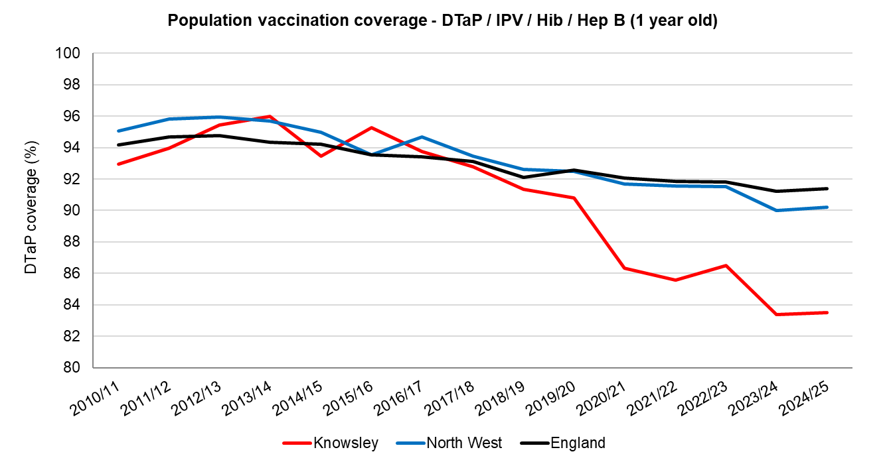
Figure 1 – Population vaccination coverage – DTaP/IPV/Hib/Hep B (1 year old) Source: Cover of Vaccination Evaluated Rapidly (COVER) data collected by the UK Health Security Agency (UKHSA). Available from NHS Digital

Data below (Figure 2) shows children who received three doses of DTaP/IPV/Hib/Hep B vaccine at any time by their second birthday as a percentage of all children whose second birthday falls within the time period.

The coverage of the Dtap/IPV/Hib/HepB immunisation in Knowsley was 85.7% in 2024/25 and has been in decline since 2013/14 when the coverage was 97.3%. Coverage during 2024/25 in Knowsley was again much lower than that of England (92.5%) and the North West Region (91.7%).

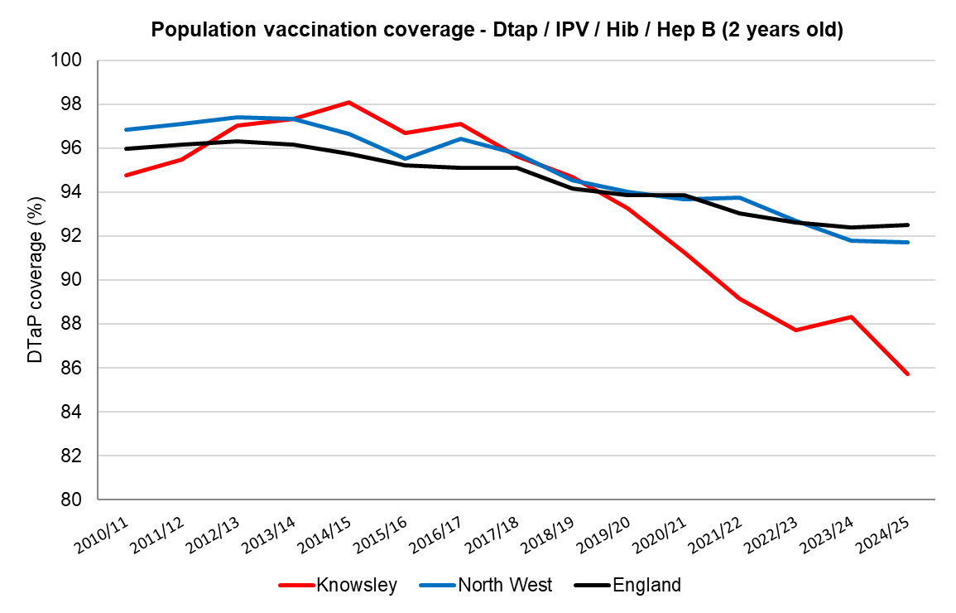
Figure 2 – Population vaccination coverage – Dtap/IPV/Hib/Hep B (2 year old) Source: Cover of Vaccination Evaluated Rapidly (COVER) data collected by The UK Health Security Agency (UKHSA). Available from NHS Digital

5.1.2 Pneumococcal Conjugate Vaccine (PCV)
The PCV vaccine protects against pneumococcal infections, which can cause a variety of different conditions such as ear infections, chest infections as well as serious septicaemia (blood poisoning), pneumonia and meningitis. The first two doses were given at eight weeks old and sixteen weeks and the third at twelve months. However, this changed in January 2020 to reduce the number of vaccines offered from three to two. These are now at twelve weeks and the second on or after the child’s first birthday.

Figure 3 shows the coverage of the PCV vaccine in those aged up to twelve months in Knowsley from 2010/11 to 2024/25. Note that no data is available for 2020/21; this is due to the change in the vaccine schedule and how the vaccination is recorded. Coverage of the PCV vaccine in Knowsley (87.9%) was lower than England (93.1%) and the North West region (92.6%) in 2024/25.

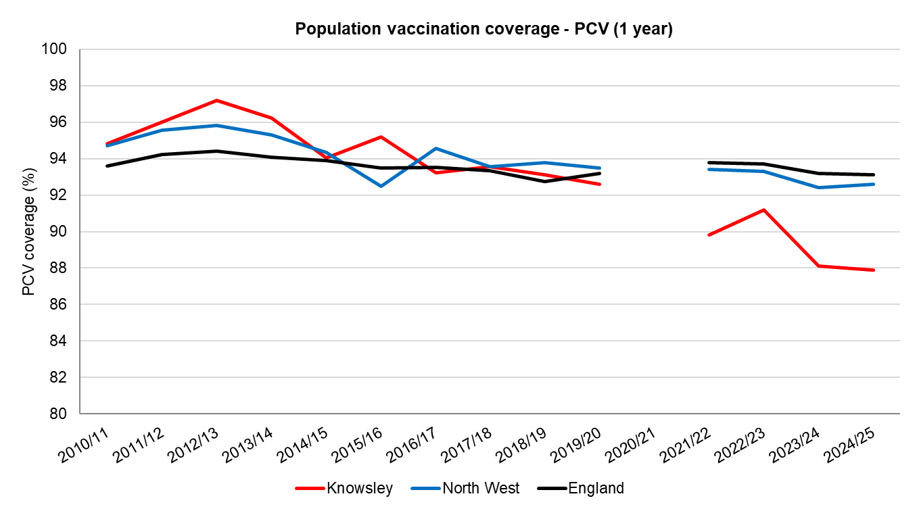

Figure 3 – Population vaccination coverage – PCV (12 months). Source: Cover of Vaccination Evaluated Rapidly (COVER) data collected by The UK Health Security Agency (UKHSA). Available from NHS Digital.

The coverage of the PCV vaccine booster in those aged up to 24 months in Knowsley was 78.6% in 2024/25 (Figure 4). PCV coverage dropped markedly between 2018/19 and 2021/22, plateaued and then fell again between 2023/24 and 2024/25. Coverage of the PCV vaccine booster in Knowsley in 2024/25 was almost 10% lower than in England (88.0%) and the North West region (88.0%).
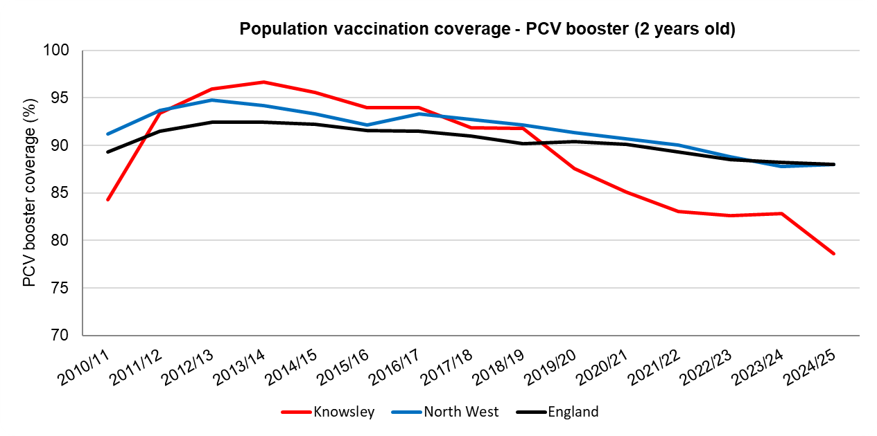
Figure 4 – Population vaccination coverage – PCV booster (24 months). Source: Cover of Vaccination Evaluated Rapidly (COVER) data collected by The UK Health Security Agency (UKHSA). Available from NHS Digital

5.1.3 Rotavirus
Rotavirus is the most common cause of serious diarrhoea and vomiting in young children. It can cause death through severe dehydration and is highly infectious. Before a vaccine was developed, it affected almost every child in the world by the age of five. This vaccination is offered at aged two months and three months.

The coverage of the Rotavirus vaccine in those aged up to twelve months in Knowsley has been falling since 2016/17 (Figure 5). Coverage of the Rotavirus vaccine in Knowsley in 2024/25 was 81.3%, which is lower than England (88.8%) and slightly lower than the North West region (87.2%) in 2018/19.

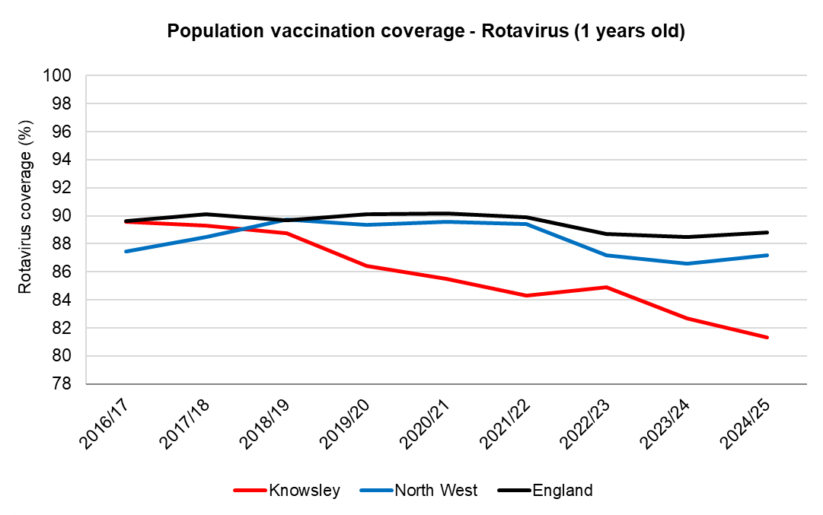
Figure 5 – Population vaccination coverage – Rotavirus (1 year old). Source: Cover of Vaccination Evaluated Rapidly (COVER) data collected by The UK Health Security Agency (UKHSA). Available from NHS Digital

5.1.4 Meningococcal B (MenB)
The MenB vaccine protects against infection by meningococcal group B bacteria, which are responsible for more than 90% of meningococcal infections in young children. MenB vaccine is given to babies at eight and sixteen weeks, with a booster on or after the child’s first birthday. The disease mainly affects young babies, with a peak at around five to six months of age.

The coverage of the MenB vaccine in those aged up to twelve months in Knowsley has decreased markedly, from 93.0% in 2018/19 to 84.0% in 2024/25 (Figure 6). This decline was much steeper than in England and the North West region where coverage in 2024/25 remains high, at 91.0% and 90.1% respectively.

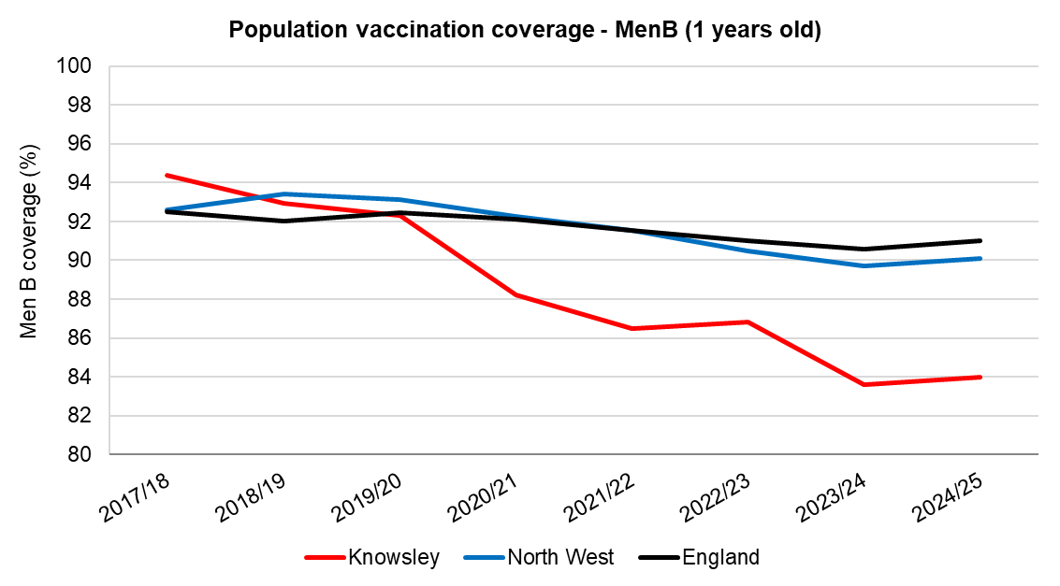
Figure 6 – Population vaccination coverage – Men B (1 year old). Source: Cover of Vaccination Evaluated Rapidly (COVER) data collected by The UK Health Security Agency (UKHSA). Available from NHS Digital

5.1.5 Hib/MenC booster
Hib and meningitis C infections are serious and potentially fatal. They can both cause meningitis and blood poisoning (septicaemia). The Hib/MenC booster is given to children on or after their first birthday. The vaccine boosts the protection provided by the first course of Hib vaccine, which babies receive in the 6-in-1 vaccine at eight, twelve and sixteen weeks old, and begins their protection against meningitis C.

The coverage for the Hib/MenC booster (recorded for two year olds) was 78.9% in Knowsley during 2024/25. Coverage for the Hib/MenC booster in Knowsley was much lower than North West (88.5%) and England (88.5%) during 2024/25. Since 2014/15 coverage has decreased sharply in Knowsley and has fallen from a high of 97.8% in 2014/15 to a new low in 2024/25 (Figure 7).

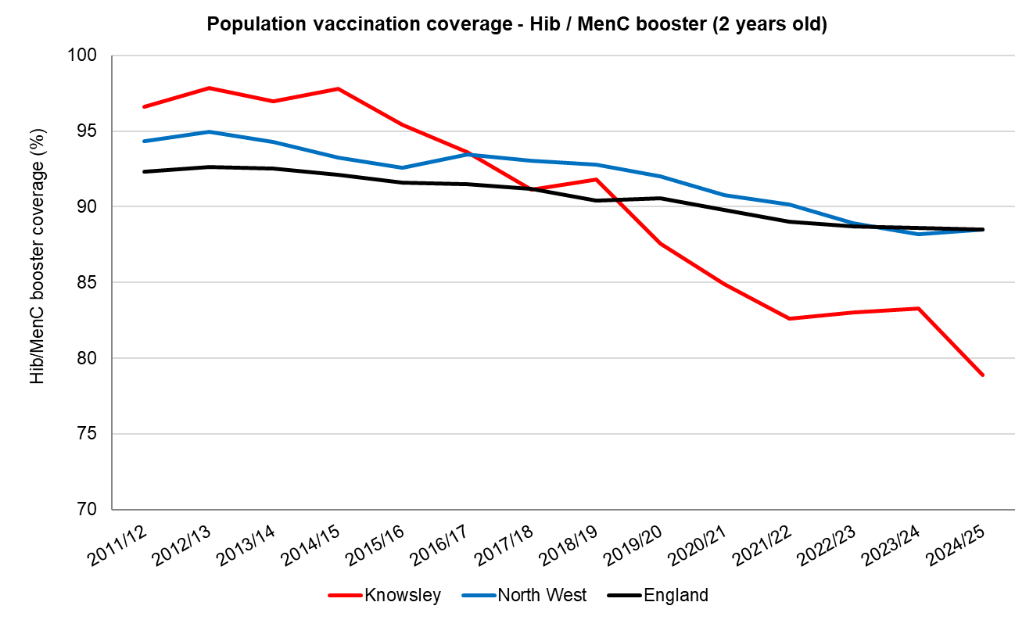
Figure 7 – Population vaccination coverage – Hib/MenC booster (2 years old) Source: Cover of Vaccination Evaluated Rapidly (COVER) data collected by The UK Health Security Agency (UKHSA). Available from NHS Digital

The chart below (Figure 8) shows data for children living in Knowsley who received a booster dose of Hib/MenC vaccine at any time by their fifth birthday as a percentage of all children in Knowsley whose fifth birthday fell within the time period.

The coverage for the Hib/MenC booster (recorded at 5 years old) was 86.7% in Knowsley during 2024/25. Coverage for the Hib/MenC booster in Knowsley was lower than the North West (91.5%) and England (88.9%) during 2024/25. There has been a downward trend in Hib/MenC booster coverage in Knowsley since 2013/14 when coverage was 97.5%.

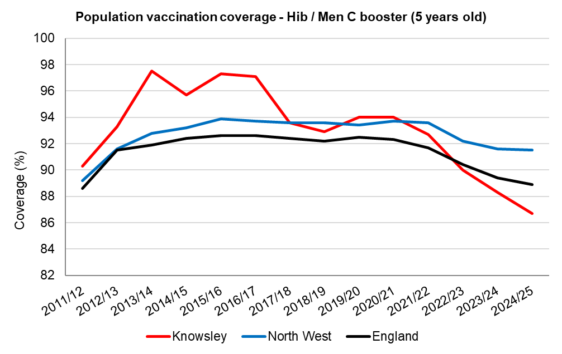
Figure 8 – Population vaccination coverage – Hib/Men C booster (5 years old) Source: Cover of Vaccination Evaluated Rapidly (COVER) data collected by The UK Health Security Agency (UKHSA). Available from NHS Digital

5.1.6 Measles, Mumps and Rubella (MMR)
The MMR was a combined vaccine that protected against three separate illnesses: measles, mumps and rubella (German measles) in a single injection. The full course of MMR vaccination required two doses. The first dose of the MMR vaccine was given to children on or after their first birthday and the second at three years four months old or soon after. In January 2026, a new measles, mumps, rubella, and varicella (chickenpox) vaccine (MMRV) replaced the MMR vaccine, and is administered in two doses at 12 months and 18 months.

Measles, mumps and rubella are common highly infectious conditions that can have serious and potentially fatal complications, including meningitis, encephalitis and deafness. They can also lead to complications in pregnancy that affect the unborn baby and can lead to miscarriage. Since the MMR vaccine was introduced in 1988, it is rare for children in the UK to develop these serious conditions. However, in 2024 and 2025 there were several outbreaks across the North West, including the one in Knowsley in June 2025 and in July 2025 a child sadly died from measles in Liverpool City Region. Varicella (chickenpox) poses risks of severe complications, especially for adults, pregnant women, and the immunocompromised. While often mild in children, it can also lead to serious complications including secondary bacterial infections (for example, Group A streptococcus), pneumonia, encephalitis, and, rarely, death. It is therefore important that parents ensure their child is up to date with the MMRV vaccination.

The coverage of the MMR vaccine (one dose – after first birthday) in Knowsley was 79.2% during 2024/25. Coverage of the MMR vaccine in Knowsley was much lower than the North West (88.9%) and England (88.9%) in 2024/25 (Figure 9).

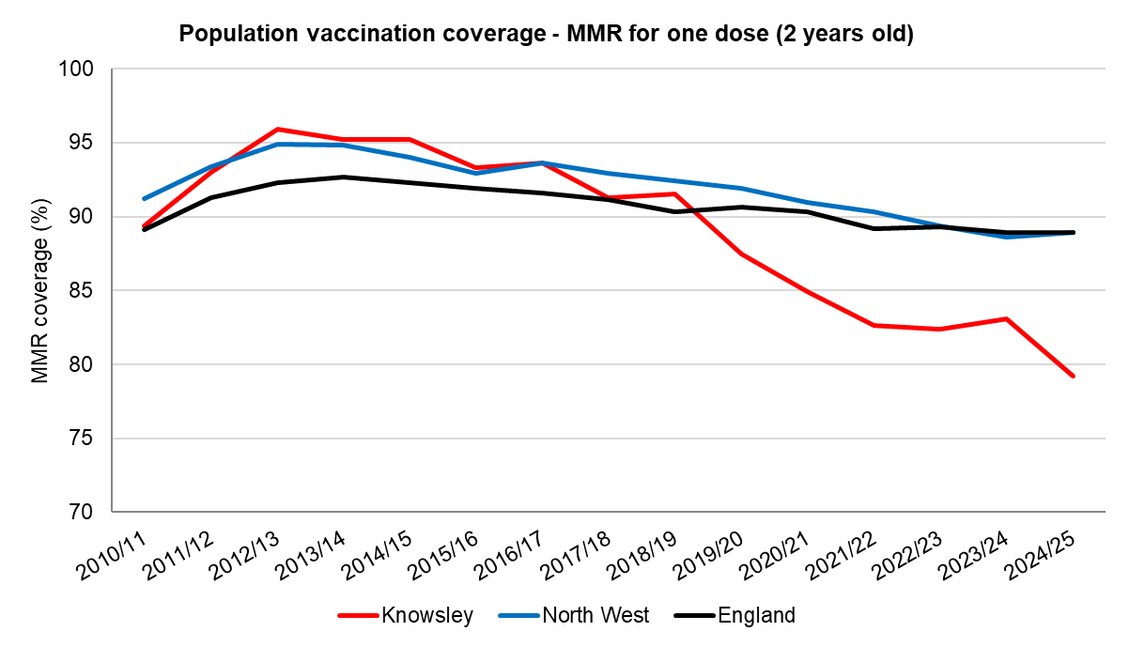
Figure 9 – Population vaccination coverage – MMR for one dose (2 years old) Source: Cover of Vaccination Evaluated Rapidly (COVER) data collected by The UK Health Security Agency (UKHSA). Available from NHS Digital

The coverage of the MMR vaccine (one dose) in Knowsley given to children after three years four months during 2024/25 was 88.1% (Figure 10). Coverage of the vaccine in 2024/25 in Knowsley was lower than England (91.9%) and the North West region (91.8%).

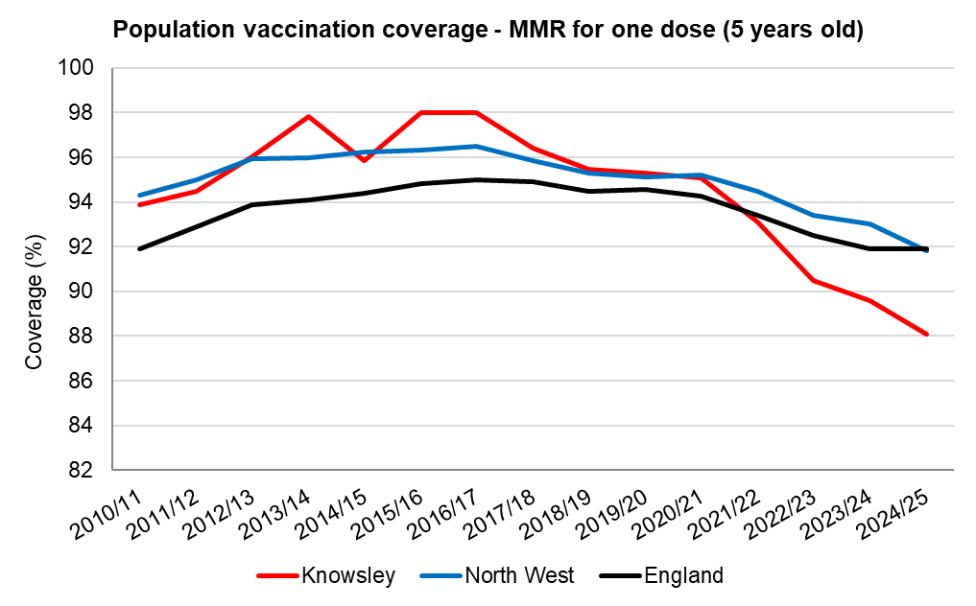
Figure 10 – Population vaccination coverage – MMR for one dose (5 years old) Source: Cover of Vaccination Evaluated Rapidly (COVER) data collected by The UK Health Security Agency (UKHSA). Available from NHS Digital

MMR coverage for two doses by 5 years old is calculated as children who received two doses of MMR on or after their first birthday and at any time up to their fifth birthday, as a percentage of all children whose fifth birthday falls within the time period. This coverage of the MMR vaccine in Knowsley during 2024/25 was 76.9%, this was lower than England (83.7%) and the North West region (83.7%). Coverage has been declining steadily in Knowsley since 2018/19 and has fallen by over 10% since then (Figure 11).
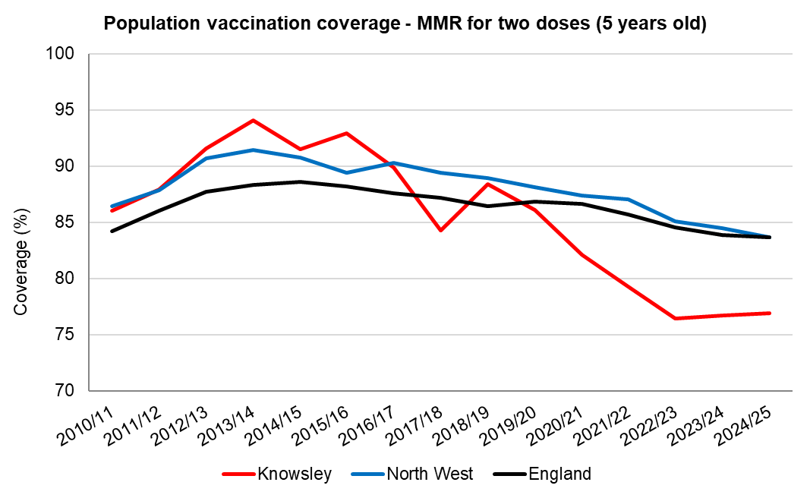

Figure 11 – Population vaccination coverage – MMR for two doses (5 years old) Source: Cover of Vaccination Evaluated Rapidly (COVER) data collected by The UK Health Security Agency (UKHSA). Available from NHS Digital

5.1.7 DTaP/IPV
The 4-in-1 pre-school booster vaccine is offered to children aged three years four months old or soon after to boost their protection against diphtheria, tetanus, whooping cough (pertussis) and polio.

The coverage of the 4-in-1 vaccine in Knowsley during 2024/25 was 75.6%. Coverage of the 4-in-1 vaccine in Knowsley was lower than England (81.4%) and the North West region (81.3%) during 2024/25 (Figure 12).

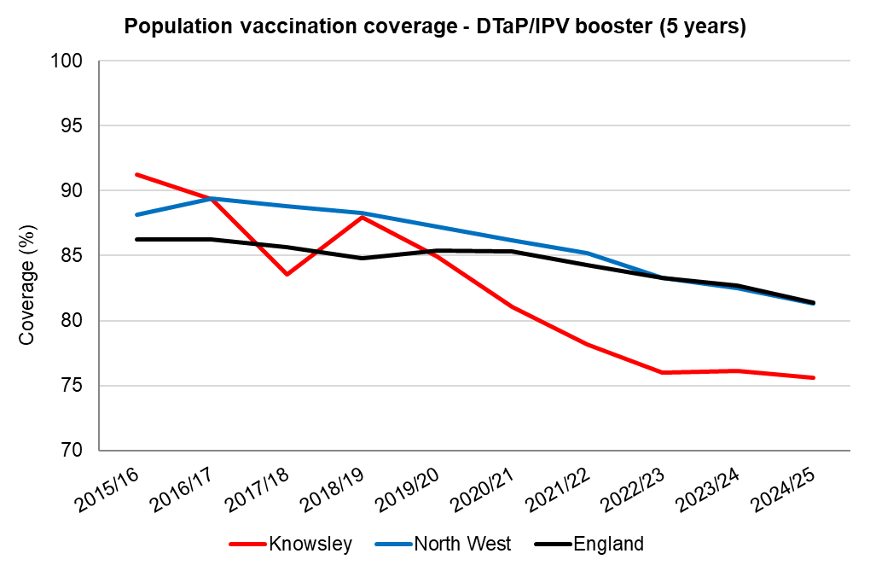
Figure 12 – Population vaccination coverage – Dtap/IPV (5 years old) Source: Cover of Vaccination Evaluated Rapidly (COVER) data collected by The UK Health Security Agency (UKHSA). Available from NHS Digital

5.1.8 Seasonal Flu
Flu vaccines are offered annually to all children aged two to three years, all children of primary school age, and for children in risk groups aged six months to less than eighteen years. Eligible groups are reviewed every year but in the most recent years, children in years 7-11 have also been offered Flu vaccination. A key objective of the children’s flu vaccination programme is to maximise reduction of flu transmission, in addition to providing individual protection.

Influenza vaccine in pre-school children aged two and three years
In Knowsley in 2024/25 uptake for all children aged two years was 20.1% which was much lower than both the North West (35.9%) and England (41.7%) (Figure 13A).

A similar picture was seen for all children aged three years: uptake in Knowsley in 2024/25 was 29.9% compared to 40% in the North West and 43.5% in England (Figure 13B).

The overall trend in pre-school vaccination coverage in Knowsley is similar to that in the North West and England: coverage has decreased since 2020/21 but plateaued between 2022/23 and 2024/25.

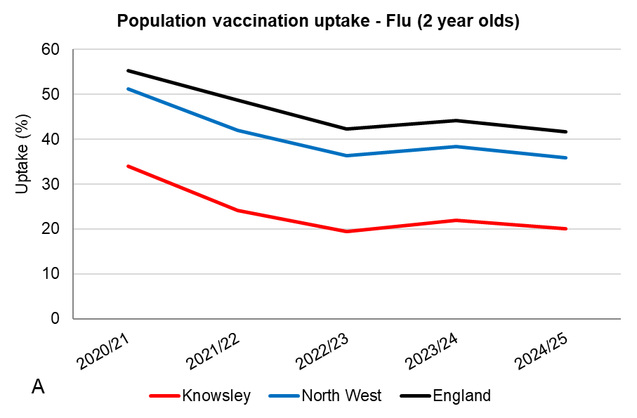 | 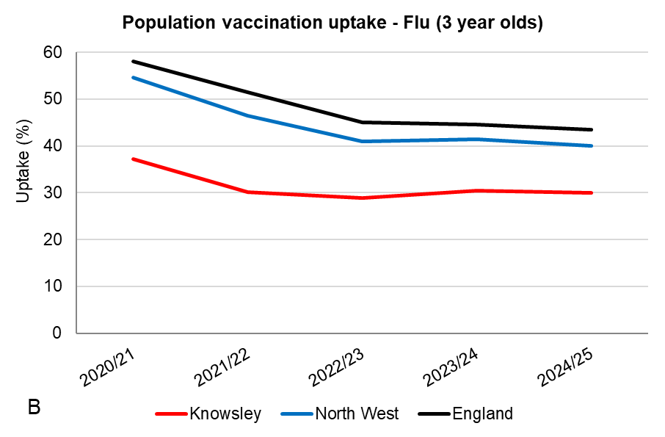
Figure 13: Seasonal influenza vaccine uptake: panel A shows coverage for 2 year olds and panel B shows coverage for 3 year olds. Due to changes in reporting, only the last 4 years are shown. Source: Influenza Vaccine Uptake Monitoring Programme, UK Health Security Agency (UKHSA). Data available at: Seasonal influenza vaccine uptake in GP patients: winter season 2024 to 2025 - GOV.UK
Vaccinations carried out in school age children
The sections below describe vaccinations in school aged children – note that due to the repeated school closures during the pandemic years (March 2020 to March 2021) school based vaccination programmes were interrupted. Data therefore show a drop off in vaccination coverage which is especially pronounced during 2019/2020 which covers the period July 2019 to end-June 2020.

Influenza vaccine in school age children
Since 2013, flu vaccination has been offered to children in a phased roll-out to provide individual protection to the children and to help reduce transmission across all age groups to protect vulnerable members of the population.

From 2019/20, the school programme was extended to include Year 6 children meaning that all primary school aged children in England were offered the vaccine for the first time. The following year (2020/21) the programme was extended to include Year 7 children and during the 2021/2022 season, the programme was extended as a temporary measure to include children of Years 8 through 11, making this the first season where all children aged 2 through to 16 years old had been offered the vaccine. In 2022/23 all primary school-aged children and secondary school-aged children in Years 7, 8 and 9 were offered flu vaccine, with any remaining vaccine offered to Years 10 and 11, subject to vaccine availability. Finally, in the most recent complete season for which data is available (2024/25) all children in primary and secondary school (reception to Year 11) were eligible from the start of the season. Data in Figure 14 below is therefore not shown for Years 10 and 11 as the offer was variable across the years.

In Knowsley, the uptake of flu vaccination of children in primary school has been declining across all age groups since 2019/20 (Figure 14). In 2024/25 in Knowsley, the lowest uptake of 37.7% was seen in Year 6 (Table 1). For children in secondary school in 2024/25 in Knowsley, uptake was lower than for the primary school years and dropped to less than 30% across all years: 29% for Year 7, 29.4% for Year 8, 26.3% for Year 9, 25.1% for Year 10 and 23.8% for Year 11 (Table 1).

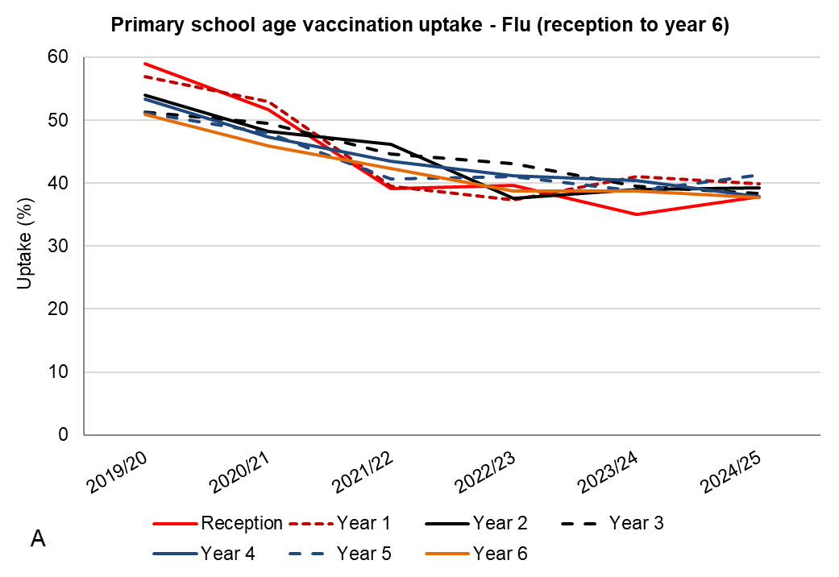 | 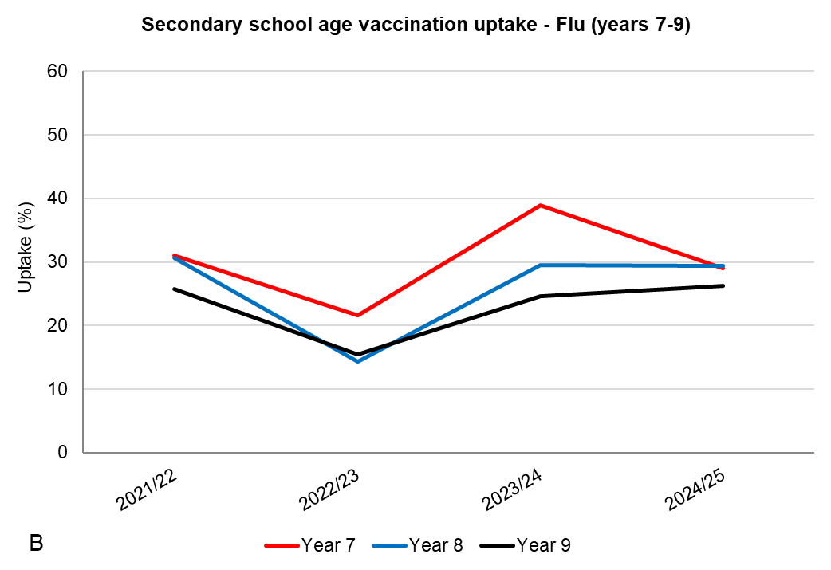

Figure 14: Seasonal influenza vaccine uptake: panel A shows coverage for primary age school children (all years) and panel B shows coverage for secondary school age children (years 7-9 only). Source: Influenza Vaccine Uptake Monitoring Programme, UK Health Security Agency (UKHSA). Data available at: Seasonal influenza vaccine uptake in children of school age: winter season 2024 to 2025 - GOV.UK

Table 1. Flu vaccination uptake for children in primary and secondary school (all year groups): 2023/24 and 2024/25 seasons in Knowsley compared to the North West region and England.

Year group | 2023/24 |  |  | 2024/25
Year group | Knowsley | North West | England | Knowsley | North West | England
Reception | 35.0 | 56.1 | 55.9 | 37.9 | 55.7 | 54.7
Year 1 | 41.1 | 57.3 | 56.4 | 39.9 | 56.6 | 55.6
Year 2 | 39.0 | 56.8 | 55.6 | 39.3 | 56.2 | 55.3
Year 3 | 39.5 | 57.3 | 55.8 | 38.4 | 55.6 | 54.6
Year 4 | 40.4 | 55.6 | 55.1 | 37.9 | 55.5 | 54.6
Year 5 | 38.8 | 55.5 | 54.1 | 41.3 | 54.9 | 54.1
Year 6 | 38.8 | 54.2 | 53.3 | 37.7 | 54.2 | 52.9
Year 7 | 38.9 | 44.1 | 49.1 | 29.0 | 45.1 | 50.0
Year 8 | 29.5 | 40.1 | 45.0 | 29.4 | 40.9 | 46.0
Year 9 | 24.6 | 37.8 | 42.5 | 26.3 | 39.3 | 44.5
Year 10 | 28.8 | 36.5 | 41.6 | 25.1 | 37.6 | 42.5
Year 11 | 23.1 | 30.1 | 35.7 | 23.8 | 34.8 | 40.0

5.1.9 HPV Vaccination
Human papilloma virus (HPV) is the name for a group of viruses. There are many types of HPV, some of which are called "high risk" because they are linked to the development of cancers, such as cervical cancer, anal cancer, genital cancers, and cancers of the head and neck. Other types can cause conditions such as warts or verrucas.

Nearly all cervical cancers (99.7%) are caused by infection with a high-risk type of HPV.

Girls and boys aged twelve to thirteen years are routinely offered the HPV vaccination when they are in school Year 8. The vaccination is delivered locally by the School Aged Immunisation Service (SAIS) who work with local schools.

Those who missed their HPV vaccination in school Year 8 can continue to have the vaccine up to their 25th birthday. Note that HPV was previously delivered on a 2-dose schedule but in September 2023, the adolescent HPV vaccination programme moved to a one-dose schedule. Coverage numbers given in this report are therefore stated as single dose figures.

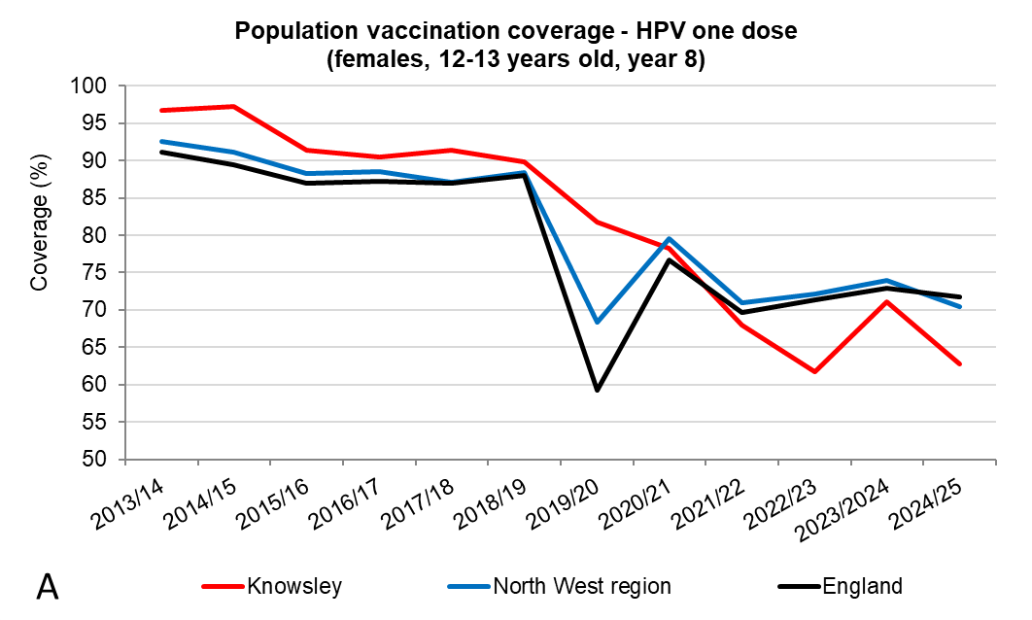 | 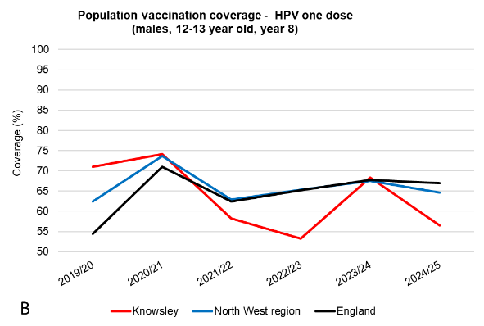

Figure 15: Population vaccination coverage - HPV vaccination coverage for one dose (A - females 12-13 years old; B males 12-13 years old) Source: Cover of Vaccination Evaluated Rapidly (COVER) data collected by The UK Health Security Agency (UKHSA). Available from NHS Digital

Coverage of the HPV vaccine in Knowsley during 2024/25 was 62.7% for Year 8 girls which was significantly lower than England (71.7%) and the North West region (70.4%). The trend in coverage over the years has been that of decline both locally and nationally, this is particularly the case since the pandemic. The latest year in Knowsley has seen a large decrease of 8.4% from the previous year 2023/24 (Figure 15A). In 2024/25 Knowsley had the 4th lowest coverage of upper-tier Local Authority areas out of 24 areas, and the lowest in Cheshire and Merseyside.

Coverage of the HPV vaccine in Knowsley during 2024/25 was 56.5% for Year 8 boys which was significantly lower than England (67.0%) and the North West region (64.6%). The latest year in Knowsley has seen a large decrease of 11.9% from the previous year 2023/24 (Figure 15B). In 2024/25 Knowsley had the 7th lowest coverage of upper-tier Local Authority areas out of 24 areas, and the 2nd lowest in Cheshire and Merseyside, in which Liverpool has the lowest coverage.

5.1.10 Td/IPV
The teenage booster, also known as the 3-in-1 or the Td/IPV vaccine, is given to boost protection against three separate diseases: tetanus, diphtheria, and polio. It is routinely given at secondary school (in school Year 9) at the same time as the MenACWY vaccine.
The latest year data for 2024/25, showed a large decline in Knowsley coverage in Year 9 from 71.4% in 2023/24 to 62.9% in 2024/25 (Figure 16). In this latest year Knowsley was significantly lower than Cheshire and Merseyside (73.9%) and England (72.9%). Knowsley had the lowest coverage in Cheshire and Merseyside.

In 2024/25 coverage in Year 10 in Knowsley was better than Year 9 and was 77.3%, higher than England (74.7%) and Cheshire and Merseyside (73.9%). Knowsley had the 4th highest coverage for Year 10 out of 9 Cheshire and Merseyside Local Authority areas. The campaign in 2023/24 did not include Year 10 pupils.

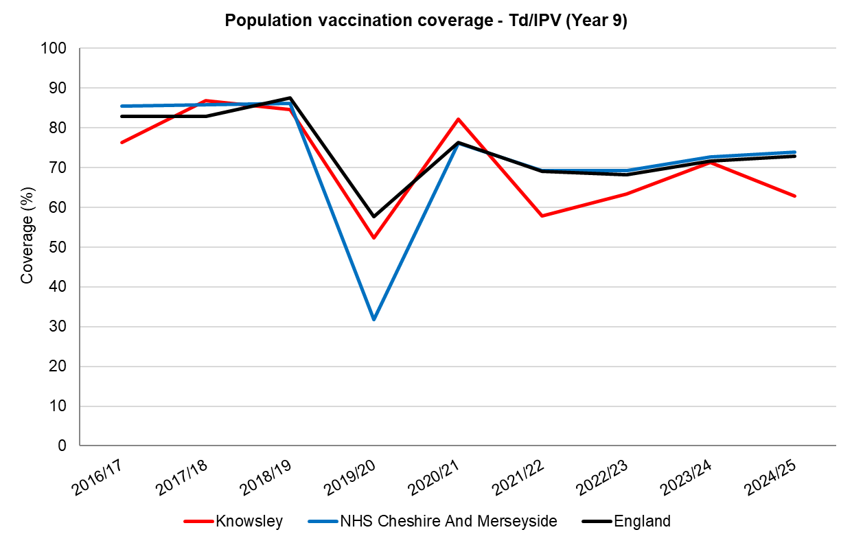
Figure 16: Population vaccination coverage – Td/IPV vaccination coverage in Year 9. Source: Cover of Vaccination Evaluated Rapidly (COVER) data collected by The UK Health Security Agency (UKHSA). Available from NHS Digital

5.1.11 MenACWY
The MenACWY vaccine is a single dose injection which protects against four different strains of the meningococcal bacteria that cause meningitis and blood poisoning (septicaemia): A, C, W and Y.

Children aged 13 to 14 years (school Year 9) are offered the MenACWY vaccine in school as part of the routine adolescent school-based immunisation programme; in some local authorities Year 10 students are also offered the vaccine. In addition, anyone born on or after 1st September 1996 who missed their routine school vaccination in school or the catch-up MenACWY vaccination can get the vaccine from their GP up to their 25th birthday.

In 2024/25, 62.9% of Year 9 children in Knowsley (aged 13-14 years) were vaccinated for MenACWY. This was significantly lower than England (72.8%) and lower than the North West region (66.6%) (Figure 17A). Coverage data for the Year 10 cohort (aged 14-15 years) showed that 77.2% of children were vaccinated in this Year group in Knowsley, which was higher than both England (75.1%) and the North West (73.8%) (Figure 17B).

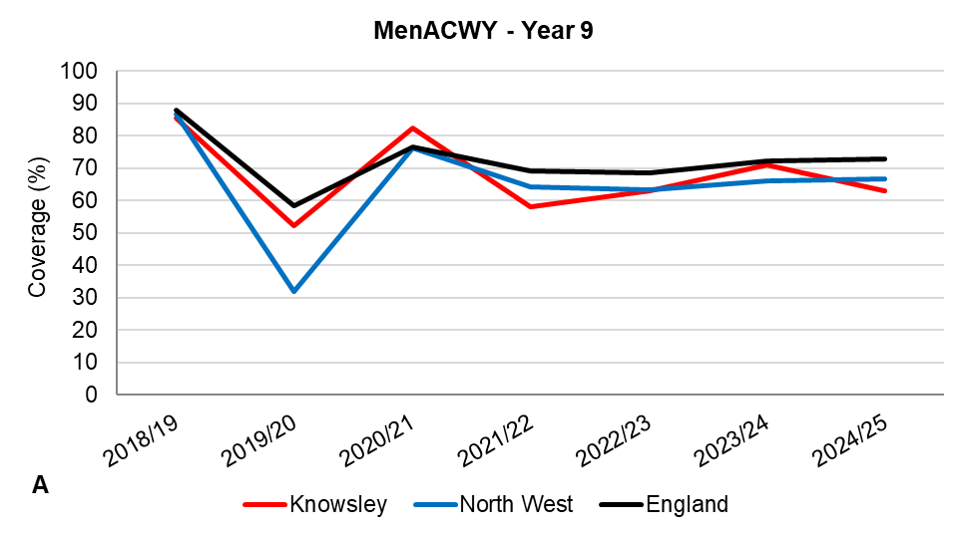 | 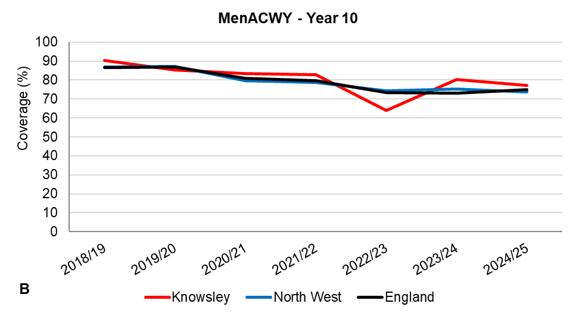

Figure 17: Population vaccination coverage – Men ACWY vaccination coverage in Years 9 and 10. Source: Cover of Vaccination Evaluated Rapidly (COVER) data collected by The UK Health Security Agency (UKHSA). Available from NHS Digital

Older teenagers and new university students are at higher risk of infection because many of them mix closely with lots of new people, some of whom may unknowingly carry the meningococcal bacteria at the back of their noses and throats. For this reason, students going to university or college for the first time, including overseas and mature students, who have not yet had the MenACWY vaccine remain eligible up to their 25th birthday.

5.2 Adult immunisations

5.2.1 Influenza vaccinations
Influenza is a serious infectious disease which can cause severe complications such as pneumonia and death. The annual seasonal flu vaccination programme is nationally commissioned and predominantly delivered by Primary Care and community pharmacies. It delivers flu vaccination to population groups at risk of the complications of influenza; these at-risk groups are reviewed annually. In recent years, eligible adults have included all individuals aged 65 years and over, those aged 18–64 years with qualifying clinical risk conditions (e.g., chronic respiratory/heart disease, diabetes, immunosuppression), pregnant individuals, care home residents, carers, and frontline health/social care workers.

Annual seasonal influenza immunisation uptake for those aged 65 years and over in Knowsley was 66.0% in the winter of 2024/25 (Figure 18), below the 75% national target. Coverage in Knowsley during 2024/25 was lower than the North West region (73.7%) and England (74.9%). There is some variation seen at practice level and the range in Knowsley general practices was 55% - 74%. Following an increase in flu vaccination uptake in those aged 65 years and over during the COVID-19 pandemic, uptake has been falling across Knowsley, the North West and England for the past 4 years.
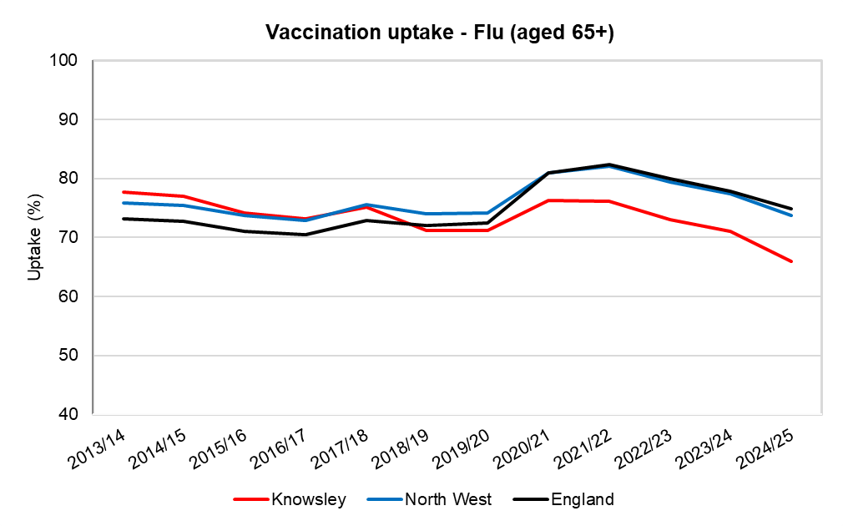
Figure 18: Population vaccination uptake - Flu (aged 65+) 2013/14 to 2024/25. Source: Influenza Vaccine Uptake Monitoring Programme, UK Health Security Agency (UKHSA). Data available at: Seasonal influenza vaccine uptake in GP patients: winter season 2024 to 2025 - GOV.UK

Flu vaccination uptake in the population deemed 'at risk' in Knowsley fell from 49.2% in 2020/21 to 33.6% in 2024/25 (Figure 19). Although similar drops were seen in the North West and England, uptake remained higher than in Knowsley: 39% and 40% respectively.

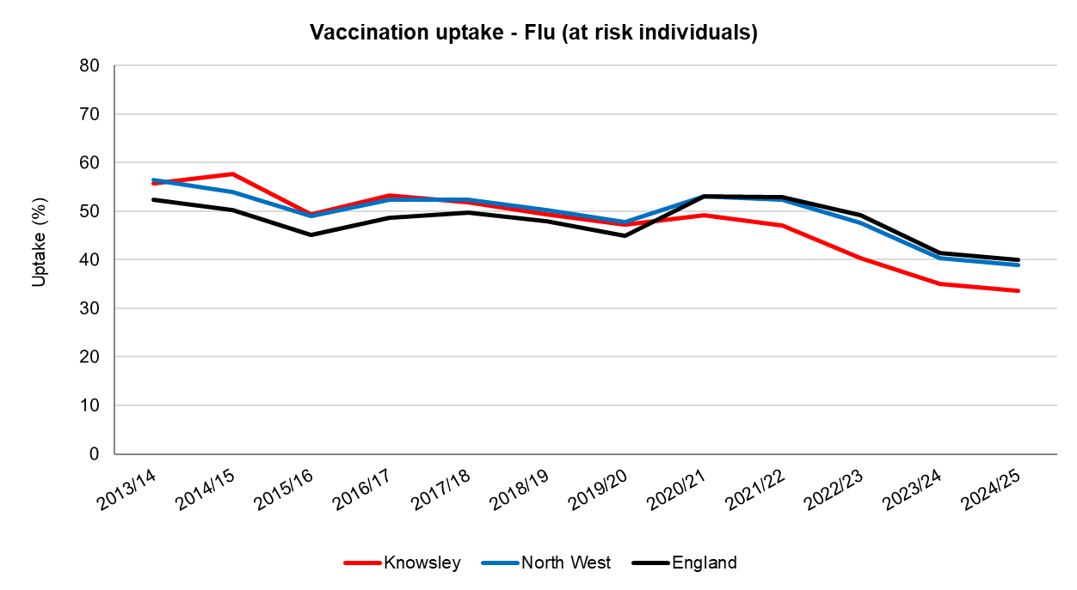
Figure 19: Population vaccination coverage - Flu (at risk individuals) 2013/14 to 2024/25 Source: Influenza Vaccine Uptake Monitoring Programme, UK Health Security Agency (UKHSA). Data available at: Seasonal influenza vaccine uptake in GP patients: winter season 2024 to 2025 - GOV.UK

Flu vaccination uptake in Knowsley for all pregnant women in 2024/25 was 24.9%, this was lower than the England figure of 35% and also the North West which was 33.1% (Figure 20). Uptake in pregnant women has dropped since 2019/20 when it was 45.9% in Knowsley; while it also declined in the North West and England the drop was less pronounced. There is some variation seen at practice level and the range of uptake in Knowsley general practices was 24% - 48%.

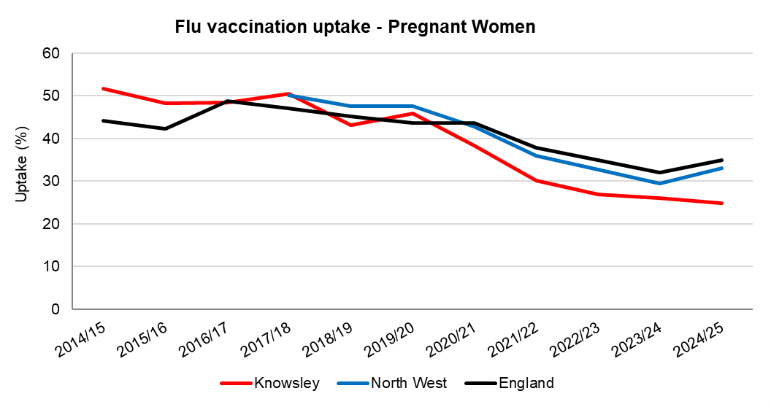
Figure 20: Population vaccination coverage - Flu (Pregnant Women) 2014/15 to 2024/25. Source: Influenza Vaccine Uptake Monitoring Programme, UK Health Security Agency (UKHSA). Data available at: Seasonal influenza vaccine uptake in GP patients: winter season 2024 to 2025 - GOV.UK

Vaccination of healthcare workers is an important element of the national programme and reduces the risk of infection to vulnerable patients. Flu vaccination uptake by staff in Merseyside trusts in 2024/25 varied from 33.4% at Mersey Care NHS Trust (an improvement from 23.7% in 2023/24), to 43.7% at Liverpool University Hospitals NHS Foundation Trust (Figure 21). Flu vaccination uptake among healthcare workers has decreased across all Merseyside trusts since 2020/21, when the uptake was between 82% and 95%. Although there is no published data available on seasonal flu vaccine uptake by social care staff, local unpublished data show that rates have consistently been extremely low in recent years.

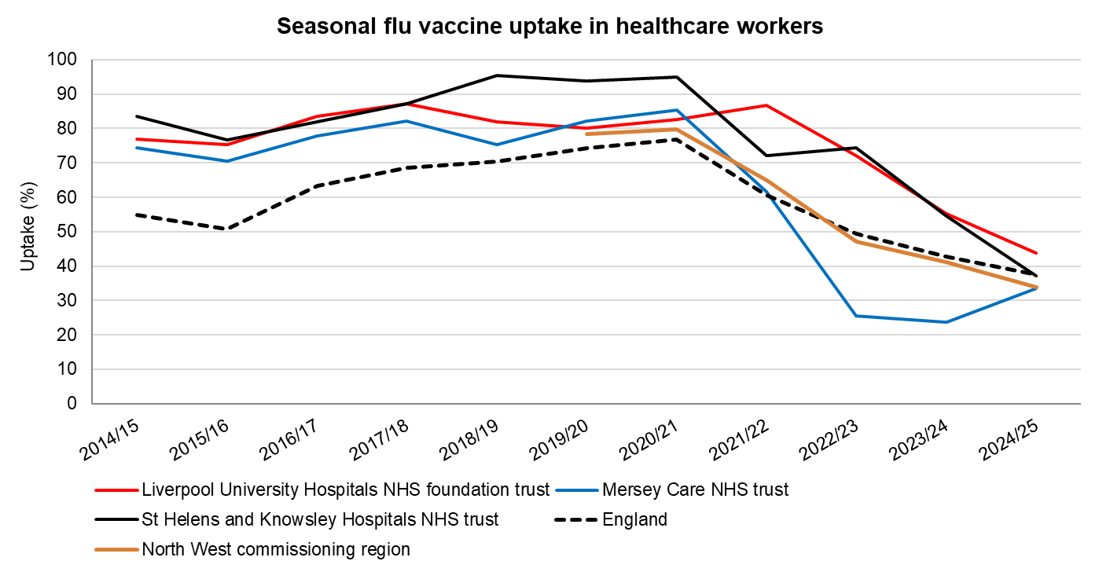
Figure 21: Seasonal flu vaccine coverage in healthcare workers 2014/15 to 2024/25. Source: Influenza Vaccine Uptake Monitoring Programme, UK Health Security Agency (UKHSA). Data available at

5.2.2 COVID-19 Booster Vaccination
Uptake data for the 2024 Autumn COVID-19 booster vaccinations for those age 65+ show that Knowsley uptake was significantly lower than North West and England for all 65+ age groups. Uptake did increase with age both locally and nationally. Even for the old age group of 80+ Knowsley was nearly 15% lower than England and 12% lower than the North West.

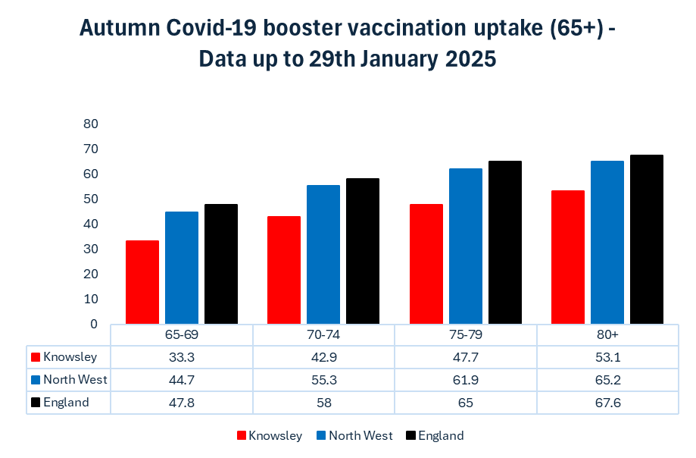
Figure 22: Autumn COVID-19 booster vaccination uptake (aged 65+) Data up to 29th January 2025. Source: UK Health Security Agency (UKHSA) data dashboard.

5.2.3 Shingles Vaccination
Shingles is caused by the reactivation of the chickenpox virus in people who have previously been infected. The virus may be reactivated, or reawakened, due to other factors such as age, stress, other illnesses or medication. Around one in five people who have had chickenpox will get shingles at some point. Shingles causes a rash and pain which can persist.

The shingles vaccine was launched in September 2013 and consisted of a single dose of Zostavax shingles vaccine to all 70 year olds as well as a catch-up programme for older cohorts. Adults became eligible at 70 years old and remained eligible until their 80th birthday.

From September 2021, a new shingles recombinant sub-unit vaccine (Shingrix) was added to the programme to increase protection against shingles amongst eligible cohorts unable to have the live Zostavax shingles vaccine due to immunosuppression or/and contraindication.

Figure 23 shows uptake in those aged 71 years in Knowsley; coverage was 49.7% in 2022/23 which was similar to the North West (48.6%) and England (50.8%). The success of the flu vaccination programme for over sixty fives may offer opportunities to improve shingles vaccination uptake through linking the offer for the two together, although the shingles vaccination can be given at any time of the year.

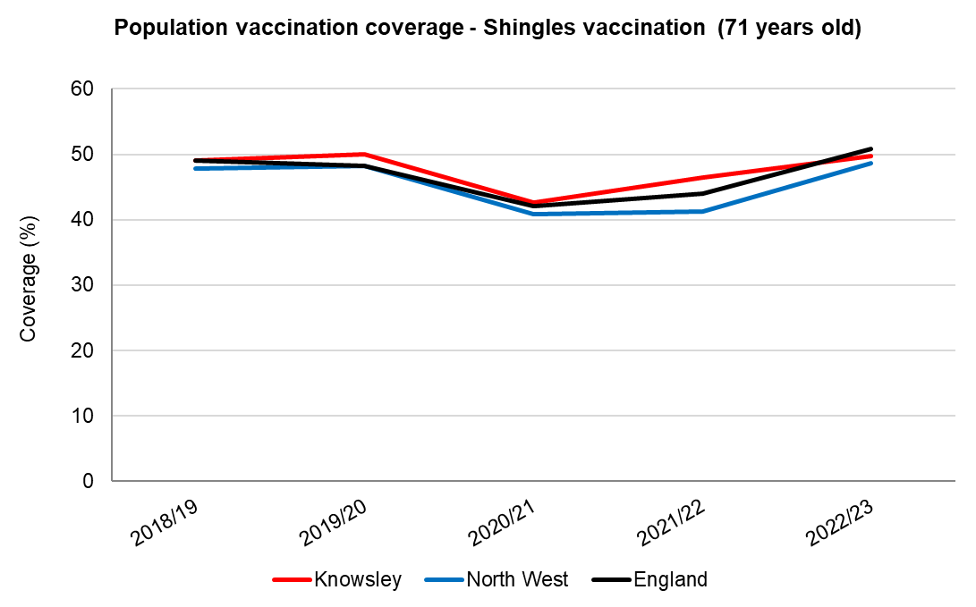

Figure 23: Population vaccination coverage Shingles (aged 71) 2018/19 to 2022/23. Source: UK Health Security Agency

From September 2023, a new programme was introduced, offering two doses of Shingrix vaccine to all severely immunosuppressed individuals from 50 years of age and immunocompetent individuals turning 65 and 70 years of age.

New data was recently released for the new Shingrix vaccine from Quarter 3 for 2024/25 for vaccination coverage of those turning 66 years old - this showed that Knowsley coverage for 1 dose was 37.3%, this was higher than the North West (36.5%) but lower than England (39.2%) (Figure 24). Coverage for 2 doses of Shingrix was very low at 16.0%, much lower than the North West (22.6%) and England (25.1%). The gap between 1 dose and 2 dose was the highest in the country of upper tier Local Authority areas at age 66 years.

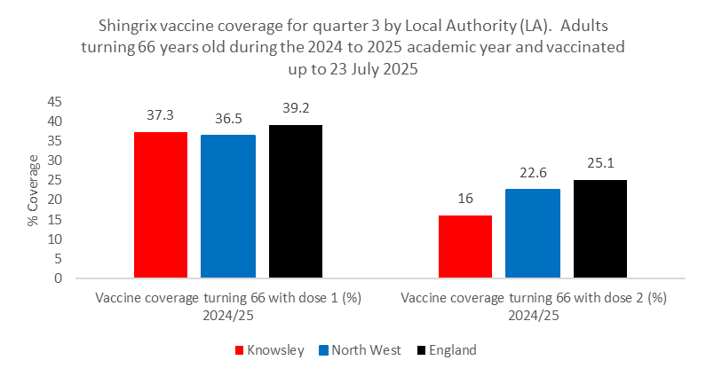
Figure 24: Shingrix vaccine coverage Shingles (aged 66) 1 and 2 doses, quarter 3 2024/25. Source: UK Health Security Agency

Quarter 3 data for 2024/25 for vaccination coverage of those turning age 71 showed that Knowsley coverage for 1 dose was 50.4%, this was higher than the North West (48.7%) but lower than England (51.1%). Coverage for 2 doses of Shingrix was very low at 25.9% (Figure 25), much lower than the North West (32.3%) and England (34.8%). The gap between 1 dose and 2 dose was the highest in the country of upper tier Local Authority areas at age 71 years.

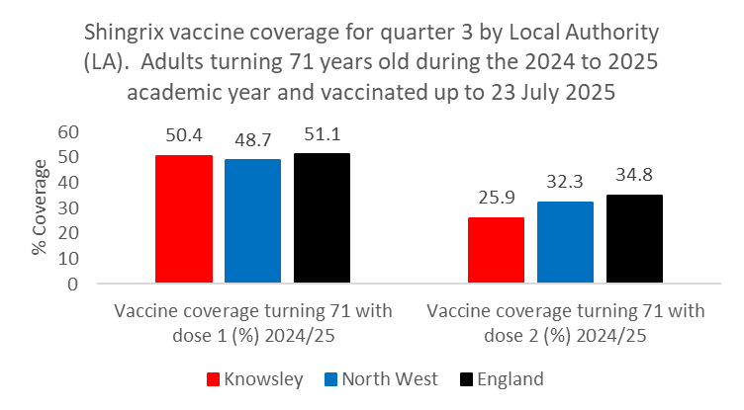
Figure 25: Shingrix vaccine coverage Shingles (aged 71) 1 and 2 doses, quarter 3 2024/25. Source: UK Health Security Agency

5.2.4 Pneumococcal Polysaccharide Vaccine (PPV)
PPV is also known as the pneumonia vaccine and is offered to people aged sixty-five and over. The PPV vaccine protects against serious and potentially fatal pneumococcal infections caused by the bacterium Streptococcus pneumoniae; these infections can lead to pneumonia, septicaemia (a kind of blood poisoning) and meningitis. PPV is administered as a single one-off dose; re-vaccination every 5 years is only recommended for individuals in certain clinical risk groups.
In Knowsley vaccination coverage for PPV has dropped slightly over the past decade, from 79.5% in 2014/15 to 73.5% in 2024/25; coverage is similar to North West and England levels (Figure 26).
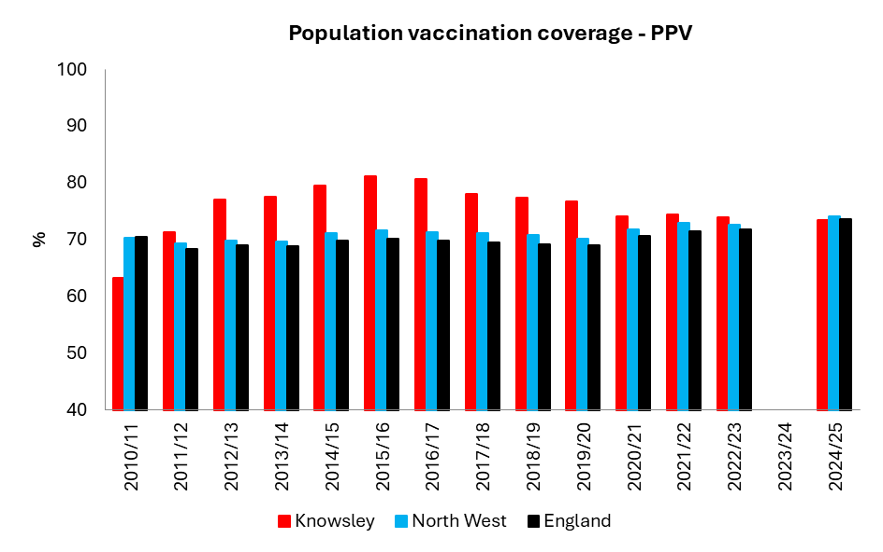
Figure 26: Population vaccination coverage PPV (65 years and over)) 2013/14 to 2024.25. Source: UK Health Security Agency
*Note: Due to data quality issues, UKHSA did not publish local authority coverage data in 2023/24.

5.2.5 Pertussis vaccination in pregnancy
Whooping cough (pertussis) is a highly contagious bacterial infection of the lungs and airways that causes repeated coughing bouts that can last for two to three months. Infants aged less than three months old are at highest risk of severe infections and death. The pertussis (whooping cough) vaccine is offered during pregnancy, ideally from sixteen weeks up to thirty-two weeks’ gestation, in order to maximise the chance that the baby is protected from birth, through the transfer of antibodies before birth. Pertussis vaccination in pregnancy ensures that newborn babies are protected against whooping cough until they can have their own vaccination at 8 weeks of age.

The Prenatal Pertussis Coverage of the vaccine is measured in women who receive the vaccine in the fourteen weeks prior to delivery. In Knowsley sub-ICB between October 2024 and September 2025 the estimated monthly coverage varied between 57.6% and 83.1%. In the latest monthly data (September 2025) available, coverage in Knowsley was 64.3%, lower than the England rate of (72.9%) and Cheshire and Merseyside (75.3%).

6 COMMUNICABLE DISEASES
Infectious diseases today continue to pose a significant burden to health and society. The detection and control of these infections are an ongoing challenge, as is the growing risk of antibiotic-resistant infections.

In England, notifiable disease reporting follows two legal schedules under the Health Protection (Notification) Regulations 2010. Schedule 1 covers specific infectious diseases (for example measles, tuberculosis, meningitis, and viral haemorrhagic fevers) that medical practitioners must report immediately, within 24 hours for urgent cases or three days for routine ones. Schedule 2 lists causative organisms (for example measles virus, Neisseria meningitidis, and Mycobacterium tuberculosis) that laboratories must notify irrespective of clinical suspicion.

Alongside notifiable disease reporting, all NHS providers engage in mandatory Healthcare-Associated Infection surveillance for infections such as MRSA bloodstream infections, Clostridioides difficile, and Gram-negative bacteraemia.

All of the infections reported in section 6 are notifiable under either the Health Protection (Notification) Regulations 2010 or under the mandatory HCAI surveillance scheme.

6.1 Healthcare Associated Infections (HCAI)
Healthcare-Associated infections (HCAIs) develop either as a direct result of healthcare interventions or treatment, or from being in contact with a health or social care setting. HCAIs pose a serious risk to patients and service users and can cause significant morbidity and even death. They disproportionately affect vulnerable groups with co-morbidity.

HCAIs are a health inequalities issue, disproportionately affecting the more vulnerable members of the population who may be ageing or have long term conditions. These infections can have a profound effect on quality of life and outcomes for the patient, as well as increasing the length of hospital stays and costs of care.

It is essential that the health and social care system works together to optimise infection control and to ensure that when cases of HCAIs do occur, the lessons from gaps in care are learnt and addressed throughout the whole system. Action is also required on appropriate prescribing of antibiotics and proton-pump inhibitors (a medicine used to provide protection for the stomach against other medications or stomach symptoms).

The most well-known HCAIs include those caused by Methicillin-resistant Staphylococcus aureus (MRSA), Methicillin-sensitive Staphylococcus aureus (MSSA), and Clostridioides difficile (C. difficile). Other bacteria which can be healthcare acquired and are notifiable when they cause bloodstream infections, include Escherichia coli (E. coli), Klebsiella spp. and Pseudomonas aeruginosa. Over the past decade Carbapenemase-producing Enterobacterales (CPE) have emerged as a significant threat.

The ICB, UKHSA and Local Authority, with the collaboration of infection prevention and control services, jointly review the infection trends, support management of outbreaks and develop preventative strategies. These reviews are underpinned by national surveillance data from UKHSA’s HCAI Data Capture System.

ICBs have accountability for meeting national targets related to HCAIs, across all care settings, under the 2025/26 NHS Oversight Framework published by NHS England. ICBs are assessed annually by NHS England for performance and governance, including infection prevention obligations

Local IPC teams carry out a root cause analysis for each case of C. difficile or MRSA to capture lessons learned and identify opportunities to prevent future HCAIs.

6.1.1 C. difficile
A C. difficile infection is a type of bacterial infection that can affect the digestive system. It most commonly affects people who have been treated with antibiotics, especially people who are susceptible through chronic illness or older age. Infection is classified according to where it is most likely to have been acquired – community or hospital, although root cause analysis of cases often shows complicated patient histories of interaction with social care, community care and acute care.

During 2024/25, there were 98 reported cases of C. difficile among people aged 2 or over in Knowsley. The numbers have decreased by 32% since 2009/10 when there were 144 reported cases. The Knowsley rate was 62.5 per 100,000 population in 2024/25, which was higher than Cheshire and Merseyside NHS region (46.8 per 100,000) and almost double the England rate (33.3 per 100,000) (Figure 27).

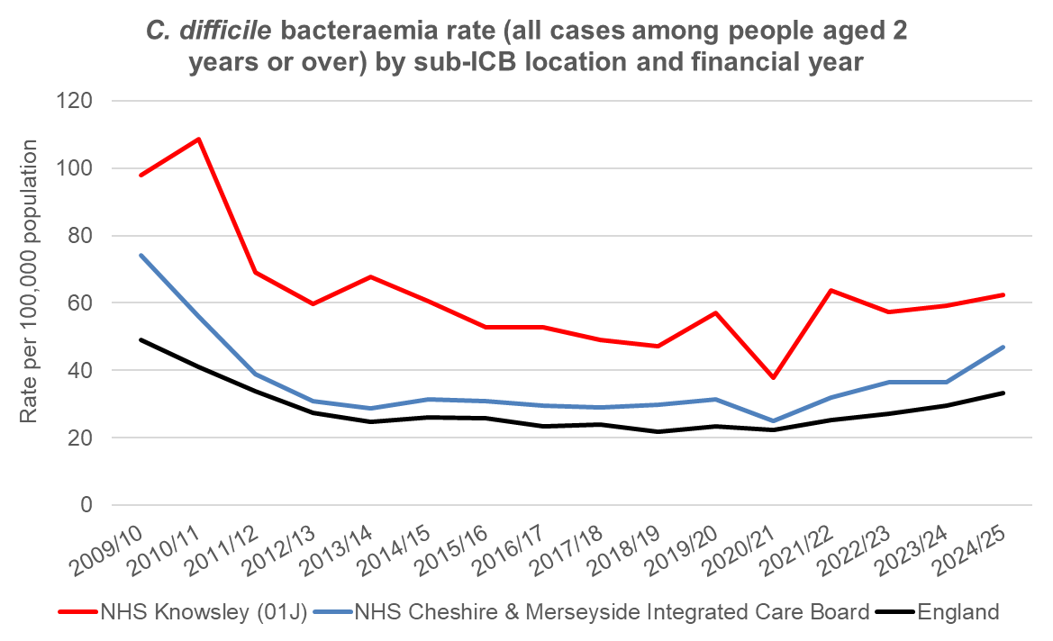
Figure 27: C. difficile bacteraemia 2009/10 to 2024/25 Source: C. difficile bacteraemia all rates by sub-ICB and financial year, UK Health Security Agency, HCAI Mandatory Surveillance Data

6.1.2 MRSA
Methicillin-resistant Staphylococcus aureus (MRSA) is a type of bacterial infection that is resistant to a number of widely used antibiotics. This means it can be more difficult to treat than other bacterial infections, and it is known as a "superbug".

The number of reported cases of MRSA recorded since 2009/10 has been relatively low in Knowsley, with an average of 3 cases per reported per year. In 2024/25, there were three cases reported in Knowsley, with four cases reported in the previous year. The NHS has a zero-tolerance policy on this infection and thus monitoring and investigation into the factors that may have caused infection needs to continue.

6.1.3 MSSA
Staphylococcus aureus is a bacterium that commonly colonises human skin and mucosa (e.g. inside the nose) without causing any problems. It can also cause disease, particularly if there is an opportunity for the bacteria to enter the body, for example through broken skin or a medical procedure. Most strains of Staphylococcus aureus are sensitive to the more commonly used antibiotics, and infections can be effectively treated. Some Staphylococcus aureus bacteria are more resistant. Unlike MRSA, those that bacteria which are sensitive to methicillin are termed methicillin-sensitive Staphylococcus aureus (MSSA).

The number of MSSA bacteraemia in the Knowsley sub-ICB area during 2024/25 was 84. The rate of MSSA bacteraemia cases in Knowsley had been declining since 2018/19 but has increased since 2020/21: from 39.0 cases per 100,000 population in that year to 53.6 cases per 100,000 population in 2024/25 (Figure 28). The 2024/25 rate is higher than both the Cheshire and Merseyside rate (31.9 cases per 100,000 population) and over double the England rate (24.2 cases per 100,000 population).

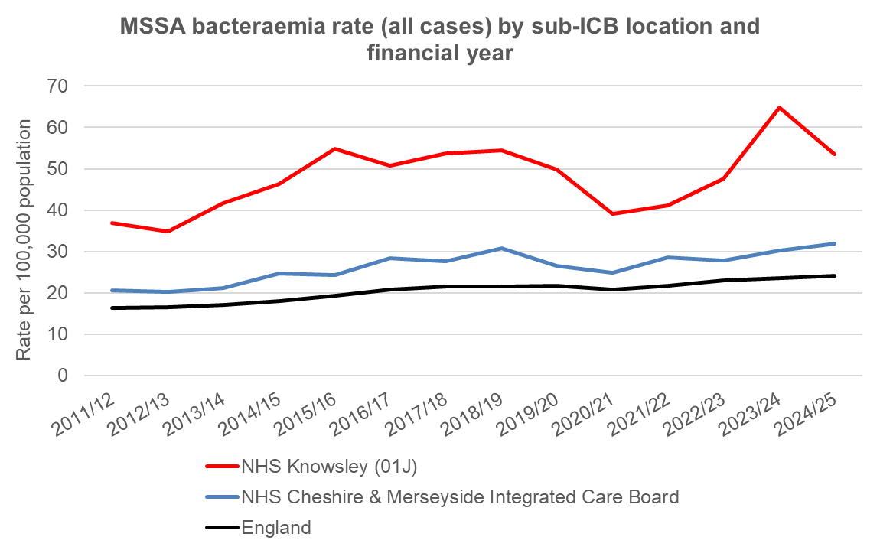
Figure 28: MSSA bacteraemia 2011/12 to 2024/25 Source: MSSA bacteraemia all rates by sub-ICB and financial year, UK Health Security Agency, HCAI Mandatory Surveillance Data

6.1.4 E. coli
Most strains of Escherichia coli (E. coli) form part of the normal intestinal micro-organism in humans and animals. However, some strains have the ability to cause disease in humans through the presence of specific virulence factors. Shiga-toxin-producing E. coli (STEC) are one type which can cause gastrointestinal illness (see section 6.3. Other strains of E. coli cause urinary tract infections (UTIs) and life-threatening bacteraemia, with the latter being notifiable to the HCAI mandatory surveillance system.

The total number of E. coli bacteraemia in the Knowsley sub-ICB area during 2024/25 was 225. In 2024/25, the rate of E.coli bacteraemia cases in Knowsley was 143.5 cases per 100,000 population, higher than Cheshire and Merseyside (91.5 cases per 100,000 population) and almost double the England rate (76.6 cases per 100,000 population). Over the period 2012/13 to 2024/25, the rate in Knowsley sub-ICB has been consistently higher than that of Cheshire and Merseyside and England (Figure 29).

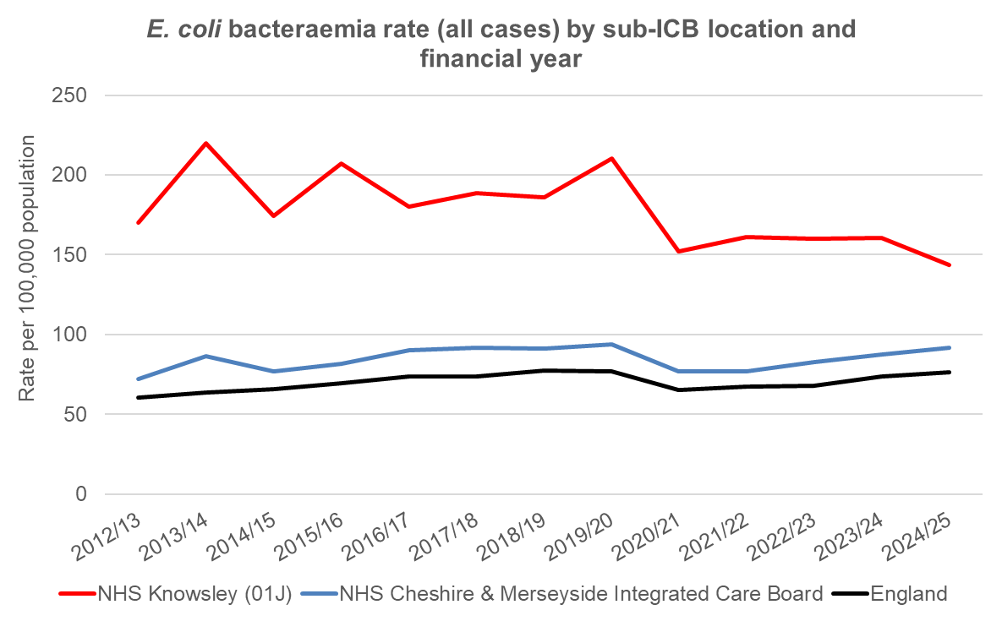
Figure 29: E.coli bacteraemia 2012/13 to 2024/25 Source: E. coli bacteraemia all rates by sub-ICB and financial year, UKHSA, Mandatory HCAI Data Capture System

6.1.5 Klebsiella spp.
These bacteria can cause a range of healthcare-associated infections, including pneumonia, bloodstream infections, wound or surgical site infections and meningitis. There were 55 Klebsiella spp. bacteraemia cases in Knowsley sub-ICB in 2024/25 and the rate was higher than for both England and Cheshire and Merseyside ICB (Figure 30).

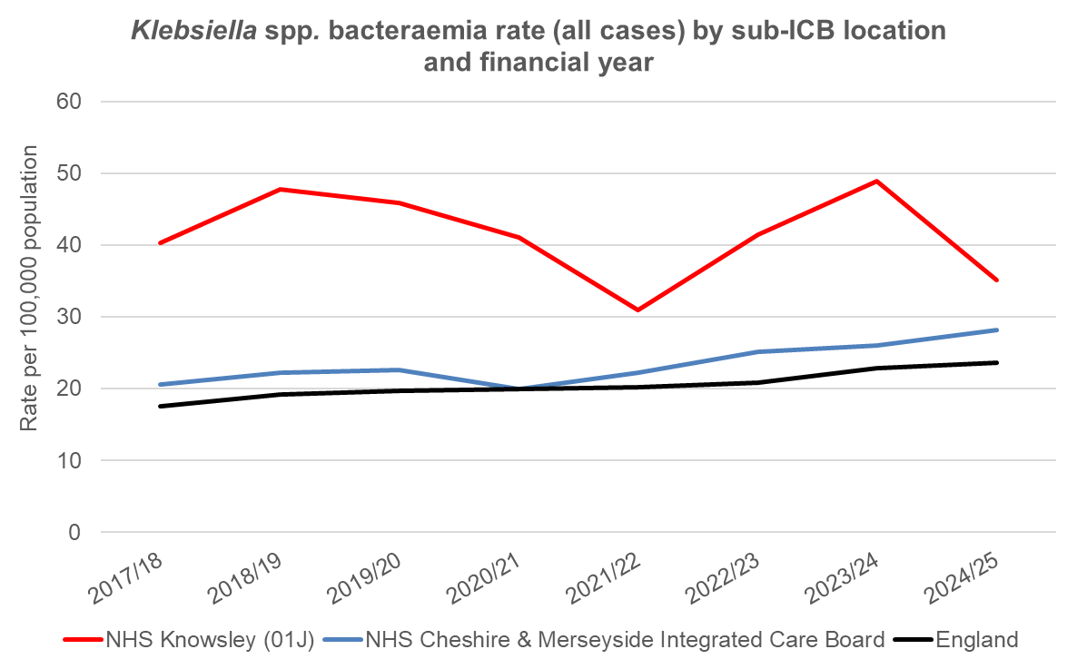
Figure 30: Klebsiella spp. bacteraemia 2012/13 to 2024/25 Source: E. coli bacteraemia all rates by sub-ICB and financial year, UKHSA, Mandatory HCAI Data Capture System

6.1.6 Pseudomonas aeruginosa
Pseudomonas aeruginosa is a Gram-negative bacterium. It can cause a wide range of infections, particularly in those with a weakened immune system e.g., cancer patients, newborns and people with diabetes or cystic fibrosis.
The organism can contaminate devices that are left inside the body, such as respiratory equipment and catheters. Pseudomonas aeruginosa is resistant to many commonly used antibiotics.
The annual number of Pseudomonas aeruginosa bacteraemias in Knowsley remains low, with an average of 11 cases reported each year since 2017/18.

6.2 Antimicrobial resistance

Antimicrobials are medicines used to kill microorganisms, and antibiotics refer specifically to those that kill bacteria. Antimicrobial resistance is becoming a key concern within the UK and across the world. Antimicrobial resistance arises when micro-organisms are able to survive exposure to a medicine that would normally eliminate them. This occurs through natural processes but is becoming increasingly common as more and more antibiotics are used in health and veterinary care.

Simple infections could become a serious risk to the population and the success of many of the medical advances made in recent years, for example organ transplantation and cancer chemotherapy, could be compromised. Antibiotics also increase the risk of healthcare associated infections and are almost always a factor when root cause analysis is undertaken locally for C. difficile cases.

Data on antimicrobial resistant organisms is complex and currently not publicly available for geographies smaller than Integrated Care Boards (ICBs). Nevertheless, the recently published annual report (2024 to 2025) of the English Programme for Antimicrobial Usage and Resistance (ESPAUR) highlights trends across the North West. The North West continues to report a substantial AMR burden, particularly for resistant E. coli and Klebsiella pneumoniae bacteraemia infections. Cheshire and Merseyside ICB had one of the highest rates of resistant bacteraemia infections: 42.8 per 100,000 population. Of note, the rate of resistant bacteraemia in England was highest in people in the most deprived quintile (23.5% of bacteraemia episodes; n = 20,823, rate = 43.3 per 100,000 population). This represents a 47.2% higher rate of resistant bacteraemia when compared to the least deprived quintile (43.3 vs 29.4 per 100,000 population) and this inequality gap between the most and least deprived quintiles has nearly doubled since 2019 when it was 29%²⁰.

Carbapenemase-Producing Gram Negative organisms (CPOs) are bacteria that have developed resistance to carbapenems, a class of powerful ‘last-resort’ antibiotics used to treat serious infections. Rates of CPO infections in the North West in 2024 were the second highest (66.9 per 100,000 population) after London (75.2 per 100,000); the rate in Cheshire and Merseyside ICB was 27.2 per 100,000²⁰.

Of serious concern is the development of organisms that are multi-drug resistant (MDR), meaning they are resistant to more than one antibiotic and therefore difficult to treat. Reports of infections from MDR gonorrhoea have increased in England in recent years and cases of MDR TB, although still low in England (2.2% of cases in 2024), are a significant burden as they often require longer treatment and have worse outcomes.

6.3 Gastrointestinal Infections

6.3.1 Overview of Gastrointestinal infections
Table 2 provides a summary of the number of the main gastrointestinal infections reported in Knowsley from 2018 to 2024.
Table 2. Annual number of selected gastrointestinal infections in Knowsley, 2018-2024
Organism | 2018 | 2019 | 2020 | 2021 | 2022 | 2023 | 2024
Campylobacter | 118 | 104 | 139 | 190 | 190 | 201 | 223
Non-typhoidal salmonella | 28 | 17 | 11 | 11 | 16 | 16 | 19
Shiga-toxin producing Escherichia coli (STEC) | 1 | 0 | 1 | 0 | 2 | 1 | 6
Shigella | 2 | 4 | 1 | 1 | 1 | 3 | 4
Listeria monocytogenes | 0 | 2 | 1 | 0 | 0 | 0 | 0
Salmonella Typhi / Paratyphi | 0 | 0 | 0 | 0 | 0 | 1 | 0
Data source: UKHSA Second Generation Surveillance System - SGSS (Laboratory Surveillance), data available from Fingertips Health Protection Profiles produced by OHID, DHSC: Health Protection | Fingertips | Department of Health and Social Care

6.3.2 Campylobacter Infections
Campylobacter is the most common cause of food poisoning in the UK, with 60,014 cases reported in 2023. Around 50-70% of campylobacter infections in humans come from poultry and it is estimated that about 50% of the chicken sold in the UK carry the bacteria.

Campylobacter infection can cause abdominal pain, severe diarrhoea, fever and vomiting. Symptoms usually develop two to five days after eating the contaminated food, but most people recover without treatment within two to five days.

There were 223 laboratory confirmed campylobacter infections in Knowsley in 2024, an increase from the 200 reported in 2023 (Table 2).

The rate of infection for campylobacter in Knowsley during 2024 was 137.2 cases per 100,000 population, which is higher than the England rate of 120.0 cases per 100,000 and the North West rate of 118.6 per 100,000. Prior to 2020, the rate of campylobacter infections in Knowsley was below the England and North West rates but between 2020 and 2021 the rate of infections in Knowsley rose more steeply and has remained above the regional and national rates since then (Figure 31).

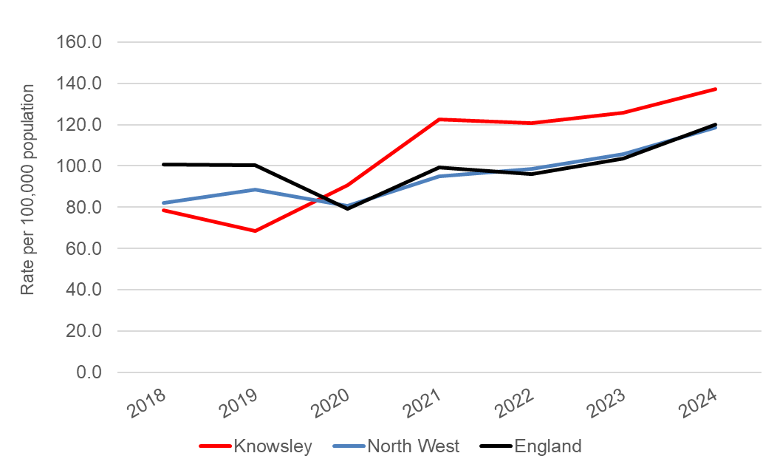
Figure 31: Campylobacter incidence rates in Knowsley compared to North West and England, 2018-2024. Data source: UKHSA Second Generation Surveillance System - SGSS (Laboratory Surveillance), data available from Fingertips Health Protection Profiles produced by OHID, DHSC: Health Protection | Fingertips | Department of Health and Social Care

6.3.3 Salmonella
Salmonella are bacteria that spread through the faecal–oral route and can cause illness in humans, most often through contaminated food or water. Typhoidal Salmonella (such as S. Typhi and S. Paratyphi) infect only humans and are usually transmitted through contaminated water or poor sanitation. Typhoidal Salmonella cause enteric (typhoid) fever, a serious systemic illness characterised by prolonged high fever, abdominal pain, headache and potentially life-threatening complications. In the UK, typhoidal infections are uncommon and usually associated with international travel.

Non-typhoidal Salmonella (including S. Enteritidis and S. Typhimurium) are far more common in the UK and are usually acquired from contaminated food such as poultry, eggs, meat and unpasteurised milk. Non-typhoidal Salmonella typically cause acute gastroenteritis with symptoms such as diarrhoea, vomiting, abdominal cramps and fever. Symptoms usually last for four to seven days and most people recover without medical treatment. Anyone can get salmonella, but young children, the elderly and people who have immune systems that are not working properly have a greater risk of becoming severely ill.

The number of non-typhoidal Salmonella infections in Knowsley during 2024 was 19 and the rate was 11.7 cases per 100,000 population, lower than the North West region (15.4 cases per 100,000 population) and England (17.7 cases per 100,000 population). Rates of non-typhoidal salmonella in Knowsley declined from 18.6 per 100,000 population in 2018 to 7.1 per 100,000 in 2021; this drop, largely due to restrictions put in place during the first 18 months of the COVID-19 pandemic, was also seen for the North West and England (Figure 32). Although rates have increased across all three areas since 2021, the rate of increase has been slower in Knowsley than in the North West and England.

There was 1 case of Salmonella Typhoid / Paratyphoid in a Knowsley resident in 2023. Prior to that the last reported case was in 2012.

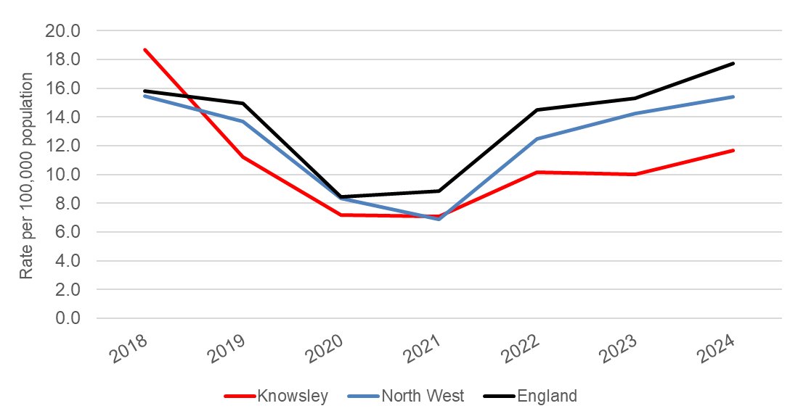
Figure 32: Non-typhoidal Salmonella incidence rates in Knowsley compared to North West and England, 2018-2024 Data source: UKHSA Second Generation Surveillance System - SGSS (Laboratory Surveillance), data available from Fingertips Health Protection Profiles produced by OHID, DHSC: Health Protection | Fingertips | Department of Health and Social Care

6.4 Vaccine preventable diseases
The most common vaccine-preventable diseases in England are pertussis, measles, mumps and meningococcal disease. Data are available on laboratory confirmed cases of these infections.

A large measles outbreak began in Birmingham in October 2023 and subsequently increases in measles were seen across England. In the North West, the number of cases started to increase in early 2024, with a total of 99 cases reported that year and a rate of 1.3 cases per 100,000. In Knowsley the number of confirmed measles cases remained low between 2018 and 2024, with most years seeing no cases (Table 3). Knowsley saw significant measles transmission in June 2025 when a primary school outbreak and subsequent community transmission led to 19 confirmed cases of measles among residents.

Table 3. Annual number of selected vaccine preventable diseases in Knowsley, 2018-2024
Disease | 2018 | 2019 | 2020 | 2021 | 2022 | 2023 | 2024
Measles | 1 | 0 | 0 | 0 | 0 | 0 | <10¥
Mumps | 36 | 36 | 3 | 0 | 0 | 0 | -
Pertussis | 1 | 14 | 0 | 0 | 0 | 2 | -
Invasive meningococcal disease* | 1 | 4 | 2 | 0 | 0 | 1 | 3
¥ 2024 data not available on Fingertips but UKHSA publication reports that there were less than 10 confirmed cases of measles in Knowsley in 2024: Confirmed cases of measles in England by month, age, region and upper-tier local authority: 2025. Confirmed cases of measles in England by month, age, region and upper-tier local authority: 2025 - GOV.UK
*For meningococcal disease the time periods are not calendar years but rather July-June; in the table the first year is Jul 2017 to Jun 2018 and the last year is Jul 2023 to Jun 2024.
Data sources: UKHSA enhanced surveillance systems for vaccine preventable diseases. Data available from Fingertips Health Protection Profiles produced by OHID, DHSC: Health Protection | Fingertips | Department of Health and Social Care.

6.5 Hepatitis B and C

6.5.1 Hepatitis B

Hepatitis B is a viral infection that attacks the liver and can cause both acute and chronic disease. The virus is highly contagious and is transmitted through contact with the blood or other body fluids of an infected person. Hepatitis B virus can be spread by:
- sharing or use of contaminated equipment during injecting drug use;
- vertical transmission (mother to baby) from an infected mother to her unborn child;
- sexual transmission;
- horizontal transmission (non-sexual contact between individuals, for example household contact with an infected person);
- receipt of infectious blood (via transfusion) or infectious blood products (for example, clotting factors) in countries where screening of blood donors and donations is not performed;
- needle stick or other sharps injuries (in particular those sustained by hospital personnel);
- tattooing and body piercing.

Symptoms during acute infection can include tiredness, abdominal pain, a “flu-like illness”, nausea, vomiting, joint pains, loss of appetite and jaundice. The long term complications of chronic Hepatitis B infection include cirrhosis and primary liver cancer.

Reports of acute Hepatitis B from laboratories in England provide the main information source on the incidence of Hepatitis B. Estimation of the true incidence of Hepatitis B infection requires adjustment for under-reporting (which is estimated at around 25%) and for the proportion of infections that are asymptomatic. There were 777 new laboratory reports of hepatitis B in North West residents in 2022, representing a rate of 10.3 per 100,000 population. The North West rate in 2022 was lower than the England rate of 16.4 per 100,000 population. In Knowsley there were less than 5 cases per year in 2021 and 2022, giving a rate of 0.6 per 100,000 for 2022, which was the lowest rate of all upper tier local authorities in the North West.

6.5.2 Hepatitis C

Hepatitis C (HCV) is a virus that also infects the liver. If left untreated it can cause serious and potentially life-threatening damage to the liver over many years. Injecting drug use remains the most important risk factor for HCV infection in the UK and it is estimated that around half of those who inject drugs have the infection. However, there are other ways in which the infection can be spread;

- sharing razors or toothbrushes;
- from a pregnant woman to her unborn baby;
- through unprotected sex – although this is very rare.

Eighty percent of Hepatitis C infections do not cause any noticeable symptoms until the liver has been significantly damaged. This means many people have the infection without realising it. When symptoms do occur, they may be vague e.g. flu-like illness, tiredness, loss of appetite and fatigue, and can be mistaken for other conditions. Initially, individuals have acute HCV infection, which some individuals are able to clear from their bodies without treatment (spontaneous viral clearance). However, 80-85% of those infected will go on to develop chronic Hepatitis C. HCV can be treated with antiviral medications, however around 10-20% of cases can develop serious liver disease such as cirrhosis and liver cancer. Because many people with HCV do not have any symptoms until the disease is advanced, testing of people at risk of infection is important to prevent transmission.

In 2016 the UK signed up to the WHO Global Health Sector Strategy (GHSS) to eliminate viral hepatitis as a public health threat by 2030, so the UK is therefore required to demonstrate achievement of the programmatic targets. In collaboration with local NHS trusts and other partners, the health and social care charity, Change Grow Live successfully delivered test and treat services that were tailored to users, allowing Knowsley to achieve micro-elimination of hepatitis C, meaning that it reached the following targets:

- 100% of people using the test and treat service have been offered a hepatitis C test.
- 90% of these people have then been tested.
- 75% of people who were diagnosed with hepatitis C have started treatment.

Testing for both Hepatitis B and C and vaccination for Hepatitis B is recommended in certain high-risk groups, and where intervention can be of benefit. Guidance exists around the promotion of testing in at-risk groups. Testing is currently recommended in primary care, sexual health clinics, drug services, prisons and immigration removal centres, and for people from medium - high prevalence areas, men who have sex with men, people diagnosed with a sexually transmitted infection, prisoners, and close contacts of someone with the disease. Pregnant women are routinely offered testing in order to reduce the risk of transmission to the newborn.

In April 2022, implementation began of an NHS England (NHSE) funded programme of opt-out testing for bloodborne viruses in Emergency Departments in areas of very high diagnosed HIV prevalence. This programme provides testing for HIV, Hepatitis B virus and Hepatitis C virus for anyone aged 16 years and over (18 years and over at some sites) and having a routine blood test during their Emergency Department attendance, unless they opt out. There are no hospital sites in Knowsley taking part in the opt-out Emergency Department testing programme.

6.6 Tuberculosis
Tuberculosis (TB) is an infection caused by a bacterium belonging to the Mycobacterium tuberculosis complex. TB usually affects the lungs but can also affect almost any other area of the body. Most transmissions occur from people with pulmonary or laryngeal TB, which can cause symptoms such as coughing, blood in sputum, weight loss and fatigue. Left undiagnosed, a patient with infectious TB can infect 10 to 15 other close individuals over a year. Furthermore, ensuring that when TB is diagnosed, patients receive the right treatment and are supported to complete the full course of treatment – which can take months – is vital to ensuring recovery and reducing the risk of the development of multidrug-resistant strains.

A vaccine, the Bacillus Calmette-Guérin vaccine (BCG), is available but in England it is only offered to certain risk groups and in certain areas. These groups include: (i) all infants (aged 0 to 12 months) and children (previously vaccinated and if over 5 years, tuberculin negative) with a parent or grandparent who was born in a country with a high annual TB incidence (40/100,000), (ii) infants (aged 0 to 12 months) living in areas of the UK where annual TB incidence is 40/100,000 or higher, and (iii) previously unvaccinated, tuberculin-negative individuals under 16 years of age who were born in or who have lived for a prolonged period (at least three months) in a country with an annual TB incidence of 40/100,000 or greater. Knowsley is not a high incidence area and BCG is therefore not offered routinely to infants.

Latent TB occurs when a person is infected with the TB bacterium but does not have any symptoms of active disease. Treatment may be required to reduce the risk of active disease. Latent TB testing is a current national focus.

In addition to country of origin and travel from a country with high TB rates, other risk factors for TB include substance misuse, alcohol, poor quality housing, poverty, homelessness and a weakened immune system. The most deprived 10% of the UK population has a rate that is seven times higher than the least deprived 10%.

A total of 5,490 cases of TB were notified in England in 2024, a rate of 9.4 per 100,000 population, which is a reduction since the peak of 8,280 cases in 2011 (15.6 per 100,000). In 2024, people born outside the UK experienced a rate 18.9 times higher than people born in the UK³⁴.

In England TB is largely centred in a few high prevalence areas. Knowsley is historically a low prevalence area. During 2022-2024, TB incidence was 2.9 per 100,000 population in Knowsley which is significantly lower than the England (8.5 per 100,000) and the North West rate (7.6 per 100,000). However, it is vital that surveillance continues within at-risk groups. Work should continue with the local TB service to ensure all front-line staff are aware of TB and understand its risk factors and where to seek help.

6.7 Respiratory infections

Respiratory infections are infections of parts of the body involved in breathing, such as the sinuses, throat, airways or lungs. Respiratory infections can be caused by wide range of bacteria and viruses but the ones that have the largest impact in terms of morbidity and mortality are SARS-CoV-2, Influenza and Respiratory Syncytial Virus (RSV).

Respiratory infections can cause a range of illnesses, from relatively mild and short-lived symptoms to chest pain, severe difficulty breathing and prolonged illness requiring hospitalisation. Children, the elderly and individuals with pre-existing health conditions are at highest risk of severe illness. As many people do not seek health care or get tested when their symptoms are mild, our best and most consistent method of monitoring trends in respiratory infections is using data for individuals who were admitted to hospital with respiratory conditions.

6.7.1 Emergency hospital admissions

In Knowsley during the 2023-24 season the crude rate of emergency admissions for lower respiratory infections in young children aged 0-4 years was 284.4 per 10,000 population, higher than the North West (255.5 per 10,000) and England rates (207.7 per 10,000). Although all three geographies saw a decrease in the rate of emergency admissions for lower respiratory infections in young children since the previous year (2022/23), the trend has been increasing since 2011/12 and remained consistently higher in Knowsley than in the North West and England (Figure 33).

Bronchiolitis is a viral respiratory infection of the lower airways which mainly affects infants under the age of 1 year but occasionally infants up to the age of 2 years. In a minority of cases bronchiolitis can be severe and require hospitalisation. The rate of emergency hospital admissions for bronchiolitis in children aged under 2 years in Knowsley was 5926 per 100,000 population, again higher than the rate for the North West and England, and showing an increasing trend (Figure 34).

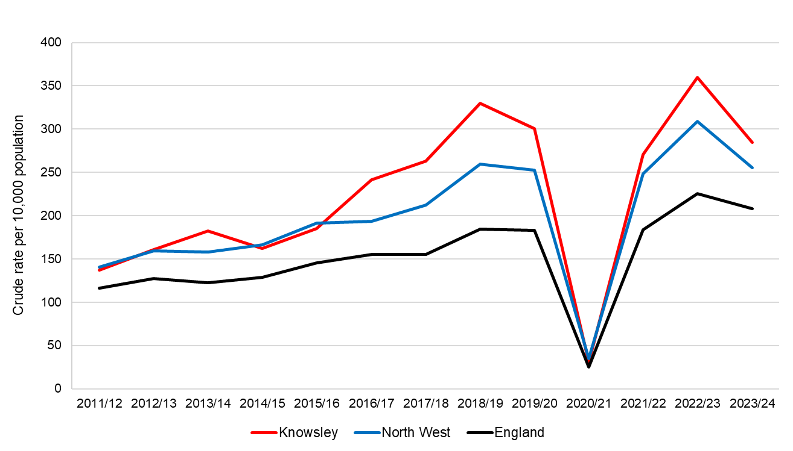
Figure 33. Emergency admissions for lower respiratory tract infections in infants and young children (0 to 4 years). Source: Health Protection Profile: OHID, based on NHS England and Office for National Statistics data https://fingertips.phe.org.uk/search/respiratory
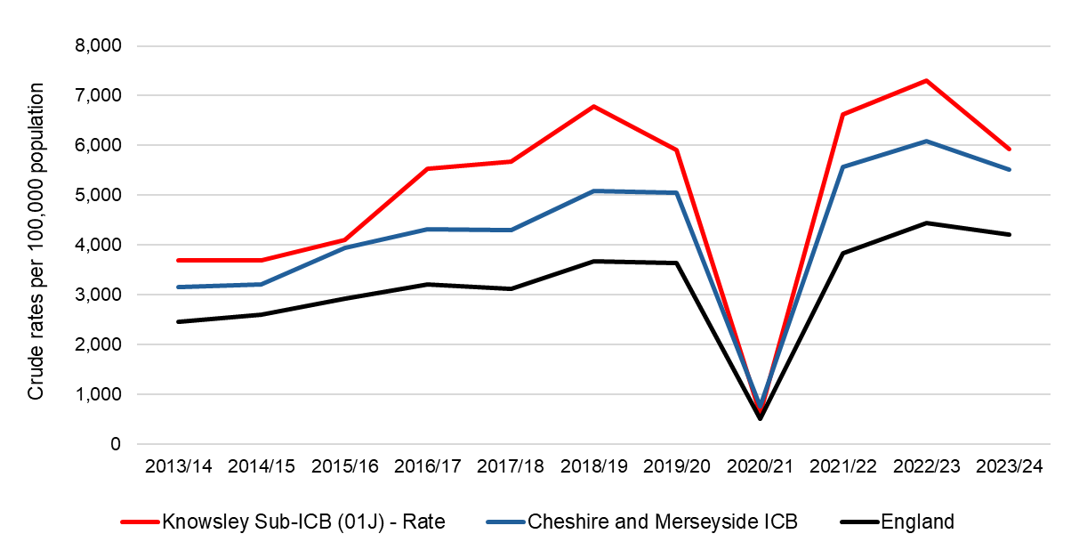

Figure 34. Emergency hospital admissions for bronchiolitis in children aged under 2 years. Source: Health Protection Profile: OHID, based on NHS England and Office for National Statistics data. https://fingertips.phe.org.uk/search/respiratory

6.7.2 Mortality from influenza and pneumonia

Rate of deaths where influenza and pneumonia were mentioned as a contributing cause on the death certificate are monitored. For Knowsley the age-standardised mortality rate involving influenza and pneumonia (all ages) was 221 per 100,000 population in the 3-year period from 2022 to 2024, higher than the North West and England rates which were 179 and 148 per 100,000 respectively (Figure 35). The overall trend in the mortality rate has been downward locally, regionally and nationally over the past 20 years but the rate did increase in pandemic years and some years after the pandemic. The latest few periods however have seen a return to a declining trend.

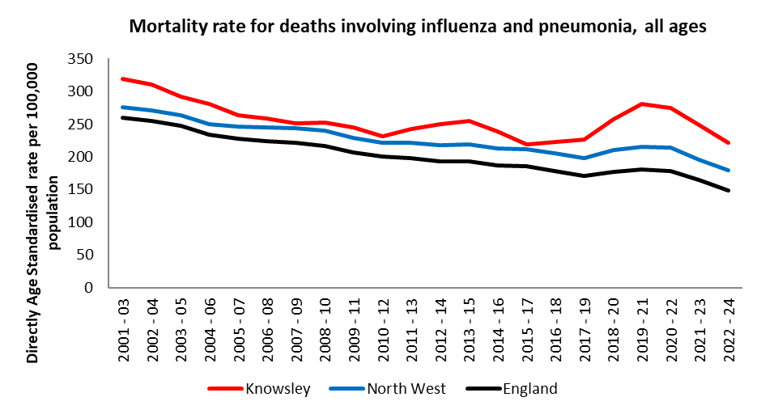
Figure 35. Mortality rates for deaths involving influenza and pneumonia, all ages (persons). Health Protection Profile: OHID, based on Office for National Statistics data; Fingertips | Department of Health and Social Care

7 EXCESS WINTER DEATHS
Excess winter mortality (EWM) is defined as ‘the extra numbers of deaths during the winter months in relation to the other seasons of the year’ and is thought to be a direct consequence of the cold weather. The ONS method is used to calculate EWM and defines the winter period as December to March. The methodology compares winter deaths with the average number of deaths occurring in the preceding August to November and the following April to July.

Understanding seasonal changes in temperature is important especially in the winter months so that additional help can be made available for those that are most at risk of these cold conditions. Population groups such as the elderly, children and those with long term conditions, such as respiratory disease, are particularly vulnerable during this period, especially those on lower incomes and those not living in energy efficient housing.

Figure 36 highlights that the number of excess winter deaths (EWD) in Knowsley has varied over a 23-year period. The highest recorded number of EWD since 2001/02 occurred in 2022/23 (183 EWD). Since 2001/02, there has been an average of 78 excess winter deaths per year in Knowsley meaning that the number of EWDs in 2024/25 (109) was 39.7% above this average.

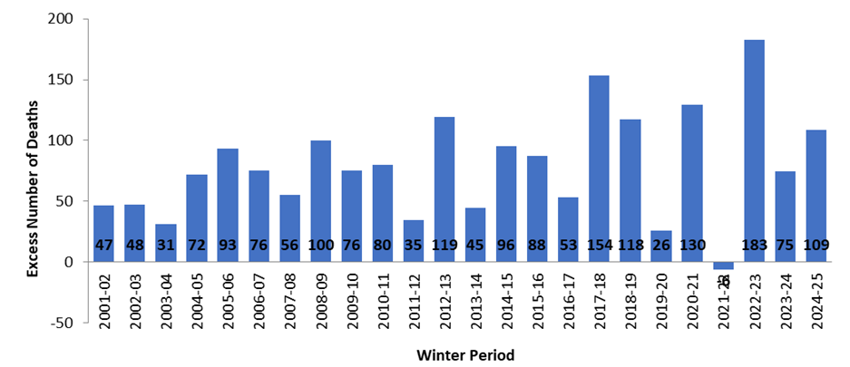

Figure 36: Excess Winter Mortality in Knowsley, 2001/02 to 2024/25. Source: Primary Care Mortality Database, OHID

Large fluctuation in EWDs is common and trends over time are not smooth. To provide a clear trend over time and to smooth out short-term fluctuations in EWDs, a five-year moving average is calculated and shown in Figure 37. The lowest 5-year moving average is 58 in 2003/04; and the highest is 101 in 2016/17.

Figure 37. Excess Winter Mortality and 5 Year Central Moving Average in Knowsley, 2001/02 - 2024/25. Primary Care Mortality Database, OHID

Figure 38 shows the underlying causes that affected the EWD Index for Knowsley.
- The main underlying causes of EWDs in England and Wales during 2024/25 were respiratory disease, circulatory disease and Dementia all showing similar mortality index figures.

- There were 112 respiratory disease related deaths in the winter months, which equated to 44% of all respiratory deaths across the year (August 2024 – July 2025). The 42 EWDs from respiratory-related causes accounted for 39% of all EWDs.

- There were 125 circulatory-related deaths in the winter months, which equates to 38% of all circulatory deaths across the year (August 2024 – July 2025). The 21 EWDs from circulatory related diseases accounted for 19% of all EWDs.

There were 65 Dementia and Alzheimer’s disease related deaths in the winter months, compared to 91 in the non-winter months (August 2024 – July 2025). This means 42% of all Dementia and Alzheimer’s related disease related deaths occurred during the winter months. The 20 EWDs from Dementia and Alzheimer’s related diseases accounted for 18% of all EWDs.

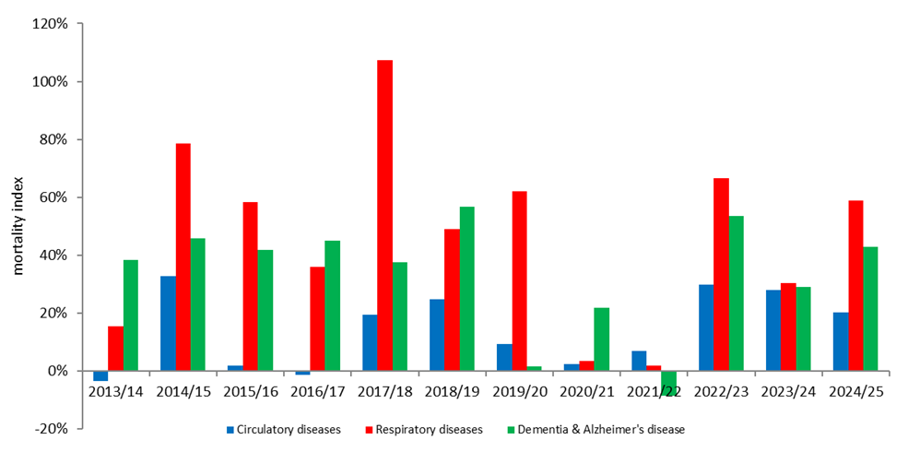
Figure 38. Excess Winter Mortality Index for Knowsley, by underlying causes 2013/14 - 2024/25. Primary Care Mortality Database, OHID

Figure 39 highlights excess winter mortality index by age group in Knowsley over a fourteen-year period. There are large fluctuations across all age groups.
  - In 2024/25, the age group will the highest EWD mortality index was those 85+, with a total of 46 EWDs. This equates to 42% of all EWDs. However, this figure has increased from 38 EWDs in 2023/24, although fluctuations in data are common across the years. The EWM Index was 29.5% for this age group in 2023/24, which is higher than the 23.5% average percentage since 2001/02.

- The number of EWDs for the 65 to 84 age group increased from 29 (2023/24) to 66 (2024/25). The EWDs for this age group equates to 61% of all EWDs. The EWM Index has also increased from 11.7% to 27.4% for this age group. The average percentage since 2001/02 is 15.5%, which means the latest EWM Index is 11.9% lower than average.

- In 2024/25, there were -4 EWDs for the Under 65s age group. This equates to -3.6% of all EWDs. This means there were 4 less deaths in the winter period than the average of the other seasons. The EWM Index for this age group has decreased from 8.6% in 2023/24 to -3.6 in 2024/25.

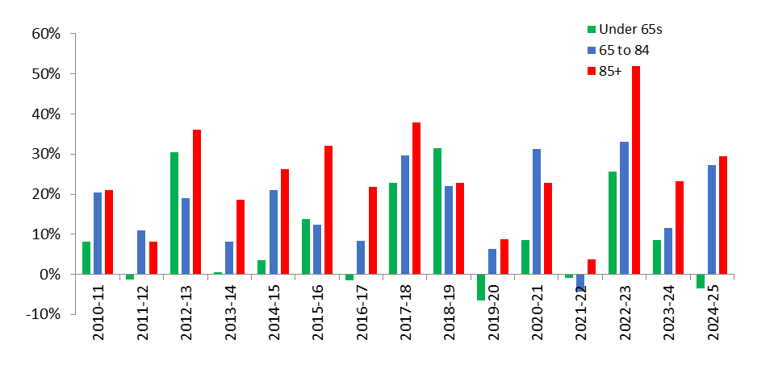
Figure 39. Excess Winter Mortality Index for Knowsley, by age group 2013/14 - 2024/25. Primary Care Mortality Database, OHID

8 ANTIMICROBIAL PRESCRIBING TRENDS
Antibiotics are medications used to treat and, in some cases, prevent bacterial infections. They can be used to treat relatively mild conditions such as acne, as well as potentially life-threatening conditions such as pneumonia. Antibiotics are used in humans and in animals. There are now hundreds of different types of antibiotics, but they can be broadly classified into following groups:

- penicillin – widely used to treat a variety of infections, including skin infections, chest infections and urinary tract infections;
- cephalosporins – can be used to treat a wide range of infections, but are also effective for treating more serious infections, such as septicaemia and meningitis;
- aminoglycosides – tend to only be used to treat very serious illnesses such as septicaemia, as they can cause serious side effects, including hearing loss and kidney damage; they break down quickly inside the digestive system, so they have to be given by injection, but are also used as drops for some ear or eye infections;
- tetracyclines – can be used to treat a wide range of infections; commonly used to treat moderate to severe acne and rosacea, which causes flushing of the skin and spots;

- macrolides – can be particularly useful for treating lung and chest infections; can also be a useful alternative for people with a penicillin allergy or to treat penicillin-resistant strains of bacteria;

- fluoroquinolones – broad-spectrum antibiotics that can be used to treat a wide range of infections.

- carbapenems – a powerful group of broad spectrum beta-lactam (penicillin-related) antibiotics. In many cases, these are our last effective defence against infections caused by multi-resistant bacteria, such as some strains of Klebsiella pneumoniae and Escherichia coli.

The latest (2024 to 2025) ESPAUR report shows that the largest drop in primary care antibiotic prescribing was seen in the North West: 4.5% reduction in 2024 compared to 2023. The decrease is being attributed in part to the successful rollout of TARGET (Treat Antibiotics Responsibly, Guidance, Education and Tools) training in the North West, with 835 primary healthcare professionals completing the training and 89 people completing TARGET Train-the-Trainer training. The success in primary care was offset slightly by a small increase in secondary care prescribing to give an overall reduction in antibiotic use in North West of 2.7%²¹. In Knowsley, all GP practices except one had completed TARGET toolkit training by the start of 2026

Data on prescribing is complex and needs to be adjusted for the different needs of a population. The STAR-PU (Specific Therapeutic group Age-sex Related Prescribing Units) is a weighted indicator which considers the different population needs based on the therapeutic group the drug belongs to. In December 2025 the rolling average of antimicrobial prescribing volume (items per 1000 antibacterial item-based STAR-PU) was 1.10 for Knowsley which was higher than the Cheshire and Merseyside average of 0.91 and the national average and target (0.87). Improvements have been made over the years both locally and nationally. Antimicrobial prescribing rates were down in both Knowsley and Cheshire and Merseyside over the 12 months to December 2025 (Figure 40). However, improvements still need to be made in order to reach the national target of 0.87 for STAR-PU.

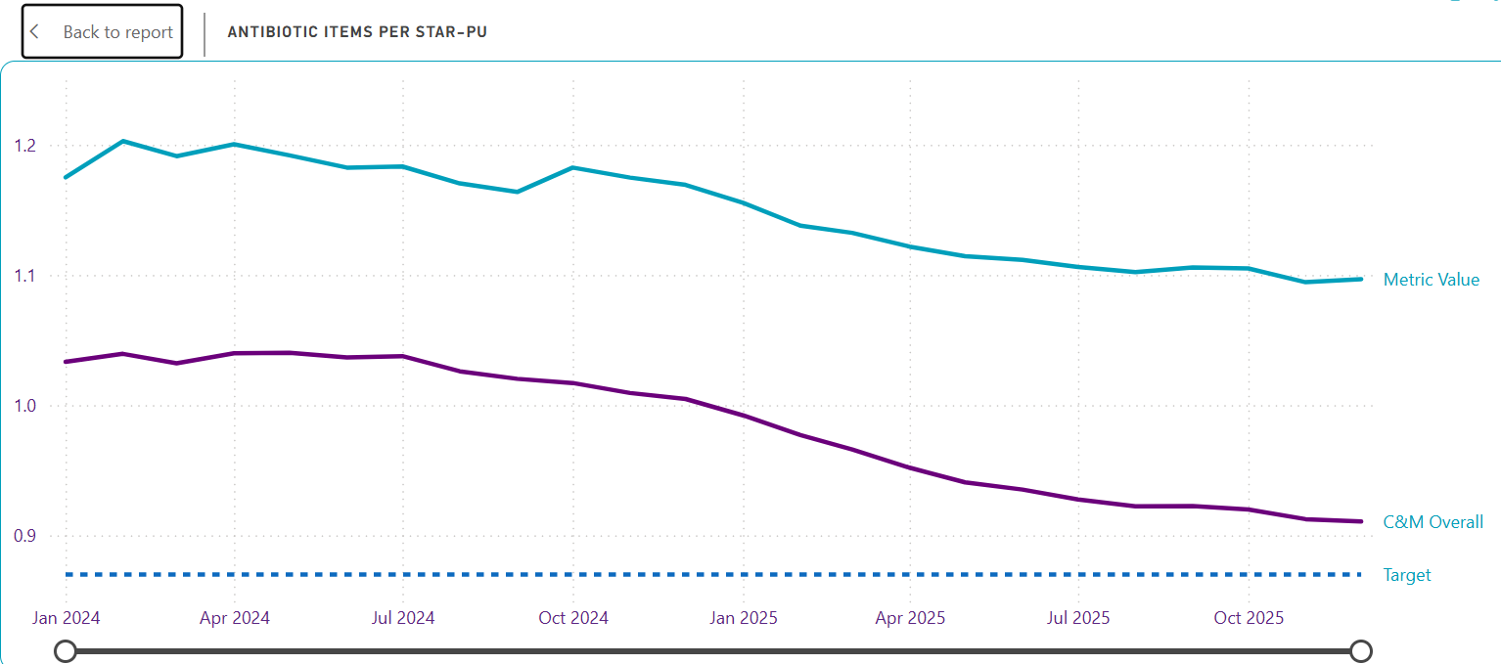

Figure 40: Antimicrobial Prescribing Volume Trends (Items per 1000 antibacterial item based STAR-PU); Graph shows Knowsley (metric value), Cheshire and Merseyside and government target. Source: Prescription data, NHS Business Services Authority.

Up to the end of October 2024 Knowsley had the second lowest spend on antibacterials when compared to the other Cheshire and Merseyside Places (Figure 41). At the antibiotic group level, the largest spend in Knowsley and across Cheshire and Merseyside was on penicillins.

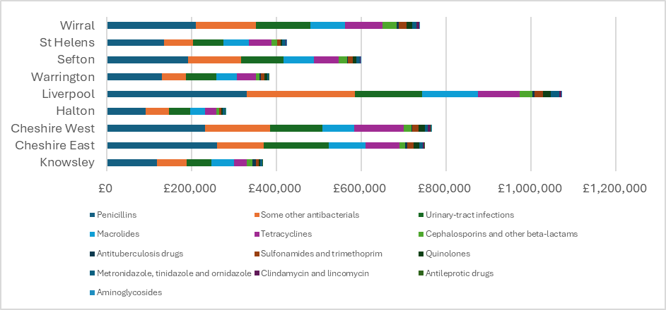

Figure 41: Comparison of Places spend on different antibacterial groups; costs for Financial Year up to Oct 2024 (Cost per 1000 antibacterial cost based STAR-PU). Source: Prescription data, NHS Business Services Authority.

At the individual drug level, the biggest spend in Knowsley was on Rifaximin and Nitrofurantoin (Figure 42). The biggest decrease in spend on an individual drug was Nitrofurantoin (£45,152 financial year to Oct 24) which was a 20.8% decrease on the previous financial year. Of non-TB antibacterials, Ciprofloxacin has seen the biggest reduction in number of items prescribed (22.8%) which is significant as Ciprofloxacin is one of the main medicines that can precipitate C. difficile infection.

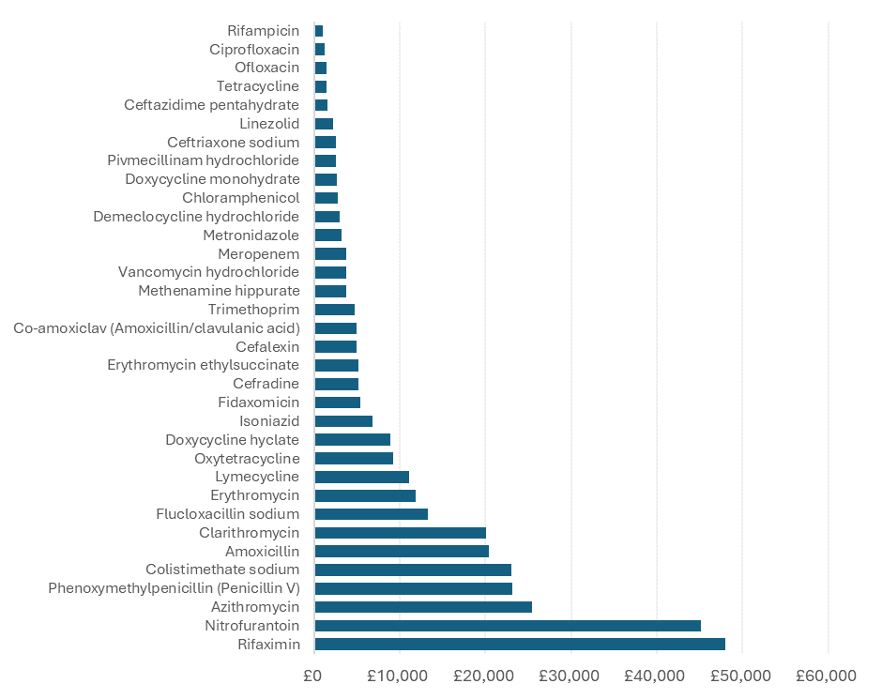
Figure 42: Spend on individual antibiotics in Knowsley, costs for Financial Year up to Oct 2024 (Cost per 1000 antibacterial cost based STAR-PU). The chart only shows antibiotics for which the spend was at least £1000 to end-Oct 2024. Source: Prescription data, NHS Business Services Authority.

9 EMERGENCY PREPAREDNESS RESILIENCE AND RESPONSE
Emergencies can happen at any time and often happen without notice. While emergency preparedness is a wide-ranging discipline extending far outside the health arena, many of the main recognised emergency risks arise from threats to health, while the consequences of all emergencies potentially have both physical and mental health dimensions. Whilst we cannot predict them, the Merseyside Community Risk Register shows which risks have been identified to affect Merseyside and prioritises them accordingly. From this document, services are able to prepare to respond to emergencies and limit their impact on health in Knowsley. Emergencies disproportionately affect those with existing health conditions and those with a low income, so taking action on these issues will reduce their impact.

A major incident or an emergency is any event or occurrence that requires organisations to put in place special arrangements in order to continue to meet the needs of the population. During an emergency, the existing needs of the population continue, as detailed elsewhere in this JSNA, but additional needs arise as a direct consequence of the incident. Different groups of people across Knowsley are vulnerable to the impact of different incidents. In addition, people not previously considered as vulnerable may become so as a result of an emergency.

Knowsley Council has its own emergency arrangements and also prepares for and responds to incidents through the Merseyside Resilience Forum (MRF), which brings together Merseyside Police, Merseyside Fire and Rescue Service, NW Ambulance Service, the NHS, Local Authorities, the UK Health Security Agency and a large number of other partners including voluntary agencies. This partnership forum works to ensure a co-ordinated response to any incident and is the focus for preparedness activity across Merseyside. Work of the Cheshire and Merseyside Local Health Resilience Partnership (LHRP) dovetails with the business of the MRF.

The Merseyside Community Risk Register identifies pandemic, emerging infectious diseases, surface water flooding and failure of national electricity supply amongst the highest risks. Alongside these, Knowsley also has significant industry with some sites governed by the Control of Major Accident Hazards Regulations 2015 (COMAH). The COMAH regulations aim to prevent and mitigate the effects on people and the environment of major accidents involving dangerous substances. The regulations specify two levels of duties – lower tier and top tier – which reflect an increasing potential for major accidents to occur in the absence of robust risk control systems. Of the four COMAH sites in Knowsley, two are classified as ‘Upper Tier’ and require emergency plans to protect the public and the environment in the surrounding area. In addition, the threat of terrorist attack is a national risk which requires preparedness across all areas.

In response to the above and other risks the MRF has a continuous programme of developing, reviewing and testing emergency plans. These include generic response plans, plans for specific threats or risks, and plans for major consequences such as humanitarian support which cut across most or all emergencies. Individual MRF partners have their own emergency plans, and this includes the Cheshire and Merseyside Integrated Care Board, health and social care providers and Knowsley Council.

10 FUTURE OPPORTUNITIES AND CHALLENGES
Health protection covers a wide range of very different topics and threats to health but all of them require collaboration with partnership organisations and the public.

Health inequalities and deprivation
According to the English Indices of Multiple Deprivation 2025, Knowsley consistently ranks as one of the most deprived local authorities in England, across a range of different domains including income deprivation. Nearly half of children (47.9%) and nearly a third of Older People (30.6%) live in income deprived households in Knowsley and a 2022 survey of Knowsley residents showed that in response to worsening financial circumstances, 41% were considering making savings by cutting heating bills. Given that hospital admission rates due to infectious diseases are nearly twice as high for people living in the 20% most deprived areas compared to the least deprived, the burden and impact of infectious diseases on individuals and the NHS is considerable in Knowsley.
Respiratory diseases and winter pressures
With high rates of hospitalisation for respiratory infections and high mortality rates from influenza, winter is a challenging time for the health and care system in general, and health inequalities and deprivation compound the issue in Knowsley. Every winter, there is a possibility of a ‘quad-demic’, where three respiratory viruses (influenza, COVID-19 and RSV) circulate alongside norovirus, which would put pressure on the NHS and the public health system. However, successful adult immunisation programmes for influenza and COVID-19 have reduced mortality and morbidity from respiratory infections, and an additional opportunity to reduce it further now lies with the new RSV vaccination campaign, introduced in September 2024 for those aged 75-79 years. In addition to these campaigns for older people, renewed focus is needed to improve vaccination uptake among healthcare workers in Knowsley as high uptake would protect the healthcare workforce and their vulnerable patients.
Low childhood vaccination uptake
Low childhood vaccination uptake in Knowsley is a challenge and efforts need to be concentrated around working with communities to understand the reasons behind low uptake and accordingly removing any existing barriers and adapting the immunisation offer for families in order to reduce inequalities and improve uptake. By simplifying the schedule and reducing the number of injections at individual visits, the introduction of a new childhood vaccination schedule in January 2026 provides an opportunity to improve vaccination uptake.
Antimicrobial resistance
AMR remains a major public health threat, with resistant Gram-negative infections (E. coli, K. pneumoniae) contributing most to the burden. The National Action Plan: Confronting antimicrobial resistance 2024 to 2029 (NAP) will be key to efforts to reduce the burden of AMR, and local efforts should be focussed around strengthening IPC and optimising the use of antimicrobials. With the successful roll out across the North West of the TARGET Antibiotics: Prescribing in Primary Care e-learning, including 89 primary healthcare professionals trained as trainers, an opportunity exists to continue training the workforce in order to further strengthen antimicrobial stewardship and reduce antibiotic prescribing.
The large and widening gap in the rate of resistant bloodstream infections between the least and most socioeconomically deprived groups, as described in the ESPAUR report, is concerning and needs to be better understood at local level. The NAP outlines plans for a toolkit for addressing health inequalities which will support regional public health teams in identifying health inequalities and providing evidenced-based resources to help them develop targeted interventions which can then be monitored and evaluated.
Health system reform
One of the most significant challenges for health protection in England is the complexity of governance structures. Responsibilities are distributed across multiple bodies, including local authorities, Integrated Care Systems (ICSs), UKHSA and – currently – NHS England.
The NHS 10-Year Health Plan, published in July 2025, promotes three transformative shifts for the NHS: a shift from hospital to community care through the introduction of neighbourhood health services, transformation to a more digitally accessible health system, and a renewed focus on prevention, ensuring it is embedded into mainstream services. The shift to community-based care offers an opportunity to embed immunisation delivery into local hubs, thereby improving access and reducing inequalities in uptake. A specific example is the commitment for health visitors and community pharmacies to deliver immunisations to infants and children in underserved communities. The digital transformation should make it easier to access vaccination records and book appointments, helping to support higher uptake but community outreach will remain vital to ensure people are not left behind by the switch to digital access.
The short timescales for transition of responsibilities, alongside the significant financial constraints and head-count reductions facing ICBs will make it challenging to take on new, complex responsibilities effectively. The transition also introduces another layer of structural complexity, with dual accountability – the ICB responsible for delivery and the council for assurance. Effective collaboration and communication, and robust reporting and escalation protocols will be key to maintaining an effective public health system at local level.

11 RECOMMENDATIONS
- Improve vaccination uptake across the life course: work with partners to develop and implement targeted, community-based interventions to address barriers to childhood and adult immunisation.

- Strengthen infection prevention and control and antimicrobial stewardship: work with IPC and health protection colleagues to strengthen IPC measures across care and educational settings. Develop local plans to tackle AMR which build on existing work underway in primary care, including on existing initiatives to reduce inappropriate prescribing of antimicrobials, and the successful roll out of TARGET training.

- Improve intelligence on health inequalities in health protection: work with partners to ensure data used in local health protection reports is broken down by key population characteristics, such as deprivation and ethnicity, where these data are available. Optimising the availability and use of demographic data in health protection surveillance reports will enable identification of inequalities at local level, inform proportionate allocation of resources, and design interventions that effectively reduce inequalities across the local population.

ONS local indicators for Knowsley, available from: https://www.ons.gov.uk/explore-local-statistics/areas/E08000011-knowsley/indicators
ONS https://www.ons.gov.uk/visualisations/censusareachanges/E08000011/
English indices of deprivation 2025: statistical release, available from: https://www.gov.uk/government/statistics/english-indices-of-deprivation-2025/english-indices-of-deprivation-2025-statistical-release#local-authority-district-analysis and data downloaded from: Local Deprivation Explorer - Download all data
ONS Healthy Life expectancy at birth, available from: https://www.ons.gov.uk/peoplepopulationandcommunity/healthandsocialcare/healthandlifeexpecta%20%20%20%20%20%20%20%20%20%20%20ncies/bulletins/healthstatelifeexpectanciesuk/between2011to2013and2022to2024
Department of Health, PHE and Local Government Association. Protecting the health of the local population: the new health protection duty of local authorities under the Local Authorities Regulations 2013. Available from: https://www.gov.uk/government/uploads/system/uploads/attachment_data/file/199773/Health_Protection_in_Local_Authorities_Final.pdf
Public Health England (2019). PHOF Data Tool. Available from: http://www.phoutcomes.info/
NHS vaccination Strategy. Available from: https://www.england.nhs.uk/long-read/nhs-vaccination-strategy/
National annual flu immunisation programme. Available from: https://www.gov.uk/government/publications/national-flu-immunisation-programme-plan-2025-to-2026/national-flu-immunisation-programme-2025-to-2026-letter#further-information
Measles and rubella elimination UK strategy 2019. Available from: https://www.gov.uk/government/publications/measles-and-rubella-elimination-uk-strategy
UK loses its measles elimination status. The British Medical Journal. Available from: https://www.bmj.com/content/392/bmj.s172
UK measles and rubella elimination indicators and status. Available from: https://www.gov.uk/government/publications/measles-and-rubella-elimination-uk/uk-measles-and-rubella-elimination
Measles outbreak as vaccine rates drop. BBC, available from: https://www.bbc.co.uk/news/articles/c20p9pql22vo
WHO Global Health Sector Strategy on Viral Hepatitis, 2022-2030. Available from: https://www.who.int/publications/i/item/9789240053779
UK 5-year action plan for antimicrobial resistance 2024 to 2026. Available from: https://www.gov.uk/government/publications/uk-5-year-action-plan-for-antimicrobial-resistance-2024-to-2029
Tuberculosis (TB) action plan for England, 2021 to 2026. Available from: https://www.gov.uk/government/publications/tuberculosis-tb-action-plan-for-england/tuberculosis-tb-action-plan-for-england-2021-to-2026
Collaborative TB Strategy for England, 2015 to 2020: End of programme report, Public Health England. Available from: https://assets.publishing.service.gov.uk/government/uploads/system/uploads/attachment_data/file/971925/Collaborative_TB_Strategy_for_England_2015-2020_End_of_Programme_Report.pdf
The end TB strategy, World Health Organisation. Available from: https://www.who.int/publications/i/item/WHO-HTM-TB-2015.19
UKHSA Strategic Plan 2023 to 2026. Available from: https://www.gov.uk/government/publications/ukhsa-strategic-plan-2023-to-2026
UKHSA Health Equity for Health Security Strategy 2023 to 2026. Available from: https://www.gov.uk/government/publications/ukhsa-health-equity-for-health-security-strategy-2023-to-2026
Child dies at Alder Hey after contracting measles. BBC, available from: https://www.bbc.co.uk/news/articles/c8j1k3k44e2o
https://www.gov.uk/government/collections/vaccine-uptake#pertussis-vaccine-uptake-in-pregnant-women
https://www.gov.uk/guidance/notifiable-diseases-and-how-to-report-them
English surveillance programme for antimicrobial utilisation and resistance (ESPAUR) Report 2024 to 2025 London: UKHSA 2025. Available from: https://www.gov.uk/government/publications/english-surveillance-programme-antimicrobial-utilisation-and-resistance-espaur-report
Antibiotic resistant gonorrhoea cases are on the rise, UKHSA 2024. Available from: https://www.gov.uk/government/news/antibiotic-resistant-gonorrhoea-cases-are-on-the-rise
https://www.gov.uk/government/publications/campylobacter-infection-annual-data/campylobacter-data-2014-to-2023
Fischer GH, Hashmi MF, Paterek E. Campylobacter Infection. [Updated 2024 Jan 10]. In: StatPearls [Internet]. Treasure Island (FL): StatPearls Publishing; 2025 Jan-. Available from: https://www.ncbi.nlm.nih.gov/books/NBK537033/
https://www.food.gov.uk/sites/default/files/media/document/campylobacter-contamination-uk-chickens-year-4-report.pdf
Fingertips Health Protection Profiles produced by OHID, DHSC: Health Protection | Fingertips | Department of Health and Social Care
Confirmed cases of measles in England by month, age, region and upper-tier local authority: 2025. Data available at: Confirmed cases of measles in England by month, age, region and upper-tier local authority: 2025 - GOV.UK
Hepatitis B in the North West: 2024 report, UK Health Security Agency. Available from: https://www.gov.uk/government/publications/hepatitis-b-regional-surveillance-reports-2024-data-to-end-of-2022/hepatitis-b-in-the-north-west-2024-report
https://www.changegrowlive.org/service/knowsley-integrated-recovery/news/micro-elimination-hepatitis-c
https://www.gov.uk/government/publications/bloodborne-viruses-opt-out-testing-in-emergency-departments
Tuberculosis: the green book, chapter 32, UKHSA. Available from: https://www.gov.uk/government/publications/tuberculosis-the-green-book-chapter-32
https://publichealthmatters.blog.gov.uk/2019/03/22/tackling-tuberculosis-in-under-served-populations/
1. Tuberculosis incidence and epidemiology, England, 2024 - GOV.UK
Health Protection | Fingertips | Department of Health and Social Care
English surveillance programme for antimicrobial utilisation and resistance (ESPAUR) Report 2024 to 2025 London: UKHSA 2025. Available from: https://www.gov.uk/government/publications/english-surveillance-programme-antimicrobial-utilisation-and-resistance-espaur-report
Merseyside Community Risk Register is available at: https://www.merseysideprepared.org.uk/main-sections/our-risks/
English indices of deprivation 2025: statistical release. Available from: English indices of deprivation 2025: statistical release - GOV.UK
Cost of Living Report for Knowsley, Citizens Advice. Available from: https://www.citizensadviceknowsley.org.uk/cost-of-living-report/
Health inequalities in Health Protection report, UKHSA. Available from: Health inequalities in health protection report - GOV.UK
UK 5-year action plan for antimicrobial resistance 2024 to 2026. Available from: https://www.gov.uk/government/publications/uk-5-year-action-plan-for-antimicrobial-resistance-2024-to-2029

