Dear Resident

You may be aware that the Elections Act 2022 included a number of new rules regarding the way we vote. In particular, some of the new rules are that:

- a voter with a disability or who needs support can choose anyone aged over 18 to accompany them in the polling station to help them to vote;
- reasonable steps must be taken to support voters with disabilities; and
- a voter will need to show an accepted form of photo identification when voting at a polling station.

A number of items will be available to voters in each polling station to assist them, should they be needed, such as a large print ballot paper, additional seating, a tactile voting device (which enables a visually impaired person to mark a ballot paper in secret) and a magnifier.

Here at Knowsley Council the attached leaflet has also been produced with the aim of making the voting process easier for those who need extra support. Everyone should be able to cast their vote without facing barriers and it is hoped that the attached helps with just that.

If you feel the leaflet would help you, please complete the ‘about me’ section and, on Thursday 7 May, hand the leaflet to the polling station staff who will be happy to help you.

Please note, if you would prefer to vote by post rather than visiting a polling station then it is not too late. You have until 5pm on Tuesday 21 April to become a postal voter for this May’s elections. If you are a postal voter your ballot paper will be posted to your home address in advance of election day, and you will be able to return your ballot paper via the post in a pre-paid envelope that will be sent to you. This would mean that you would not need to visit a polling station on election day in order to vote.

If you have any questions regarding the leaflet or becoming a postal voter, please contact the Elections Office on 0151 443 2222.

Yours Sincerely

Tom Baker
Elections Manager



Polling Station
Accessibility Leaflet

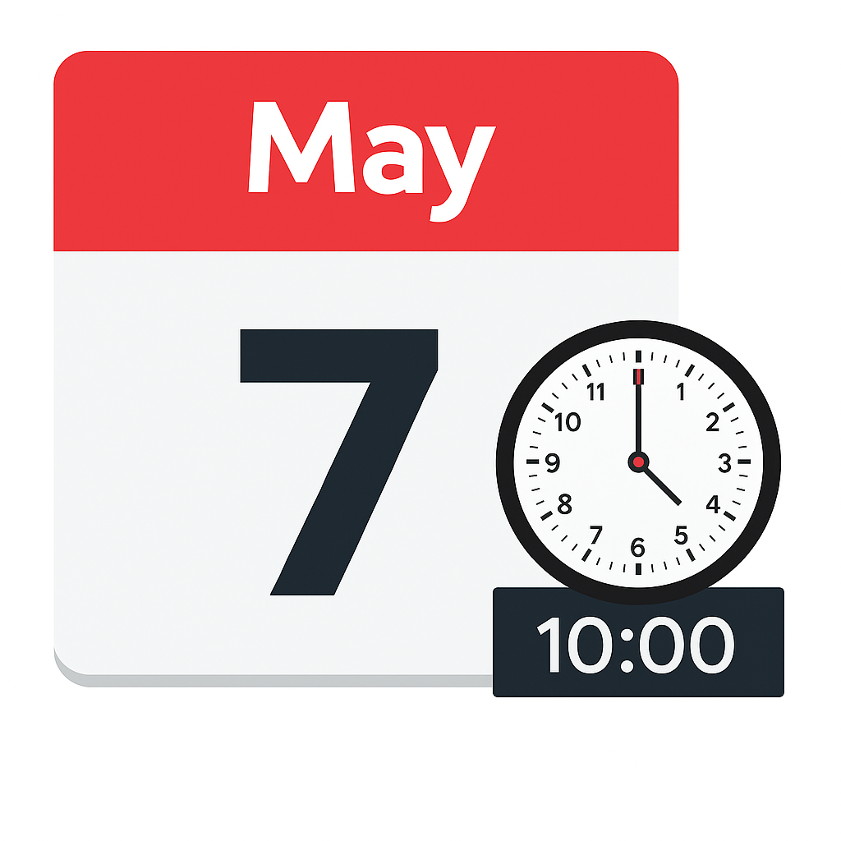

On Thursday 7 May 2026 there will be elections in Knowsley.
You can either vote in a polling station or by post.
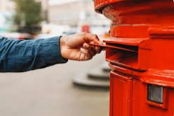
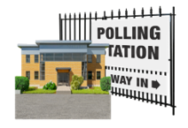

Should you be interested in becoming a postal voter, please contact elections@knowsley.gov.uk or call 0151 443 2222 (the deadline for new applications is 5pm on Tuesday 21st April).
This would mean that your ballot paper would be posted to your home address and could be returned via the post. You would not need to go to a polling station to vote.

At the Polling Station
- You will be asked your name.

- You will be asked your address.

- You will be asked to show your photo identification (this is a fairly new requirement).

- You may show this leaflet to polling station staff so that they know what support you may need.

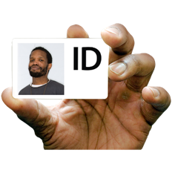

For any advice on the contents of this leaflet, or if you would like any other support to help you to vote in the forthcoming elections (for example any equipment not referenced on this leaflet such as a McGonagle Reader), please contact the Council on:

0151 443 2222
@ elections@knowsley.gov.uk
About me:
My name is: _______________________________________

My Address is: _____________________________________

I need help to support me to vote in the election.
I would like polling station staff to speak clearly and be patient.

I need: (tick any that apply)

Someone to read out the candidates on the ballot paper
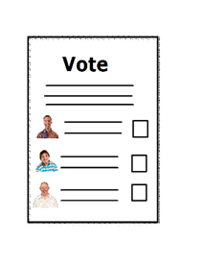
To be shown a large print ballot paper

To use the tactile voting device


To be able to lip read instructions

Someone to help mark the ballot paper with my decision (please tick 1 of the options below):

The Presiding Officer at the Polling Station

Support from ____________________ (who is over 18 years of age)
Don’t forget:
- To bring your photo identification (ID)

- Examples of identification are:

- a passport.

- a driving licence.

- some concessionary travel passes.

- photocard permits issued as part of the Blue Badge Scheme.

- You can allso visit www.electoralcommission.org.uk/i-am-a/voter/voter-id/accepted-forms-photo-id to check if your photo identification is acceptable.

- You can bring your own pen or pencil to use if you wish.

- Further information on acceptable identification can be provided by contacting the elections helpline.

0151 443 2222

ü
What other people can do:
- Explain the voting options to me.

- Use their knowledge of my communication methods to understand who I want to vote for.

- Come into the polling booth with me (with the permission of the Polling Station staff).

- Mark the ballot paper with my decision, if I permit them to do so.

- Polling Station staff can also help you to vote at your request.
X
What other people can’t do:
- Make a decision for me.

- Mark the ballot paper against my wishes.

- Stop me from voting because I have a learning disability or need support.
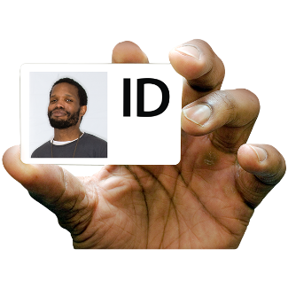

If you do not have any of the ID on the list, or you are not sure if your photo ID still looks like you, you can apply for a Voter Authority Certificate.
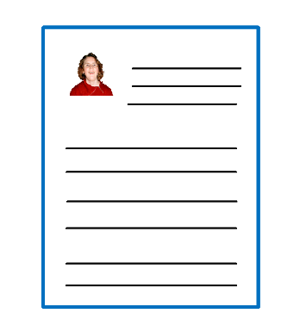

Visit www.electoralcommission.org.uk/voterID to apply or find out more.



A Voter Authority Certificate is free.

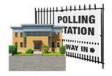
You will be able to use your Voter Authority Certificate as photo ID when you vote at a polling station.

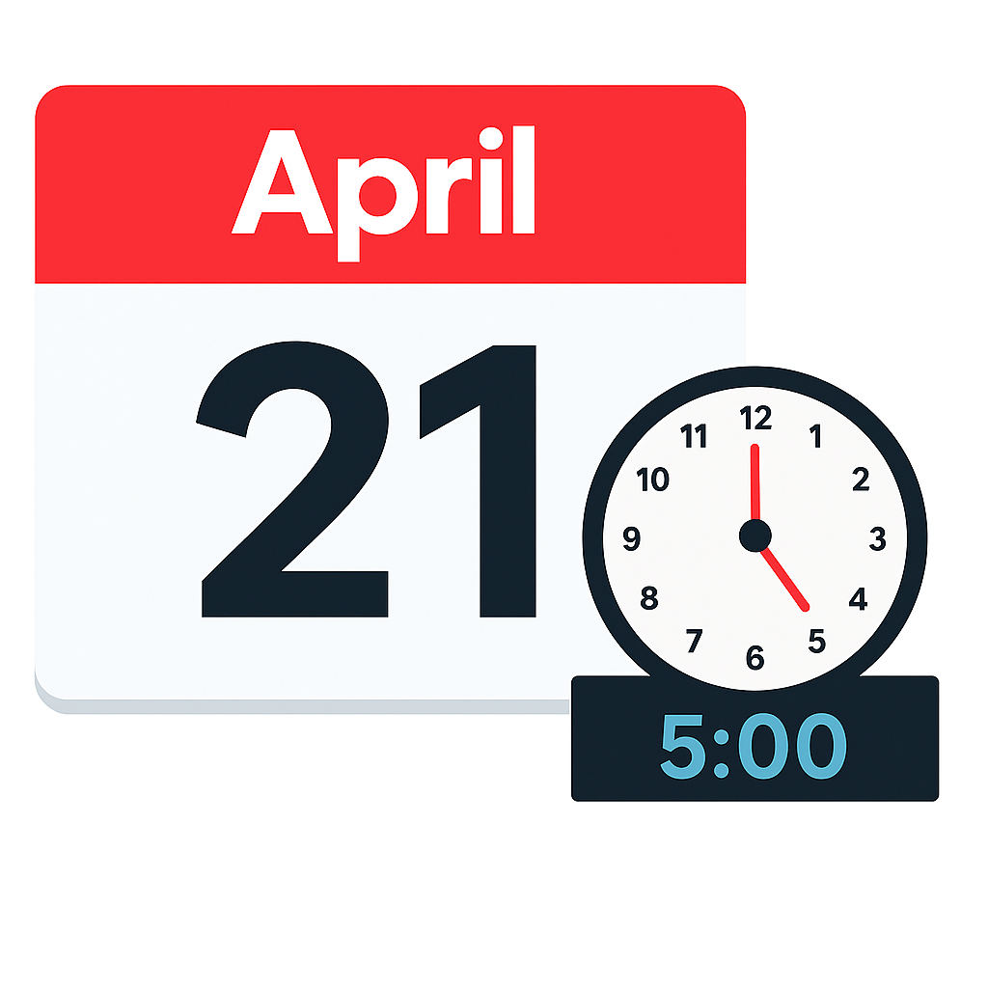
You must apply for the certificate by 5pm on Tuesday 21 April 2026.



You must be registered to vote before applying. Register today at www.gov.uk/register-to-vote .

