WORKING INSTRUCTION
Title | Calculation of required foam shot times (Oyster) | WI Reference | WI
Title | Calculation of required foam shot times (Oyster) | Issue Number | 1
Title | Calculation of required foam shot times (Oyster) | Department | Operations
Reference Documents | N/A | Responsibility | Production Operatives  Production Managers

Purpose

The purpose of this work instruction is to outline the process of calculating and inputting foaming shot times on the Oyster.

PPE Required

N/A

Instruction

A formula is used to calculate foaming shot times on the Oyster press, the formula is:

Length x Width x Thickness x Density ÷ Output = Shot time

However, there are two different types of calculations for both rebated and square ended panels. To calculate the shot time for a square ended panel, the thickness of the OSB used must be subtracted from the overall thickness of the panel. For example, if you are producing a square ended 100mm panel using 11mm OSB, the overall thickness within the calculation would be 78mm after removing 22mm to account for the thickness of the OSB.

When producing a rebated panel, both the thickness of the OSB and the size of the rebate must be subtracted from across the panel planes. The OSB thickness again should be subtracted from the overall thickness of the panel, and the size of the rebate should be subtracted from the length and width of the panel. For example, a 100mm panel at 2400mm long, produced with 40mm rebates and using 11mm OSB would have overall dimensions of 78mm thickness, 1120mm width and 2320mm length to account for both the OSB thickness and size of the rebates.

The density of a panel is determined using the ‘SIPs Shot Time Calculation’ document (QF56). This document outlines how densities vary with panel length and thickness.

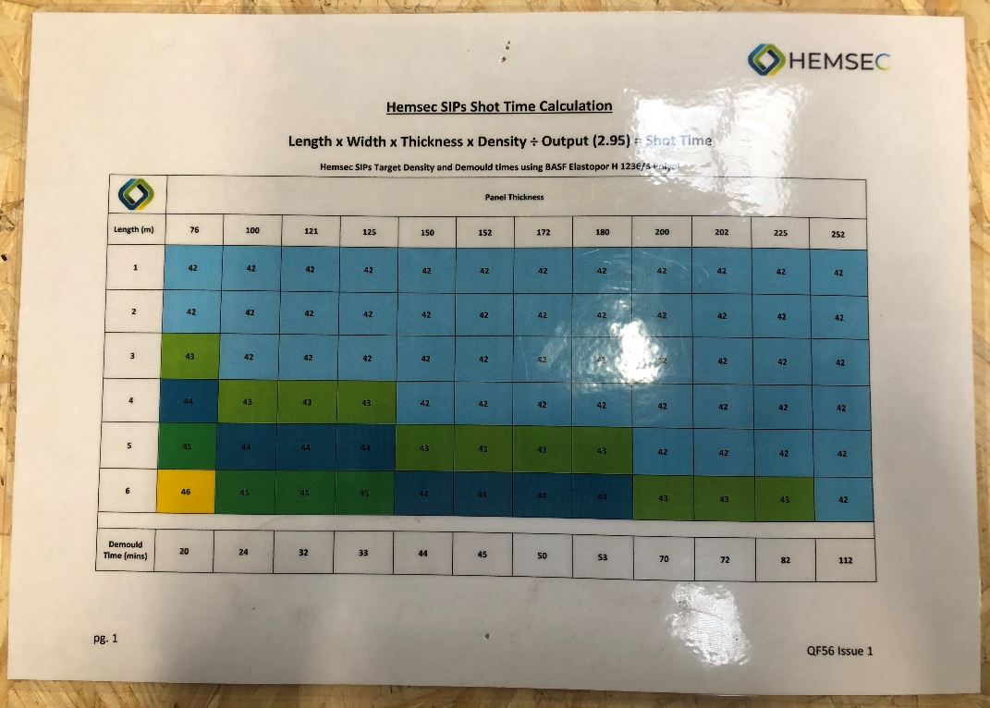

This section contains all the data needed regarding density to complete the formula

Operatives use the ‘SIP Foam Injection Record’ document to record the relevant data after calculating a shot time. An example of a completed calculation for both rebated and square ended can be seen below. The job number is also included on the sheet so its easily identifiable if a calculation needs to be checked in the future

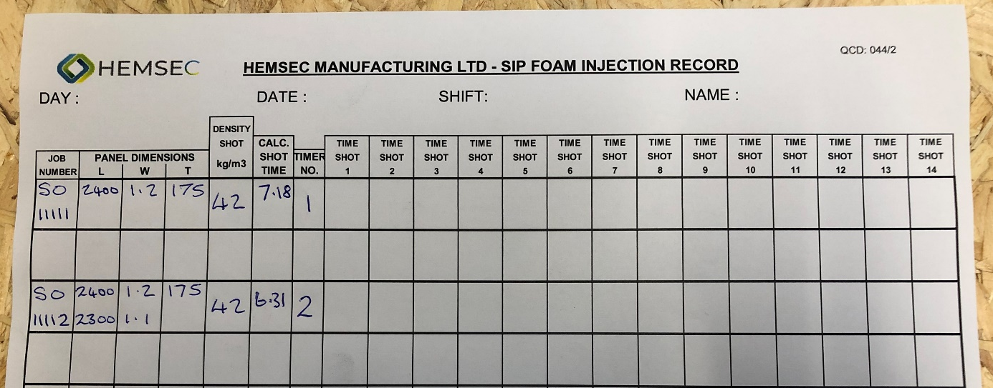

This is the square ended calculation

This is the rebated calculation

Once a shot time has been calculated, it can be input into the foaming plant ready to be used during the foaming process. This should only be carried out by a trained foaming operative.

To access the area of the foaming plant interface where shot times can be edited, select the button highlighted below. On this screen, both timers and shot times can be edited.

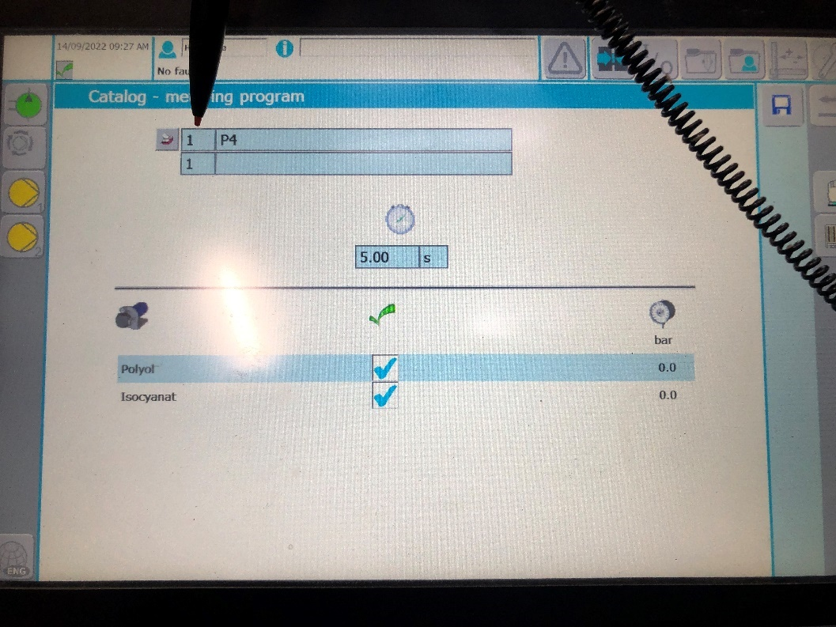
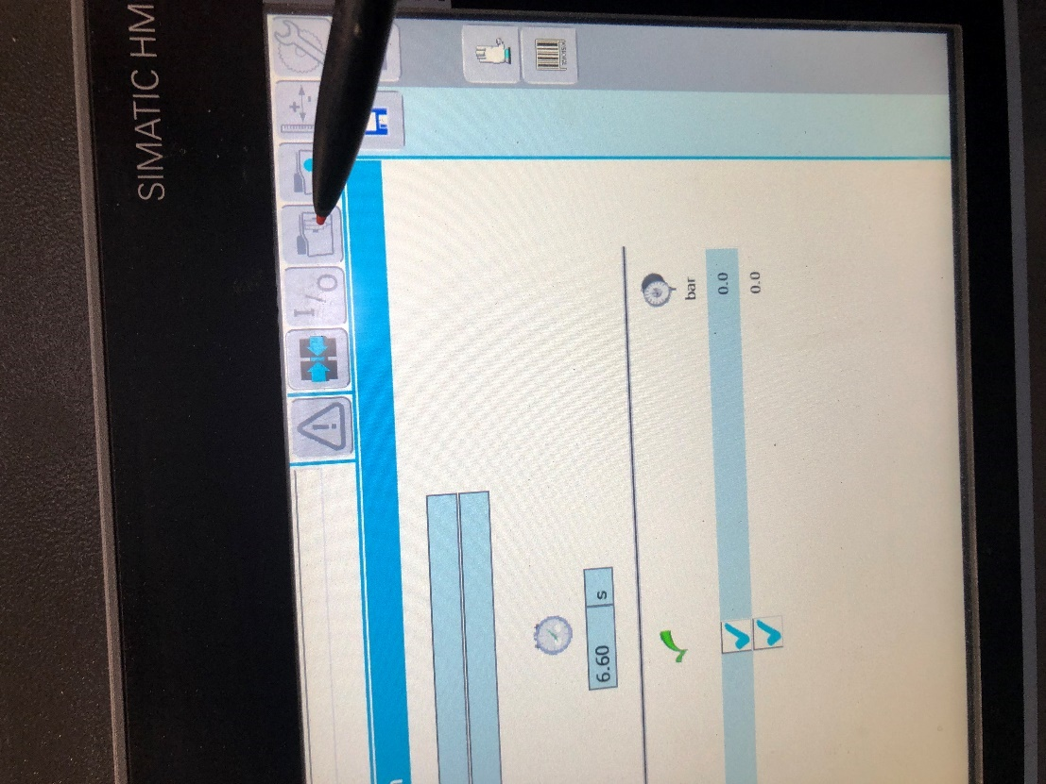
This button will take you to the screen where shot times can be edited.

To choose a specific timer to edit, select the timer number highlighted below using the stylus, this will then bring up a keyboard to input the exact timer you want to edit. For this example we will be editing timer 1.

After selecting timer 1, the shot time that has been allocated to the timer is displayed in the highlighted box below. For this example, we will be changing timer 1 from 5 seconds to 6 seconds. By clicking on the shot time, the keyboard allowing you to input a new shot time will appear. Before you can edit the shot time however, you must first input the password to authorize access to make changes to the foaming plant. The password is ‘hennecke’. Once you have input this you can continue to edit the shot times.

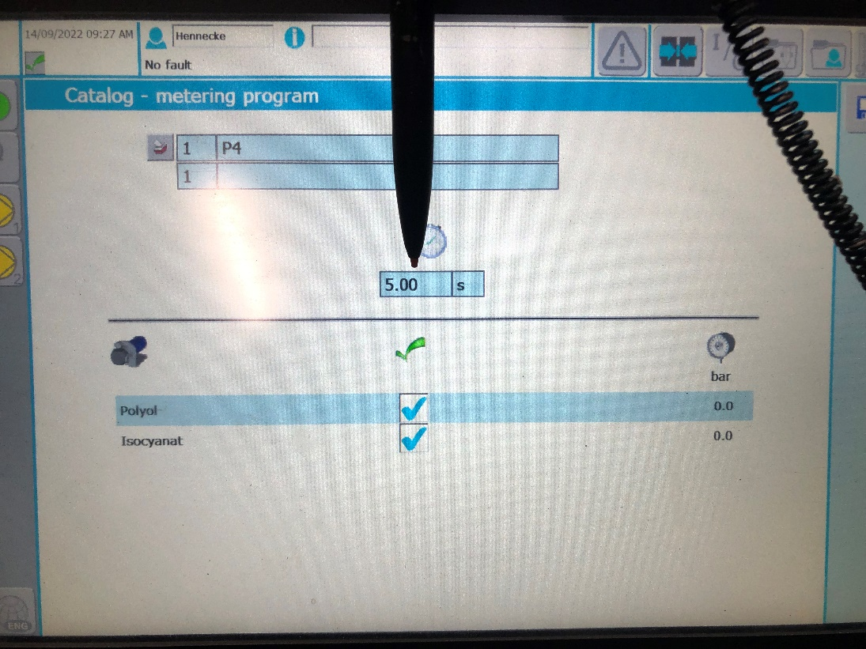

Insert password ‘hennecke’ here and press OK.

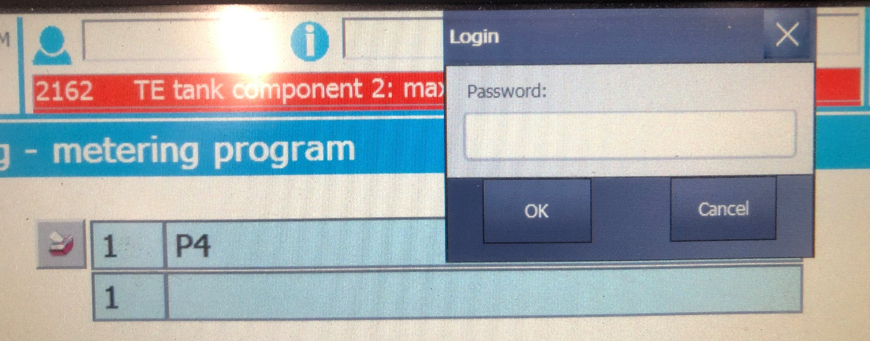

After inputting your new shot time, press the enter button highlighted below. This then confirms your new shot time.

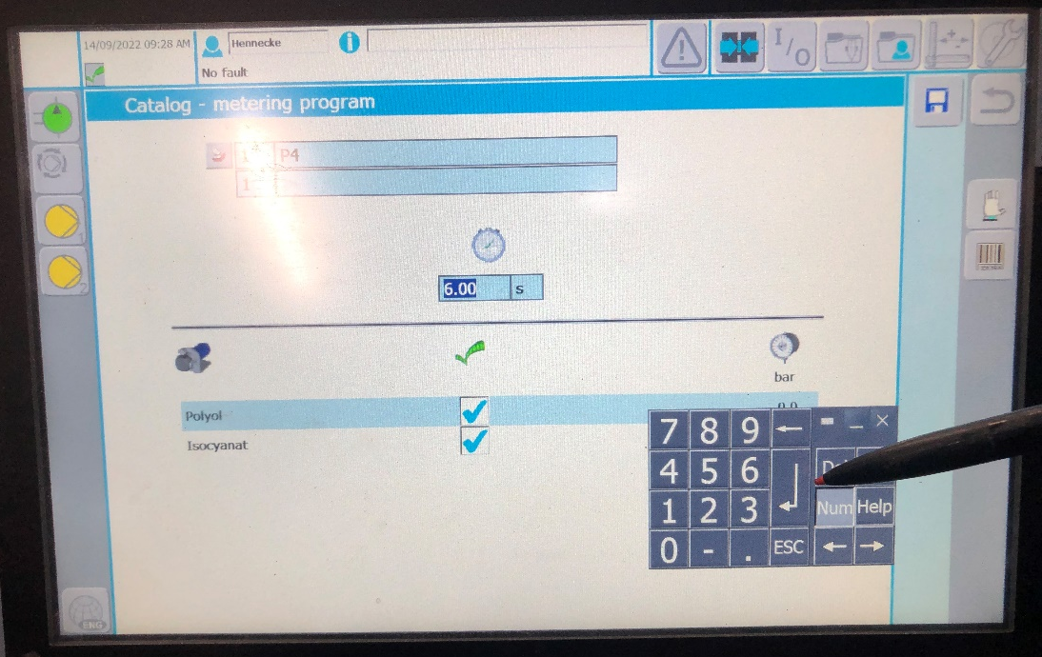

Finally save your changes by pressing the Save icon highlighted below.

