

Local Plan Monitoring Report 2024 - 2025
Published December 2025

Knowsley Local Plan: Monitoring Report
2024–25

Published December 2025
This Monitoring Report covers the year from 1 April 2024 to 31 March 2025. Data and indicators presented follow the format of our previous report for the 2023-24 period.

Demographic and socio-economic background
The population of the Knowsley Metropolitan Borough Council increased to 159,243 in 2023. This is based upon the 2023 ONS Mid-Year estimate, which is the most recent and is a 9.14% increase in the population since 145,900 was recorded in the 2011 Census.
The most recent estimates project a rise in population to 172,423 in 2032. This would be an 8.27% increase from 2023.

The most recent English Indices of Deprivation has been updated for 2025 (from 2019). This indicates Knowsley continues to be a relatively poor performer nationally in terms of income, employment, health, and education indicators. Albeit Knowsley is now ranked the 11th most deprived Borough having previously been ranked as the 2nd most deprived borough.

Employment and commercial development
At the end of 2024-25 there was a total employment land supply of 140.34ha in Knowsley with 52.70ha. available within the next five years. Almost forty percent of the most deliverable employment land in the next 5 years is within Knowsley’s Principal Regeneration Areas.

During 2024-25, 23.94 ha. of land was developed for employment use and 61,303 sqm of employment floorspace was completed, mostly for Use Class B2 “Industrial”, and B8 “Storage and distribution” purposes.

Housing development
The last Knowsley Strategic Housing Land Availability Assessment (SHLAA) was updated in 2024 and has a base date of 1 April 2024. The 2024 SHLAA estimates that there is land identified and available for 5,430 homes across the borough, of which 2,958 (“risk assessed”) could be built within the next five years (i.e. 2024-29). A 2025 update to the SHLAA will be produced in Winter 2025/26.

Dwellings are continuing to be built as the developments at East of Halewood, Halsnead Garden Village (Whiston), and the former Whitakers Garden Centre site in Prescot all progress. Consequently, the net housing completion figure was 461 dwellings for 2024-25.

It is noted that the number of completions continues to be above the annual target figure of 450 dwellings per year in the Local Plan Core Strategy.

The number of empty homes for this monitoring round was recorded as 1,561. There are no authorised Gypsy & Traveller pitches or yards for Travelling Showpeople within the borough, a situation unchanged from previous years.

Shopping and town centres
Government changes to the Use Class Order and permitted development rights means the way we monitor, and report retail and town centre permissions and completions changed in the 2021/2022 Monitoring Report and subsequent reports. The amount of retail floorspace granted planning permission was 1,388sqm, and for all town centre uses was 1,755sqm. The total amount of retail floorspace completed was 589sqm, with 604sqm completed for all town centre uses (incorporating retail uses).

Environment and conservation
The number of nationally listed buildings and structures within Knowsley has remained the same at 106. The number of heritage buildings ‘at risk’ remains at one and there were no changes to the number of conservation areas, and during the year no conservation area appraisals were updated.

During 2024-25 the number of parks in Knowsley with the prestigious Green Flag status has remained at 20. The most recent Green Flag Award was received for Bowring Park in 2024.

Plan preparation
On 6 January 2016 the Council adopted the Local Plan Core Strategy. The Core Strategy sets out the Council’s strategic planning policies, including those which:
- set targets for new housing, employment and retail development,
- identify priority locations for regeneration and investment, and
- allocate sites for new development.
The Core Strategy and SPDs are all available to view on the Council’s website at: www.knowsley.gov.uk/residents/building-and-planning/local-plan

During 2024-25 the Council continued to work positively and proactively with neighbouring authorities in accordance with the statutory ‘Duty to Cooperate’ on strategic planning matters, along with collaboration and information sharing with the Liverpool City Region Combined Authority.

Planning performance

During 2024-25, Knowsley Council made decisions on 96% percent of minor planning applications within agreed timescales (the target is 70 percent), and on 96 percent of major applications within agreed timescales (the target is 60 percent). These results are consistent with recent high performance over the last 5 years. The Council’s performance in defending appeals was also excellent, with all decisions being upheld on appeal (3 out of 3).

Just over £3,553,054 of developers contributions were secured during 2024-25 and just over £3,756,452 was collected during the year.

Contents

About the report 3
Format of this report 3
Background information 4
Part 1 Indicators Development 12
2 Employment and Economy 9
E1 – Employment land supply 9
E2 – Employment land lost 11
E3 – Employment land developed 11
E4 – Employment floorspace developed 12
3 Housing 14
H1 – Housing land availability 14
H2 – Sites for Gypsies & Travellers and Travelling Showpeople 14
H3 – Housing land lost 14
H4 – Homes lost 15
H5 – Empty homes 15
H6 – Housing completions 16
H7 – Housing change 17
R1 – Retail planning permission 18
R2 – Retail floorspace completions 20
R3 – Vacant shop units 21
EH1 – Listed buildings 23
EH2 – Conservation areas 23
EH3 – Access to parks and open spaces 25
EH4 – Quality of parks and open spaces 27
EH5 – Biodiversity 31
Other planning policies and guidance 41
Liverpool City Region Combined Authority (LCRCA) 42
Duty to Cooperate 43
7 Planning applications – decisions and appeals 45
PP1 – Planning Decisions performance 45
PP2 – Planning Appeals performance 46
8 Developer contributions 47
PP3 – Developer Contributions 47
Appendices 48
A Glossary 1
B Indicators used in this report 1
Economy and Employment 1
Retail and Town Centres 4
Data sources for indicators no longer included in the Monitoring Report 9
C Retail Permission Data Pre-2021/22 16
R1 – Retail Planning Permission (Class A) 16
R2 – Retail Floor Space Completions 17

Introduction

- Introduction

Monitoring Report 2025
  - Welcome to Knowsley Metropolitan Borough Council’s Local Plan Monitoring Report 2025. This report covers the period 1 April 2024 to 31 March 2025. This Report updates the Knowsley Local Plan: Monitoring Report 2024, which was published in December 2024.

  - The requirements to prepare an annual report on the borough’s growth and development are set out in legislation¹.

About the report
  - This document sets out information in relation to the development and planning of Knowsley, including statistics for development completed across a range of uses, the availability of land for development, and the Council’s performance in preparing plans and determining planning applications.

  - The indicators reported here continue to be drawn from the Knowsley Local Plan Monitoring Framework published in 2013, although in line with changes introduced in more recent reports, we have no longer attempted to cover the full range of indicators set out in the Monitoring Framework².

  - Appendix B provides a guide as to how the indicators we are now using relate to those presented before 2016.

Format of this report
  - The remainder of this chapter provides some demographic and socio-economic information which provides helpful background to the current planning and development situation in Knowsley.

  - Chapters 2 to 5 present the development indicators, which show the changing trends and patterns of development in the borough. It also includes related information such as how development relates to the need identified in the Local Plan, and the availability of development land across Knowsley.

  - Chapters 6 to 8 present the Council’s planning performance indicators, which show how we are doing at preparing our Local Plan and other planning policy documents, and how well we are handling planning applications and decisions.

1 In particular, the Planning and Compulsory Purchase Act 2004 (as amended by the Localism Act 2011) and the Town and Country Planning (Local Planning) (England) Regulations 2012. For the purposes of the regulations, this report fulfils the role of the “local planning authority’s monitoring report”.
2 The reasoning behind this was explained in paragraphs 1.4 to 1.6 of the 2015 monitoring report.

Background information
  - To provide context to the development indicators, which follow later in this Report, it is useful to look briefly at demographic and socio-economic data. The following background information covers the year from 1 April 2023 to 31 March 2024.

Population changes and household projections

  - The population of Knowsley Metropolitan Borough increased to 159,243 in 2023, based on the Office for National Statistics (ONS) Mid-2023 estimates. This data is greater than earlier projections which indicated the population would be 152,254 in 2028. This increase is reflective of the significant growth of overall housing provision in the borough, along with potential migratory impacts of the Covid-19 pandemic, and Knowsley’s enhanced status as being a key ‘commuter-zone’ location for Merseyside and the North-West.

  - As of 24 June 2025, the most recently released population projections regard “Subnational population projections for England: 2022-based” (subsequently referred to as 2022 based projections). This presents the following highlighted projections:
    - Projected population: 172,423 people in 2032, up from 157,107 people projected in 2022.
    - Population change: since 2022 +9.7% compared to +6.4% across England.
    - Net internal migration: +10,719 people projected to be the largest factor in the population increase between 2022 and 2032.
    - Projected median: age 39 years no change from 39 years in 2022.
Figure 1: Projected total population, 2022 to 2047

  - Population change is projected by looking at births and deaths (natural change) and people moving in and out of areas. In Knowsley, the 2022 based projections show that between 2022 and 2032:
    - More births than deaths mean that the population is projected to increase by 1,671, with 19,135 births and 17,464 deaths in Knowsley between 2022 and 2032. This means natural change would increase the population in Knowsley by 1.1%, compared with an increase of 0.2% in England.
    - Net internal migration (people moving to and from other local authorities in England) is projected to increase the population by 10,719, with 90,033 people moving to the area and 79,314 people moving from the area between 2022 and 2032. This would increase the population in Knowsley by 6.8%.
    - Net cross-border migration (between UK nations) is projected to reduce the population by 278, with 2,146 people moving to the area and 2,424 people moving from the area between 2022 and 2032. This would decrease the population in Knowsley by 0.2%.
    - Net international migration is projected to increase the population by 3,032, with 5,726 people moving to the area and 2,694 people moving from the area between 2022 and 2032. This would increase the population in Knowsley by 1.9%, compared with an increase of 6.5% in England.

  - Regarding the age profile in Knowsley in 2032, the median age in Knowsley is projected to remain the same at 39 years between 2022 and 2032. In England, the median age is projected to be 41 years in 2032. In 2032, 18% of the population in Knowsley are projected to be aged 65 years or over, up from 16% in 2022. The 50 to 59 age group are set to see the largest change in Knowsley between 2022 and 2032.
  - Between 2022 and 2032, the 2022 based projections show that the share of the working age population (people aged 16 years to State Pension age) in Knowsley is projected to stay the same, at around 63%. The old age dependency ratio (the number of people of State Pension age for every 1,000 people of working age) is projected to rise from 246 to 264 over the same period. This is below average for England in 2032 (287 per 1,000). Nationally, a high old age dependency ratio means more older people are financially reliant on the working age population to pay for pensions.
  - Regarding how the number of young people will change in Knowsley, in 2032, 22% of people are projected to be aged 18 years and under, around the same as in 2022. This is above average for England in 2032 (20%). Looking at the youngest age groups in Knowsley between 2022 and 2032, the following points are noted:
    - Infants (aged 0 to 4 years) will stay around the same, at 6%
    - Primary school age children (aged 5 to 11 years) will fall from 9% to 8%
    - Secondary school age children and sixth-form age (aged 12 to 18 years) will stay around the same, at 8%

  - The 2021 Census release showed the following statistical changes regarding household composition:
    - Other household: 4.9% (0.5% decrease since 2011)
    - One person household: 31.2% (0.2% increase since 2011)
    - Single family household: 63.9% (0.3% increase since 2011)

  - The 2021 Census release showed the following statistical changes regarding the number of people in a household:
    - 1 person: 31.2% (0.2% increase since 2011)
    - 2 people: 31.4% (0.5% increase since 2011)
    - 3 people: 18.7% (1.1% increase since 2011)
    - 4 people or more: 18.6% (1.8% decrease since 2011)

  - The 2021 Census release showed the following statistical change regarding population density:
    - Persons per square kilometre: 1,787 (6% increase since 2011)

  - The 2021 Census release showed the following statistical changes regarding accommodation type:
    - Whole house or bungalow: 89.6% (0.1% increase since 2011)
    - Flat, maisonette or apartment: 10.1% (no change since 2011)
    - A caravan or other mobile or temporary structure: 0.3% (no change since 2011)

  - The 2021 Census release showed the following statistical changes regarding the number of bedrooms in a household:
    - 1 bedroom: 6.2% (-0.5% decrease since 2011)
    - 2 bedrooms: 20.7% (-0.2% decrease since 2011)
    - 3 bedrooms: 57.6% (-0.4% decrease since 2011)
    - 4 or more bedrooms: 15.4% (+1.1% decrease since 2011)

  - The 2021 Census release showed the following statistical changes regarding the number of cars or vans available by household:
    - No cars or vans: 31.2% (-5.9% decrease since 2011)
    - 1 or more cars or vans: 68.8% (+5.9% increase since 2011)

Deprivation
  - The most recent English Indices of Deprivation has been updated for 2025 (from 2019) demonstrated that Knowsley continues to have significantly higher levels of deprivation than the rest of England and the North-West. The coefficient used for small statistical areas is comprised of income, employment, health, education, crime, barriers to housing and services, and living environment indicators.

  - Key Deprivation statistics for Knowsley:
- In 2019 Knowsley was the 2nd most deprived Local Authority. Knowsley has now improved to 11th, with only Liverpool being more deprived.
- Knowsley is the 4th most deprived Local Authority regarding employment, and is lower than the remaining Liverpool City Region Local Authorities.
- Knowsley is the 3rd most deprived local authority regarding both education health deprivation and disability, with only Liverpool being more deprived regarding health.
- Knowsley is more deprived than 94% of all other local authority districts.

Table 1: Upper Tier English Indices of Deprivation 2025 – Rank of Average Score
 | Knowsley | Wirral | Sefton | Liverpool | Halton | St. Helens
Index of Multiple Deprivation (IMD) Rank | 11 | 147 | 59 | 7 | 24 | 38
Income Rank | 24 | 61 | 76 | 23 | 40 | 54
Employment Rank | 4 | 22 | 33 | 6 | 16 | 19
Education Skills and Training Rank | 3 | 66 | 64 | 17 | 29 | 37
Health Deprivation and Disability Rank | 3 | 14 | 30 | 2 | 12 | 11
Crime Rank | 60 | 92 | 89 | 22 | 42 | 61
Barriers to Housing and Services Rank | 111 | 153 | 146 | 145 | 104 | 144
Living Environment Rank | 144 | 50 | 58 | 29 | 122 | 84
Income Deprivation Affecting Children Index (IDACI) Rank | 30 | 71 | 77 | 14 | 49 | 59
Income Deprivation Affecting Older People (IDAOPI) Rank | 19 | 77 | 82 | 15 | 52 | 72

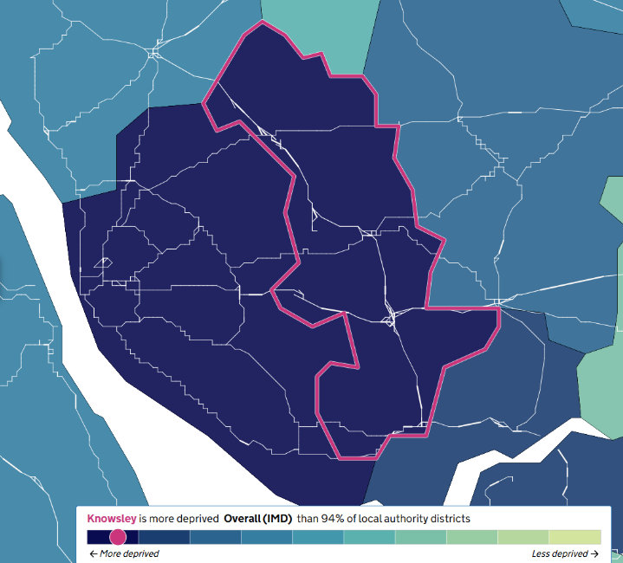
Figure 3: Knowsley - Indices of Deprivation (2019)

  - Regarding Knowsley’s major urban areas/townships, there are high concentrations of deprivation throughout the borough (Fig. 3). . In some areas, there are clear areas of differentiation such as between North Huyton and South Huyton/Roby; and North and South Halewood (Fig. 4).

  - The 2021 Census release showed the following statistical changes regarding household depravation:
    - Household is not deprived in any dimension: 40.8%
    - Household is deprived in one dimension: 32.3%
    - Household is deprived in two dimensions: 19.2%
    - Household is deprived in three dimensions: 7.3%
    - Household is deprived in four dimensions: 0.3%

  - The 2021 Census release showed the following statistical changes regarding home ownership:
- Owned: owns outright 28.6% (2.5% increase from 2011)
- Owned: owns with a mortgage or loan 31.7% (4.5% decrease from 2011)
- Rented: social rented 25.3% (1.4% decrease from 2011)
- Private rented 14.5% (3.4% increase from 2011)

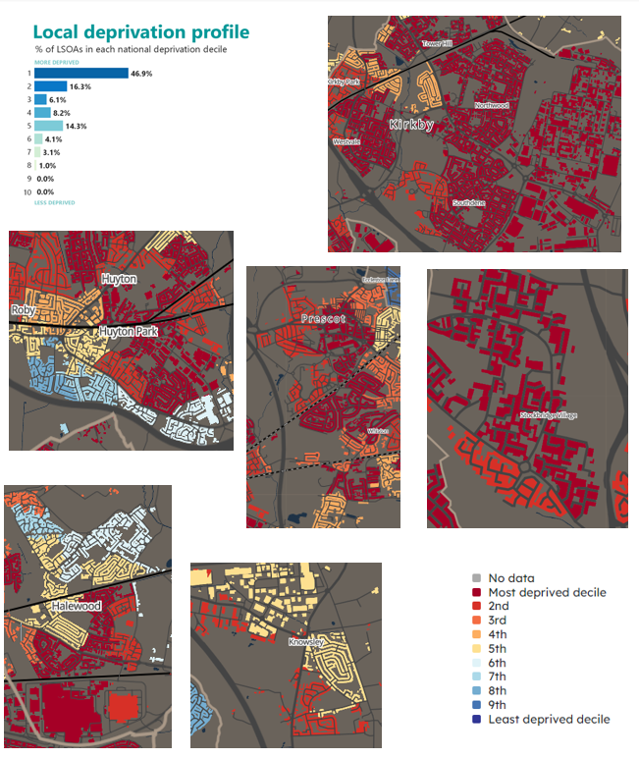
Figure 4: Multiple Deprivation Index of Knowsley’s major Town Centres (2019)

Income and Employment

  - In terms of income, Knowsley is the 24th most income-deprived local authority in England in 2025. In terms of employment 23% of working age adults in Knowsley reside in employment deprived households. With employment and income, whilst full workers in Knowsley earn less than others in the North-West region and Great Britain, it is noted that female full-time workers in Knowsley earn more than female workers in the North-West.

  - The Marmot Report (2022), produced by the Institute of Health Equity, highlighted that Knowsley has the lowest life expectancy in Merseyside, with average life expectancy approximately 10 years less than the UK average. There is also a differential of 10 years life expectancy between the most affluent and poorest areas within Knowsley, with 1 in 4 residents in Knowsley being ‘income deprived’.

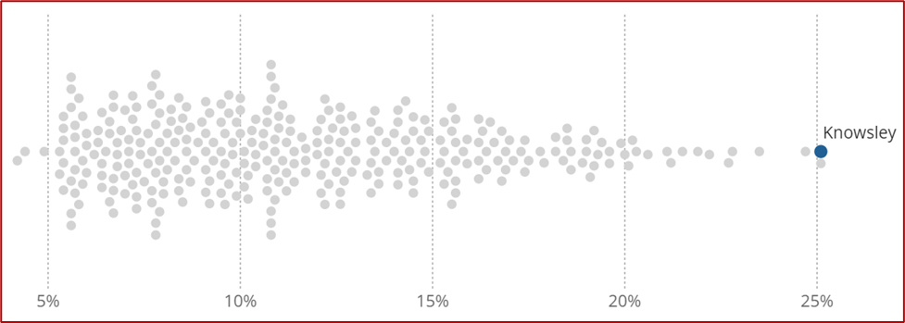
Figure 5: English local authorities by the percentage of people in income deprivation, 2019

  - In the latest 12 months to December 2024; 72.3% of people aged 16-64 in Knowsley were in employment (67,700 people) which was lower than North-West (73.4%) and England 75.7% (ONS Annual Population Survey). In Knowsley 63.8% of the 16-64 aged population were employees (59,800 people) and 8.5% were self-employed (8,000 people). These figures are lower when compared to England as 66.0% were employees and 9.5% were self-employed. Recent figures suggest that self-employment has increased in Knowsley from 4,600 people aged 16-64 in the 12 months to March 2024 to 8,000 people in December 2024.

  - The 2021 census provides the following statistics regarding economic activity in Knowsley:
- Economically active: in employment 55.9% (3.1% increase from 2011)
- Economically active: unemployed 3.5% (3.2% decrease from 2011)
- Economically inactive: 40.6% (0.2% increase from 2011).

  - The 2021 census provides the following statistics regarding education attainment levels in Knowsley:
    - No qualifications: 26.2%
    - Highest level of qualification: Level 1, 2 or 3 qualifications: 42.2%
    - Highest level of qualification: Apprenticeship: 5.5%
    - Highest level of qualification: Level 4 qualifications or above: 23.8%
    - Highest level of qualification: Other qualifications: 2.2%

  - The Census 2021 data provides the following figures regarding method of travel to workplace in Knowsley:
- Car or van: 51%
- Work mainly at or from home: 21.4%
- Foot: 7%
- Bus: 6.7%
- Passenger: 6.2%
- Train: 2.5%
- Taxi: 1.9%
- Bicycle: 1.7%
- Motorcycle: 0.2%
- Underground, metro, light rail, tram: 0.1%
- Other: 1.2%

Part 1 Indicators Development

Employment and Economy
  - The section sets out Knowsley’s position with respect to the amount of land available for future employment development and how this is distributed across the borough’s existing employment areas. It also reports on the quantity of land and floorspace taken up in the last monitoring round, including where it has happened, and the type of employment premises delivered.

E1 – Employment land supply

  - In April 2025, the total employment land supply in Knowsley was 140.34 hectares, which demonstrates a decrease in the supply of employment sites since the last monitoring report. Consequently, employment supply has reduced by 98.37 hectares from the total supply figure of 238.71 hectares stated in the adopted Local Plan Core Strategy (2016).

Table 2: Hectares of employment land available by category
Site Type | Land Available (hectares) | Sites
UDP Allocations (under construction and planning permissions) | 29.33 | 18
UDP Allocations (Expansion Land) | 22.82 | 3
UDP Regional Investment Site: Kings Business Park | 6.24 | 1
UDP South Prescot Action Area | 3.07 | 2
Non-allocated Expansion Land | 13.57 | 7
Land with remodelling potential | 2.99 | 4
Sustainable Urban Extensions | 31.53 | 3
Other employment sites, inc. under construction and planning permissions | 30.79 | 10
Total | 140.34 | 48
Source: Knowsley Council Planning Policy Team

  - The overall land supply considered to be available and potentially deliverable within 5 years is 52.70 hectares. Almost forty percent of the most deliverable employment land in the next 5 years is within Knowsley’s Principal Regeneration Areas.

Table 3: Hectares of employment land available within 5 years and over the Plan period
Area | Total Land Available | Land available within 5 years
North Huyton and Stockbridge Village | 0 | 0
Kirkby Town Centre | 0 | 0
Knowsley Industrial and Business Parks | 56.56 | 18.78
Tower Hill | 0 | 0
South Prescot | 3.07 | 1.79
Prescot Town Centre | 0 | 0
All Principal Regeneration Areas | 59.63 | 20.57
Other locations | 80.71 | 33.13
Total | 140.34 | 52.70
Local Plan Core Strategy requirement | 164.00 | 45.50
Balance (in hectares) | -23.66 | 7.20
Source: Knowsley Council Planning Policy Team

E2 – Employment land lost

  - This indicator measures the employment land removed from the borough’s supply – either because planning permission for employment uses has lapsed, or because the land has been used for other purposes.
  - In the last monitoring year there was a recorded loss of 2.13 hectares of employment land and a cumulative loss of 24.37 hectares since April 2010.

Table 4: Employment Land Lost
 | Current Monitoring Year | Last five years | Plan  period
Planning permission expired | 1.70 | 2.13 | 11.03
Land developed for other purpose | 0.43 | 7.04 | 13.34
Total | 2.13 | 9.17 | 24.37
Average | - | 1.83 | 1.62
All figures are hectares. Source: Knowsley Council Local Plan Team

E3 – Employment land developed

  - The Local Plan Core Strategy planned for a total minimum requirement of 9.11 hectares of employment land per year to be developed for the plan period.
  - In 2024-25, nearly 24 hectares of employment land was developed and consequently, the average amount of land developed for employment purposes over the life of the Local Plan has risen to 8.07 hectares per annum. With regard to the development of land for employment purposes in the borough’s Principal Employment Areas, growth has mainly occurred in Knowsley Industrial and Business Parks. Outside of the Principal Employment Areas development has continued in the Sustainable Urban Extension – land south of M62, whilst there has also been new development completed in Huyton Business Park.

Table 5: Land Developed for Employment Uses
 | Current Monitoring Year | Last five years | Plan  period
 | 2024-25 | 2020 -21 – 2024-25 | 2010-11 – 2024-25
Total | 23.94 | 63.74 | 121.11
Average | - | 12.74 | 8.07
All figures are hectares. Source: Knowsley Council Planning Policy Team
Table 6: Land Developed by Principal Employment Area
Area | Current Monitoring Year 2024-25 | Plan Period 2010-11 – 2024-25
North Huyton and Stockbridge Village | 0 | 0
Kirkby Town Centre | 0 | 0.7
Knowsley Industrial and Business Parks | 10.16 | 79.05
Tower Hill | 0 | 0
South Prescot | 0 | 0.15
Prescot Town Centre | 0 | 0
Total | 10.16 | 79.20
All figures are hectares. Source: Knowsley Council Planning Policy Team.

E4 – Employment floorspace developed

  - There is no specific target for the provision of employment floorspace in the Local Plan Core Strategy. However, it is noted that the quantum of floorspace developed for employment purposes during 2024-25 is similar to that achieved during the previous monitoring round. The redevelopment of sites in Huyton Business Park resulted in floorspace delivery exceeding the floorspace provided in Knowsley Industrial and Business Parks.

Table 7: Floorspace Developed for Employment Uses
Use | Current Monitoring Year | Last five years | Plan  period
 | 2024-25 | 2020-21 –  2024-25 | 2010-11 –  2024-25
B1 | 687 | 6,428 | 37,900
B2 | 37,045 | 94,577 | 163,139
B8 | 23,571 | 134,335 | 242,033
Other | 0 | 0 | 1,823
Total | 61,303 | 235,340 | 444,895
Average | - | 47,068 | 29,659
All figures are metres squared. Source: Knowsley Council Planning Policy Team

Table 8: Employment Floorspace developed by Principal Regeneration Area
Area | Current Monitoring Year | Plan Period
 | 2024-25 | 2010-11 –  2024-25
North Huyton and Stockbridge Village | 0 | 0
Kirkby Town Centre | 0 | 3,913
Knowsley Industrial and Business Parks | 17,761 | 246,802
Tower Hill | 0 | 0
South Prescot | 0 | 60
Prescot Town Centre | 0 | 0
Total | 17,761 | 250,715
All figures are metres squared. Source: Knowsley Council Planning Policy Team

Housing

  - This section outlines the supply and delivery of housing across Knowsley and covers the availability of land for housing, changes to the housing stock, and the number of empty homes in the borough. It also includes an indicator for the provision of authorised pitches and yards for Gypsies and Travelling Show people, although this remains at zero for the time being.

H1 – Housing land availability

  - Information on the housing land supply will be available in the Strategic Housing Land Availability Assessment (SHLAA) – 2025 Update.

H2 – Sites for Gypsies & Travellers and Travelling Showpeople

  - There are no authorised Gypsy & Traveller pitches or sites for Travelling Showpeople within Knowsley, a situation unchanged from previous years. A target for the delivery of new pitches and potentially the allocation of a site (or sites) for this purpose would be included in a future development plan document, should evidence indicate there is a clear need for provision of this type within the borough.

Table 9: Number of Gypsies, Travellers and Travelling Showpeople Pitches and Sites
 | Pitches with Consent | Sites
Gypsy & Traveller Pitches | 0 | 0
Travelling Showpeople Sites | 0 | 0
Total | 0 | 0
Source: Knowsley Council Planning Policy Team

H3 – Housing land lost to other uses

  - We have been unable to complete this indicator this year but hope to be able to include it in a future report following updated monitoring data.

H4 – Homes lost

  - The number of homes lost to demolitions and changes of use has decreased to 98, this is higher than the plan period average of 68. The demolitions can be explained by the application 19/00297/FUL at the Watch Factory site, where 98 demolitions were recorded upon the completion of the whole site. Three dwellings were lost through change of use or conversion; however, six dwellings were also created through change of use or conversion, therefore, giving a net positive of three dwellings in this category.

Table 10: Number of Homes Lost
Reason for loss | Current Monitoring Year | Plan  period
 | 2024-25 | 2010-11 – 2024-25
Demolition | -98 | -1,641
Change of use and conversions: losses | -3 | NA
Change of use and conversions: gains | +6 | NA
Change of use and conversions overall figure | +3 | 5
Total | -95
Source: Knowsley Council Planning Policy Team

H5 – Empty homes
  - At the end of the monitoring period there were a total of 1,561 empty homes in the Borough, the majority of the empty homes (1,263) were owned by private individuals/companies whilst housing associations owned 276.

Table 11: Empty homes by tenure
Tenure | Current Monitoring Year
 | 2024-25
Private | 1,263
Housing Association | 276
KMBC | 22
Total | 1,561
Source: Knowsley Council Environmental Health
Table 12: Length of time homes are empty
 | Current Monitoring Year
 | 2024-25
0-6 months | 929
6-12 months | 258
1-2 years | 169
2-5 years | 137
More than 5 years | 68
Total | 1,561
Source: Knowsley Council Environmental Health

Table 13: Empty homes brought back into use
 | Current Monitoring Year
 | 2024-25
Total | 159
Source: Knowsley Council Environmental Health

H6 – Housing completions

  - During 2024-25 the total number of new build housing completions remains higher than the Local Plan’s average target of 450 dwellings per annum.

  - The total number of affordable units completed equates to just over 50% of all the homes completed, demonstrating that the Local Plan’s approach to affordable housing delivery via Policy CS15 is having a positive impact on housing growth to meet the borough’s needs. The total affordable figure for 2024-25 includes 12 affordable housing units provided via the Affordable Housing Access Fund (s106).

Table 14: Housing completions
 | Current Monitoring Year | Plan Period
 | 2024-25 | 2010-11 to 2024-25
Total | 556 | 9,018
Of which affordable units | 283 | 2,628
Source: Knowsley Council Planning Policy Team

Table 15: Housing completions
Township | Current Monitoring Year | Plan Period
 | 2024-25 | 2010-11 to 2024-25
Huyton | 120 | 3,391
Kirkby | 18 | 1,783
Halewood | 188 | 1,104
P, W, C, KV | 230 | 2,392
Source: Knowsley Council Planning Policy Team

H7 – Housing change

  - The Local Plan Core Strategy made provision in Knowsley for a minimum of 8,100 new dwellings to be delivered between 2010 and 2028. This equates to a minimum figure of 450 dwellings per year despite the housing need for Knowsley being 255 dwellings per annum when calculated using the previous “standard method” calculation.

  - During the life of the Local Plan the number of dwellings delivered has consistently performed well against the annual average of 450 dwellings per annum and since its adoption in 2016 the net supply figure has remained positive. This can be seen when considering the 2024/25 monitoring figures with 461 net completions. This resulted in a net positive balance figure of 11 dwellings for 2024-25 above the target of 450 in the Local Plan.

Table 16: Net number of homes completed above Local Plan average target
 | Current Monitoring Year
 | 2024-25
Net completions | 461
Target for period | 450
Net balance | 11
Source: Knowsley Council Planning Policy Team

Retail and Town Centres

  - This section reviews 2024-25 data for shopping and town centres in Knowsley. This also includes other ‘main town centre uses’ such as leisure, entertainment facilities, intensive sport and recreation uses, offices, arts, culture and tourism development.

  - Key information monitored includes the amount of floorspace granted planning permission during the year for retail and other uses, and the amount of floorspace completed.

  - More information on the types of centres, including a list of the borough’s retail centres, is found in the Local Plan Core Strategy – see Policies CS4 and CS6.

Use Class Changes 2021

  - Government changes to the Use Class Order and permitted development rights means the way we monitor, and report retail and town centre permissions and completions has changed from the Local Plan Monitoring Report 2021/2022 and onwards.

  - The new use classes are now reported in this Local Plan Monitoring Report, with the statistics reflective of the previous Use Class classifications reported in Appendix C.

R1 – Retail planning permission

  - The table below shows the amount of retail use floorspace granted planning permission (Class E). It is important to note the uses have been monitored in accordance with the updated use classes, which came into force on 1 September 2020.

  - During the current monitoring year, 12 planning permissions were granted for retail floorspace, and other town centre uses, and 9 of the approvals were for proposals located in Knowsley’s retail centres. In addition, there was planning permission approval for a total of 1,388 square metres of retail floorspace.

Table 17: Retail floorspace permission
Use Class | Monitoring year
 | 2024- 2025
E (a) Shop other than the for the sale of hot food | -342
E (b) Food and drink which is mostly consumed on the premises | 102
E (c) i. financial services | 0
E (c) ii. professional services (other than medical services) | 0
E (c) iii. any other services which it is appropriate to provide in a commercial, business or service locality | 0
E (d) Indoor sport and recreation (not swimming pools, ice rinks or motorised vehicles or firearms) | 0
E (e) Medical services not attached to the residence of the practitioner | 337
E (f) Non-residential creche, day centre or nursery | 367
E (g) (i) office | 924
E (g)(ii) the research and development of products or processes | 0
E (g) (iii) any industrial process, (which can be carried out in any residential area without causing detriment to the amenity of the area) | 0
Total | 1,388
All figures are square metres. Figures are net – demolitions are subtracted from new floorspace development figures, and changes of use measured as positive for conversions to a use class, and negative for conversions from a use class. Source: Knowsley Council Planning Policy Team.

  - The table below shows the total floorspace for which permission was granted covering all main town centre uses. In addition to the ‘E’ use classes (Commercial, Business and Service), the table includes proposals for ‘F1` (Learning and non-residential institutions) and `F2’ (Local Community Uses) and main town centre uses which fall under a Sui Generis Use Class.

Table 18: Floorspace permission for all main town centre uses
Type of Centre | Monitoring year 2024-  2025
Town Centre | 337
District Centre | 0
Major Local Centre | 66
Medium Local Centre | 660
Minor Parade | 277
Out of Centre | 415
Retail Park | 0
Total | 1755
All figures are square metres. Source: Knowsley Council Planning Policy Team.

R2 – Retail floorspace completions

  - Table 19 below shows the amount of retail floorspace completed during 2024/25. Again, it is important to note that the uses have been monitored in accordance with the use classes which came into force on 1 September 2020.
  - Table 19 includes figures for changes of use to other use classes not included in the table. For example,

Table 19: Retail floorspace completions
Use Class | Monitoring year 2024-2025
E (a) Shop other than for the sale of hot food | -552
E (b) Food and drink which is mostly consumed on the premises | 724
E (c) (i) financial services | 10
E (c) (ii) professional services (other than medical services) | 0
E (c) (iii) any other services which it is appropriate to provide in a commercial, business or service locality | 0
E (d) Indoor sport and recreation (not swimming pools, ice rinks or motorised vehicles or firearms) | 0
E (e) Medical services not attached to the residence of the practitioner | 130
E (f) Non-residential creche, day centre or nursery | 0
E (g) (i) office | 277
E (g)(ii) the research and development of products or processes | 0
E (g) (iii) any industrial process, (which can be carried out in any residential area without causing detriment to the amenity of the area) | 0
Total | 589
All Figures are square meters. Source: Knowsley Council Planning Policy Team

  - The table below shows floorspace completions for all main town centre uses (‘E’ classes (Commercial, Business & Service), ‘F1 classes` (Learning and non-residential institutions) and `F2’ classes (Local Community Uses) and main town centre uses which fall under Sui Generis, either within a retail centre or in an out of centre location) by type of centre during 2024-25.

Table 20: All town centre uses floorspace completions
Type of Centre | Monitoring year 2024-2025
Town Centre | -448
District Centre | 0
Major Local Centre | 66
Medium Local Centre | 0
Minor Parade | 277
Out of Centre | 667
Retail Park | 42
Total | 604
All figures are square metres. Source: Knowsley Council Planning Policy Team.

R3 – Vacant shop units

  - The number of vacant shop units below is shown as a range i.e., the minimum and maximum number of vacant shop units recorded during the year.

Table 21: The range in vacant shop units
 | Current Monitoring Year
 | 2024-25
Kirkby Town Centre | 20-26
Prescot Town Centre | 19-26
Huyton Town Centre | 11-15
All town centres | 50-67
All town centres – percentage | 13.2-17.7%
Source: Knowsley Council Planning Policy Team.

  - It is noted in this monitoring year there has been an increase in the range of vacant shop units in all townships, as opposed to solely in Kirkby which was observed in the previous monitoring year.

- Environment and heritage
  - This section concentrates on the built and natural environment, dealing with heritage issues, access to and quality of open spaces, and biodiversity.

EH1 – Listed buildings
  - The number of nationally listed buildings within Knowsley has remained the same at 106. Church of St Chad, Old Hall Lane, remains on the Historic England ‘At Risk’ Register

Table 22: Listed buildings
 | 2024-25
Grade I | 1
Grade II* | 4
Grade II | 101
Total | 106
‘At Risk’ | 1
Source: Knowsley Council Conservation and Design Officer

EH2 – Conservation areas
  - There are 15 conservation areas in the Borough, unchanged from the previous monitoring period. Prescot Town Centre remains on the Historic England ‘At Risk’ Register, but work continues to improve the fabric and quality of the town’s buildings and spaces.

Table 23: Conservation Areas
Conservation Area | Appraisal Updated | Management Plan Updated | “At Risk” | Article 4 Direction
North Park Road and | 2018 | 2018 | No | No
South Park Road, Kirkby | 2018 | 2018 | No | No
Town End, Cronton | 2017 | 2017 | No | No
Roby | 2015 | 2015 | No | No
Victoria Road and Huyton Church Road | 2015 | 2015 | No | No
The Orchard | 2014 | 2014 | No | No
Prescot Town Centre | 2012 | 2012 | Yes | No
Halewood Village | 2005 | - | No | No
Huyton Church (St. Michael’s) | 2005 | - | No | Yes
Ingoe Lane, Kirkby | 2005 | - | No | Yes
Knowsley Village | 2005 | - | No | Yes
Old Hall Lane, Kirkby | 2005 | - | No | No
Ribblers Lane, Kirkby | 2005 | - | No | No
Tarbock Green | 2005 | - | No | No
Tarbock Village | 2005 | - | No | No
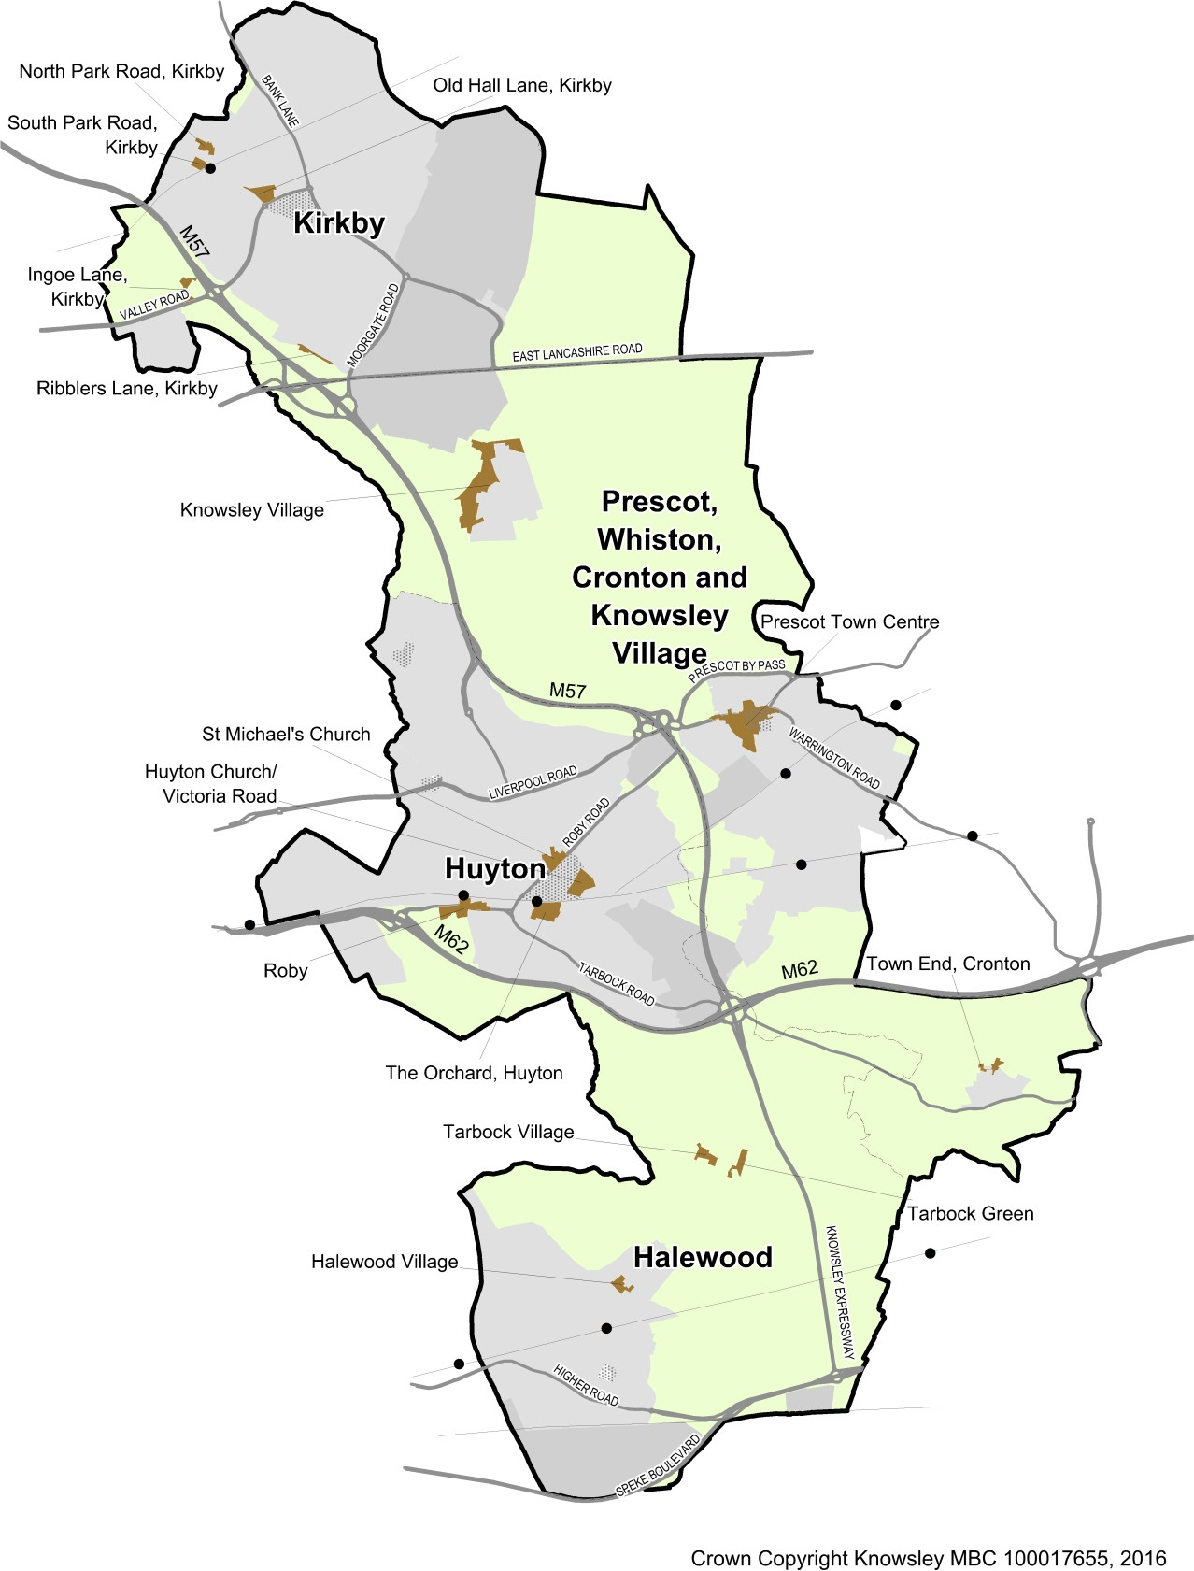
Source: Knowsley Council Conservation and Design Officer and Historic England
Figure 6: Conservation areas

EH3 – Access to parks and open spaces

  - The Knowsley Playing Pitch Strategy 2022 underpins Local Plan Policy CS8 (Green Infrastructure) and Policy CS21 (Greenspaces and Trees). The audit identified a total of 121 grass football pitches in Knowsley across 42 sites. Of these, 81 pitches are available for community use across 27 sites. A total of 259 teams were identified as playing within Knowsley. This consists of 37 men’s teams, two women’s teams, 91 youth boys’ teams, three youth girl’s teams and 126 mini football teams. Of the clubs which quantify their potential future demand, there is a predicted growth of 20 teams.

Table 24: Quantitative headline findings (overall position)
Sport | Pitch type | Current picture (2020/21) | Future demand (2028)
Football (grass pitches) | Adult | Spare capacity of 6 Match Equivalent Sessions (MES) | Spare capacity of 4.5 MES
Football (grass pitches) | Youth 11v11 | Shortfall of 2 MES | Shortfall of 3.5 MES
Football (grass pitches) | Youth 9v9 | Spare capacity of 2 MES | Shortfall of 1 MES
Football (grass pitches) | Mini 7v7 | Spare capacity of 3 MES | Spare capacity of 1 MES
Football (grass pitches) | Mini 5v5 | Spare capacity of 4.5 MES | Spare capacity of 2.5 MES
Football  (3G pitches) | Full size, w/sports lighting | All 3Gs known to be operating at near or at capacity midweek. | Future demand indicates a need for one additional full-size pitch in additional to 11.5 hours of use deriving from population increases.
Cricket | Senior | Spare capacity of 25 match sessions per season | Sufficient capacity to accommodate demand
Hockey | Full size, floodlit | No current demand | No future demand

  - The Council’s requirements for open space provision are set out in the Developer Contributions SPD, which was adopted in January 2016. The borough is divided into 38 ‘Substantial Residential Areas’ (SRAs), and for most public open space uses – parks and gardens, amenity greenspace, provision for children and young people, and allotments – each SRA is expected to be self-sufficient. Areas of the borough which are not largely residential are not included within SRAs.

  - Figure 7 below shows the total open space provision across the borough, while Figure 8 shows the level of provision across the four different typologies measured. This information is drawn from the Council’s 2015 Green Space audit, so is unchanged since the last monitoring report.

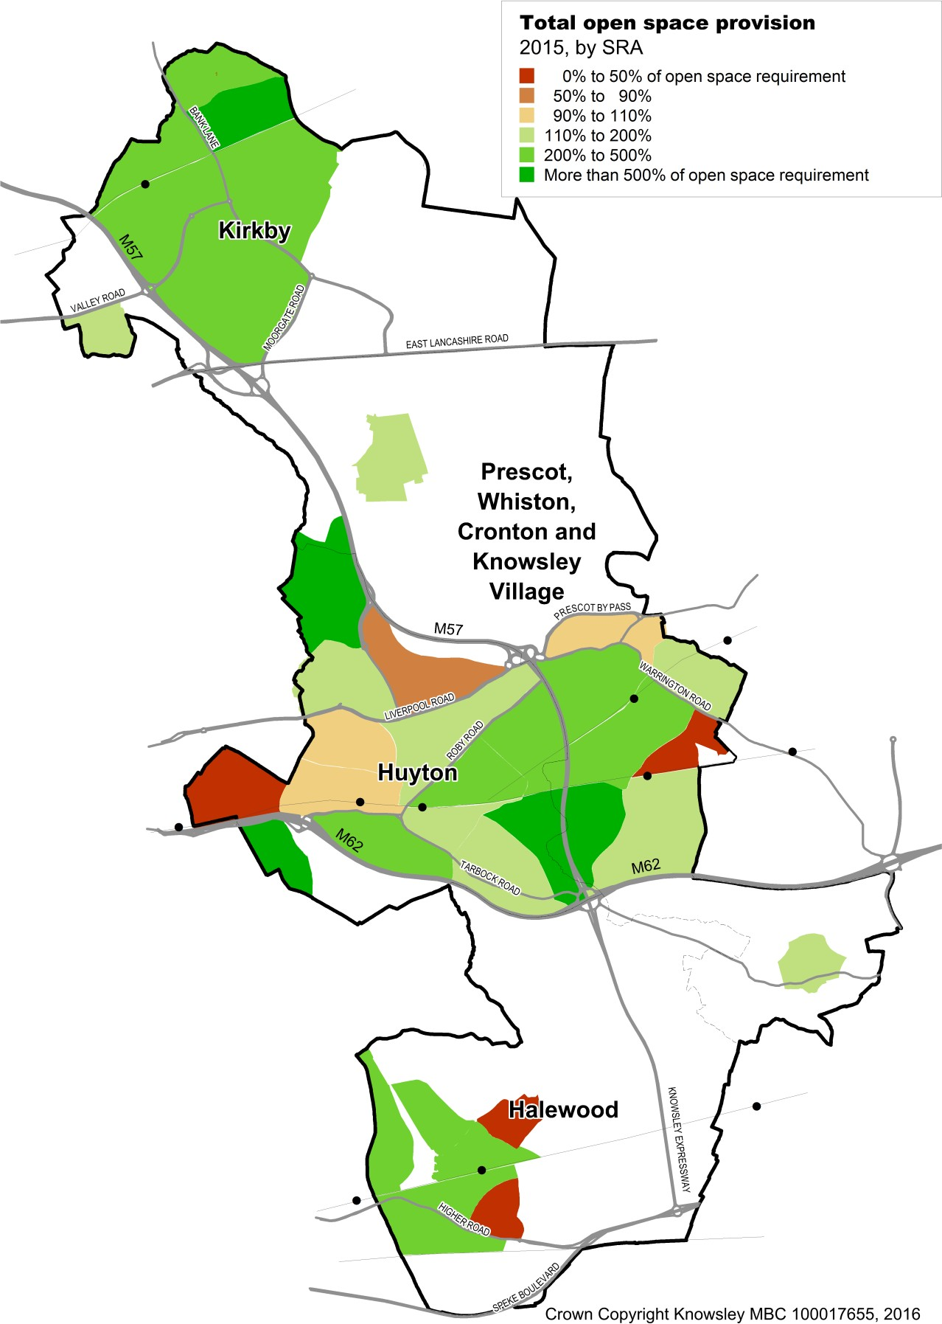

Figure 7: Total open space provision by SRA
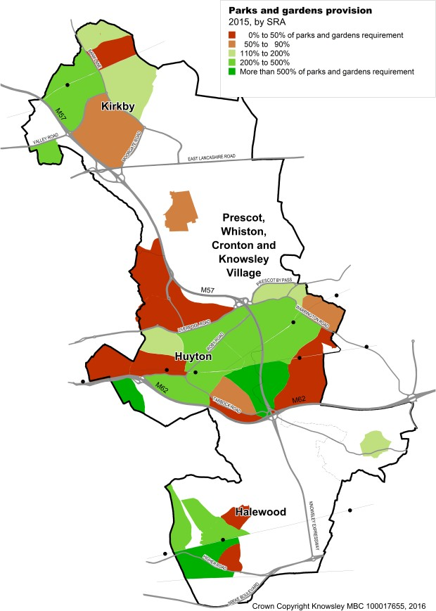
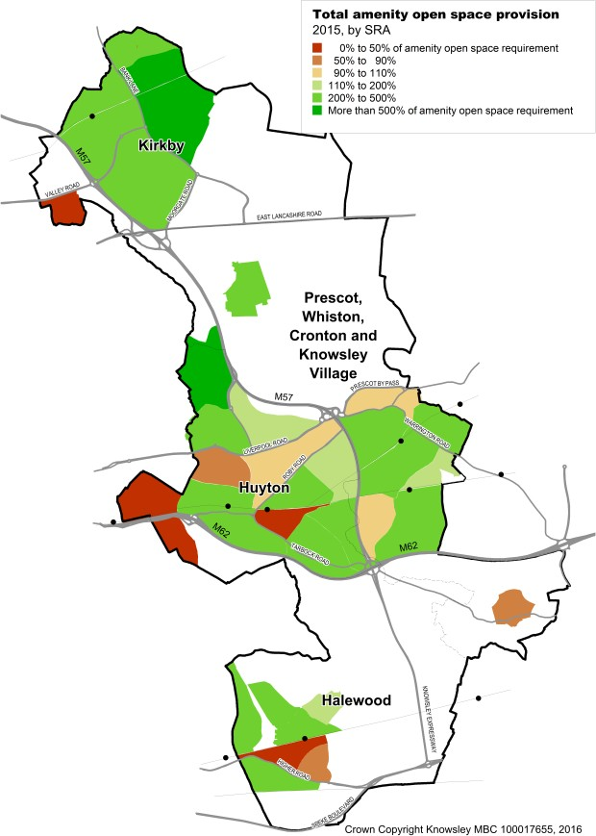
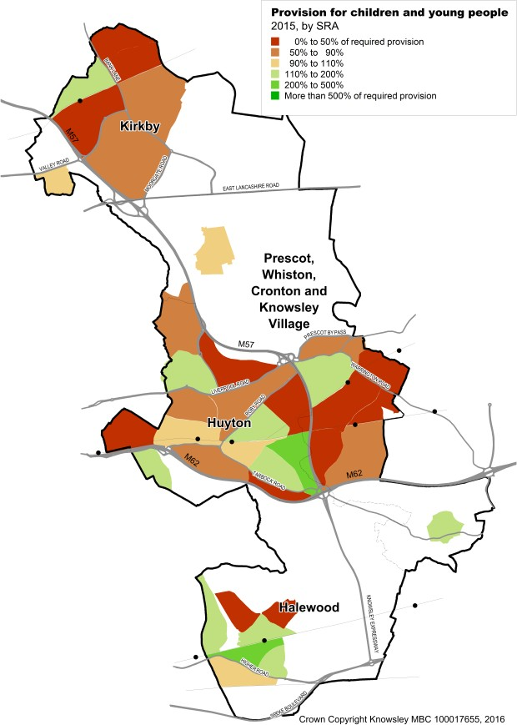
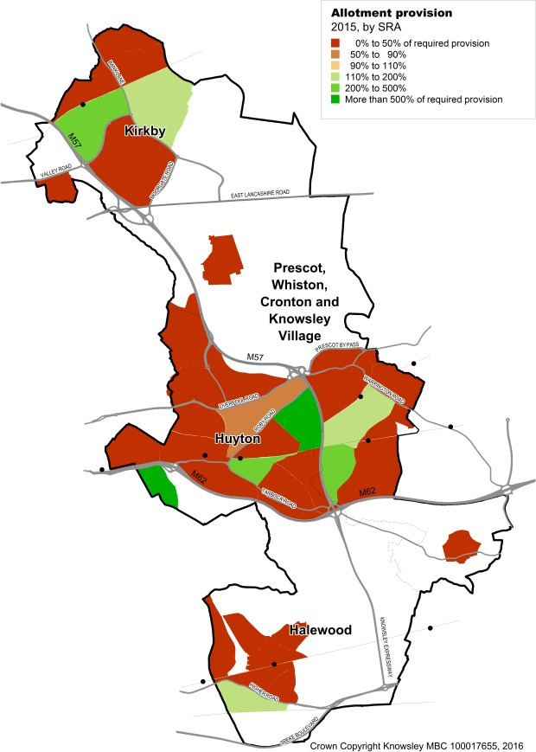
Figure 8: Open space provision – parks and gardens, amenity spaces, provision for children and young people, and allotments

EH4 – Quality of parks and open spaces

  - Launched in 1996 the Green Flag Award scheme is the UK’s benchmark national standard for parks and green spaces. There are 20 Knowsley parks with Green Flag award status in 2024-25. The most recent Green Flag Award was received for Bowring Park after being submitted in the year 2023/24. While the numbers have remained static in recent years, overall, there has been an increase of 12 parks from the beginning of the plan period with further submissions anticipated over the coming years.

  - Knowsley anticipate applying for Green Flag status for current development projects once they are complete, such as Finch Woods. For more information on the Green Flag Award scheme, see the website at www.greenflagaward.org.

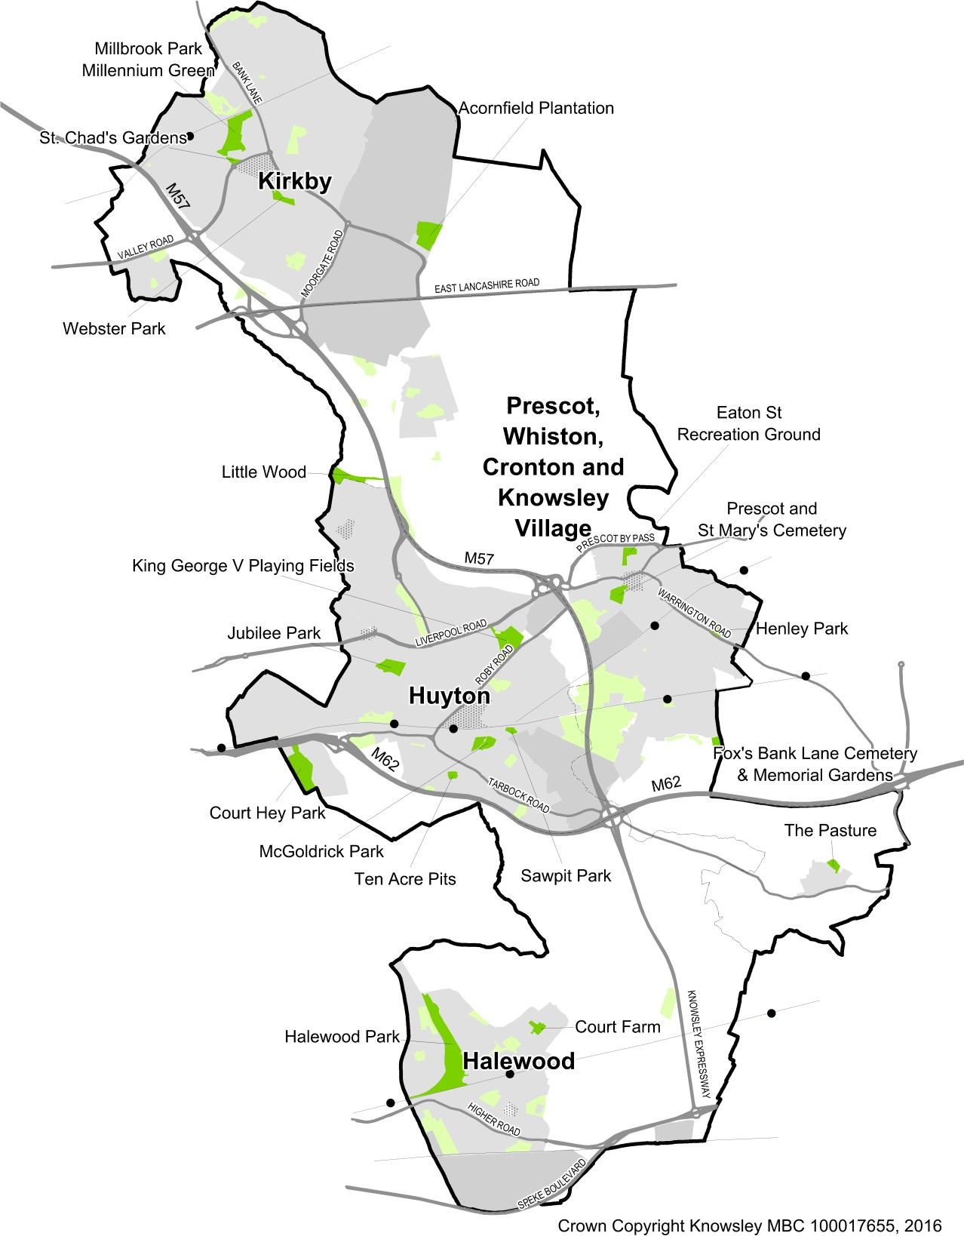
Figure 9: Knowsley's parks - Green Flag Award winners - Other parks shown light green and unlabelled

EH5 – Biodiversity

  - The number of sites with specific environmental designations in Knowsley remains the same as previous years at 65 local wildlife sites (LWS). Monitoring of the LWSs provides up-to-date information on the number of sites with active conservation management.

Table 25: Biodiversity sites - monitoring and management
Category | Current Monitoring Year
 | 2024-25
Sites of Special Scientific Interest | 0
Special Areas of Conservation | 0
Special Protection Areas | 0
RAMSAR sites | 0
Local wildlife sites | 65
% Where monitoring taking place | 12.0%
% Where conservation Management implemented | 50.0%
Local geological sites | 0
Local Nature Reserves | 0
Source: Merseyside Environmental Advisory Service

Part 2 Indicators Plan preparation and planning performance

- Knowsley’s Development Plan Development Plan Documents Knowsley Local Plan: Core Strategy
  - The Knowsley Local Plan Core Strategy was adopted by Knowsley Council on 6 January 2016 and is available on the Council’s website, along with its adoption Statement.

    - Knowsley Local Plan Core Strategy 2016
    - Knowsley Local Plan Core Strategy Adoption Statement

  - The Policies Map is also available on the Council’s website:

    - Knowsley Local Plan Policies Map

  - Some policies of the 2006 Knowsley Replacement Unitary Development Plan policies remain current and relevant because they are ‘saved’ and remain in use as part of the adopted Local Plan (see Appendix C of Local Plan Core Strategy).

  - The Merseyside and Halton Joint Waste Local Plan (adopted in 2013) also forms part of the development plan.

    - Merseyside and Halton Joint Waste Local Plan

  - The Local Plan and other development plan documents are used in making decisions on planning applications and guides investment and regeneration programmes within the Borough.

Other planning policies and guidance

Supplementary Planning Documents

  - Supplementary Planning Documents (SPDs) provide additional detail to the Local Plan policies, to provide guidance to developers and decision makers. During 2024 to 2025, no SPDs were adopted.

  - SPDs (as of publication date of this document) can be found on the Council’s website at Supplementary planning documents | Knowsley Council

Other Knowsley Council Documents
  - During 2024-25 support was provided to the Knowsley Highways Authority in their work on the draft Local Cycling and Walking Infrastructure Plan. This document was adopted in Autumn 2025, following the public consultation in Spring 2025.

Future planning policy documents

Statement of Community Involvement

  - The Statement of Community Involvement (SCI) sets out the Council’s approach to community and stakeholder involvement in planning matters. A SCI was previously adopted in April 2017. Following public consultation in November 2022, a new SCI was adopted in June 2023.

Local Development Scheme

  - As part of the Local Plan, the council must prepare a Local Development Scheme (LDS), which outlines the schedule for the plan's preparation. The LDS serves several crucial purposes:
- The LDS is an essential tool for ensuring that the Local Plan is developed in a transparent, efficient, and inclusive manner.
- By providing clear timelines and engaging with the public, the LDS helps to ensure that the Local Plan meets the needs of the Knowsley community.

  - An updated LDS for Knowsley is effective from the 1st of March 2025.

Liverpool City Region Combined Authority (LCRCA)

Statement of Cooperation on Local Planning

  - The Liverpool City Region Devolution Agreement established the need for the development of a Single Spatial Framework for the City Region relating to strategic land use planning. The Liverpool City Region Combined Authority lead the devising of the Framework.

  - The Liverpool City Region Spatial Planning Statement of Common Ground (‘‘the Statement’’) was adopted in October 2019. The Statement covers the Liverpool City Region’s six Local Authorities, plus West Lancashire district council. The Statement also builds on a range of earlier collaborative work across the city region, particularly the Statement of Cooperation.

  - The Statement was established in response to the National Planning Policy Framework (NPPF), requiring that strategic policymaking authorities ought to document agreement and cooperation on cross boundary strategic planning matters. In addition, the Statement directly responds to the Duty to Cooperate statutory requirement.

  - The Statement covers a variety of spatial planning matters within the city region, including:

- Housing Delivery
- Economic Land (Strategic B8 sites)
- Green Belt
- Environmental and Green Infrastructure
- Transport Planning
- Health and Wellbeing
- Digital Inclusion

  - For each, the Statement identifies the points of common ground already established, along with specifying the areas where the city region authorities will work together to address cross boundary strategic matters.

  - The Statement informs the policy matters being covered by the emerging Spatial Development Strategy (SDS) for the Liverpool City Region, which is a requirement of the Liverpool City Region Devolution Deal.

  - During 2024-25 support was provided to the Combined Authority in their work on the evidence base for the Liverpool City Region SDS.

  - The Combined Authority undertook a public consultation on a draft SDS between 24th November 2023 and February 16th, 2024.

Duty to Cooperate
  - Throughout 2024-25, the Council worked with neighbouring authorities and key stakeholders on strategic planning matters, as part of the `Duty to Cooperate` statutory required through the Localism Act 2011.

  - Responses were submitted to the following consultations from our neighbours and the LCRA during the year:

    - Liverpool City Region Spatial Development Strategy ‘Public Participation’ stage: Strategic Housing Employment Land Supply
    - St Helens Borough Council adopted SPDs:
    - Developer Contributions
    - Transport and Travel

  - Responses to the emerging waste local plans of non-neighbouring local authorities are provided on the Council’s behalf by Merseyside Environmental Advisory Services (MEAS). MEAS also respond on behalf of the six Waste Local Plan districts to requests from local authorities within England regarding waste planning matters, which are normally associated with the preparation of waste local plans and in particular waste capacity and waste movements in and out of the plan area.

  - During 2024-25 support was provided to the MEAS in their work on the evidence base for an assessment of the Merseyside and Halton Joint Waste Local Plan.

  - During 2024/25, MEAS began going through a process of updating and streamlining the joint annual Local Aggregate Assessment for Merseyside and Halton, Warrington, and Greater Manchester.

Planning applications – decisions and appeals
  - This section looks at how the Council deals with planning applications – both in terms of how quickly it processes applications and (using appeals as a proxy indicator) how well it determines applications.

PP1 – Planning Decisions performance

  - Targets are set nationally and locally for the speed of decision making on planning applications. For ‘minor’ applications the local target is to determine 70 percent of applications within eight weeks or an agreed extension (this is tougher than the national target of 65 percent). For ‘major’ applications, the target (local and national) is to determine 60 percent within 13 weeks on an agreed extension.
  - The number of minor applications received in 2024-25 increased in relation to previous year. The Council’s performance in determining these applications comfortably exceeded both the national and local target, with a performance of 96% of applications determined in time.

  - The number of major applications received in 2024-25 decreased from the previous year (from 33 to 27 with the Council’s performance, in their determination, being 96%, far exceeding the national and local targets for making decisions on major applications.

Table 26: Minor and major application statistics
 | Current Monitoring Year
 | 2024-25
Minor applications | 97
Determined within 8 weeks | 96%
Major applications | 27
Determined within 13 weeks | 96%
Source: Knowsley Council Development Management Monitoring System

PP2 – Planning Appeals performance

  - There are no local performance targets for planning appeals, although the Council’s approach on planning applications is to discuss and agree amendments with applicants for planning permission so that unacceptable development proposals can be made acceptable through the submission of amended plans and details. In this way the number of appeals is reduced; and in the few occasions where they are submitted the intent is that the decision taken is entirely defendable.

  - In the context of a small number of appeals submitted to Knowsley each year, a year-on-year comparison is of limited value because each appeal relates to a separate planning application and a different set of circumstances. However, if there was a significant increase in the number of appeals lost over several years, this would suggest that the Council needed to look closely at reviewing its decision-making processes or planning policies. Having said that, during 2024/25 only 3 appeals were determined and all of the original LPA decisions were upheld.

Table 27: Planning appeals statistics
 | Current Monitoring Year
 | 2024-25
Total appeals | 3
LPA decision upheld following appeal | 3
Percentage of LPA decisions upheld following appeal | 100%
Source: Knowsley Council Development Management Monitoring System

Developer contributions
  - This section provides information relating to the Council’s performance in securing and collecting ‘developer contributions’ from applicants for planning permission to make unacceptable development acceptable through providing essential infrastructure and services.

PP3 – Developer Contributions
  - The value of financial contributions secured (i.e., the amount which could be paid to the Council if all developments went ahead and made the maximum level of contributions set out in permissions) was £3,553,054.
  - The value of financial contributions collected (i.e., funds realised from developments going ahead and reaching the stage where payment of contributions is required) in 2024-2025 has decreased. The developer contributions secured from 13 new schemes for this period was £3,756,452.64. This does not include any monitoring fees set by Knowsley, to cover the costs of monitoring and reporting on the agreed developer contributions.
  - The number of applications making ‘in kind contributions is 2 and will potentially provide 64 new affordable homes.

Table 28: Contributions secured and collected
 | Current Monitoring Year
 | 2024-25
New applications making ‘in kind’ contributions | 2
New applications making financial contributions | 13
Value of new financial contributions secured | £3,553,054.34
Value of financial contributions collected | £3,756,452.64
Number of schemes where financial contributions reduced or removed | 1
Source: Knowsley Council Development Management Monitoring System

Appendices

Glossary
This glossary explains some of the terms used within this report; it is based on a more comprehensive version which can be found in Appendix A of the Local Plan: Core Strategy10.

Adoption

The confirmation by the Local Planning Authority that a planning policy document should be used to determine or guide (as appropriate) development decisions. This is usually publicised by legal notices in newspapers, with the adopted documents being made available for purchase and available to view on the Council’s website.

Affordable Housing

Social rented, affordable rented and intermediate housing for specified eligible households whose needs are not met by the market, and which seeks to meet the needs of current and future eligible households at a cost low enough for them to afford11.

Allocated Site/Site Allocation

Sites which are identified for a specific use e.g., housing on the Local Plan Policies Map.

Biodiversity

The variety of life in all forms (e.g., wildlife, plants etc).

Biodiversity Action Plan (BAP)

An overarching framework for habitat and species conservation, which works on the basis of partnership to identify local priorities and targets.

Brownfield Land/Previously Developed Land (PDL)

Land which is or was occupied by a permanent structure, including the curtilage of the developed land (although it should not be assumed that the whole of the curtilage should be developed) and any associated fixed surface infrastructure. This excludes: land that is or has been occupied by agricultural or forestry buildings; land that has been developed for minerals extraction or waste disposal by landfill purposes where provision for restoration has been made through development control procedures; land in built-up areas such as private residential gardens, parks, recreation grounds and allotments; and land that was previously-developed but where the remains of the permanent structure or fixed surface structure have blended into the landscape in the process of time.

10 Available online at https://localplanmaps.knowsley.gov.uk/documents/knowsley-local-plan- adopted-core-strategy.pdf
11 Refer to NPPF Glossary for the latest definition of affordable housing.

Community Area (CA)

A collection of Substantial Residential Areas (SRA) which relate to the largest settlements in Knowsley (Huyton, Kirkby, Prescot/Whiston and Halewood), which is used to calculate the surplus and deficits for outdoor sports facilities relative to adopted standards under Policy CS21. The size of the Community Areas reflects the fact that residents of the borough travel beyond SRA boundaries to visit such facilities. A map indicating boundaries of the CAs can be viewed in the Developer Contributions SPD.

Community Infrastructure Levy (CIL)

A levy allowing local authorities to raise funds from owners or developers of land undertaking new building projects in their area. The CIL must be collected through the preparation of a Charging Schedule, supported by a range of infrastructure planning and economic viability evidence. There is no CIL in Knowsley.

Comparison Goods/Convenience Goods

Comparison goods include clothing, shoes, household appliances, books, etc, where the customer can make a comparison between different retailers. This differs from convenience goods, which include everyday items such as food and drink.

Conservation Area

An area defined in the Planning (Listed Buildings and Conservation Areas) Act 1990 as ‘an area of special architectural and historic interest, the character or appearance of which it is desirable to preserve or enhance.’ Councils must publish a map showing the boundaries of these areas where extra planning controls apply and also produce a conservation area proposals statement.

Core Strategy

See entry for ‘Local Plan Core Strategy’.

Deliverable Site

To be considered deliverable for housing development, sites should:

- Be available now.
- Offer a suitable location for development now and contribute to the creation of sustainable, mixed communities; and
- Have a reasonable prospect that housing will be delivered on the site within five years.

Density

A measurement of how intensively land is occupied by built development. For housing, this is measured in dwellings per hectare (dpha).

Design and Access Statement

A document that explains the design concepts, implications and justification associated with a planning application. This includes how an applicant has carefully considered how everyone, including disabled people, older people and young children, will be able to use the development.

Developer Contribution

In-kind or financial contributions provided by developers to contribute to the cost of infrastructure and other items, in order that the development is acceptable in planning terms and accords with the policies in the Local Plan. This can take the form of a legal agreement or the operation of a tariff-based system for contributions. Legal agreements may take the form of a ‘planning obligation’, which is a legally enforceable obligation entered into under section 106 of the Town and Country Planning Act 1990, to mitigate the impacts of a development proposal.

Development Brief

A document that sets out detailed development principles for a development site.

Development Plan

Local Plans and Neighbourhood Plans, which have been adopted or made under powers in the Planning and Compulsory Purchase Act 2004, as amended by the Localism Act 2011.
The Knowsley Development Plan includes the Local Plan: Core Strategy; and the Merseyside and Halton Joint Waste Local Plan.

Development Plan Document (DPD)

Planning policy documents which carry the most weight in a Local Plan. Once prepared they have to be submitted to the Secretary of State at the Department for Levelling Up Housing and Communities. An independent planning inspector then examines them to make sure that they meet legislative, regulatory and national policy requirements.

Development Management

The process by which proposals for new development are assessed by the local planning authority. This is undertaken primarily through the determination of planning applications.

District Centre

A group of shops often containing at least one supermarket or superstore, and a range of non-retail services, such as banks, building societies and restaurants, as well as local public facilities such as a library.

Economic Viability Assessment

The assessment of a development scheme, in order that the level of financial viability can be established. Such assessments are undertaken by developers in advance of pursuing a scheme. This can be calculated from development costs, profit and land value, all of which are deducted from scheme value to work out a residual value (positive or negative) which indicates the viability of the scheme. A variety of methods are available. It can be used to inform policy positions, and on a scheme-by-scheme basis when planning applications are being assessed.

Evidence Base

The range of reports, studies, data, and surveys specifically collected and used to inform Local Plan preparation.

Extra Care Accommodation

Housing which offers self-contained accommodation together with communal facilities and where care and support services are provided from a team based on site.

Green Belt Land

Designated land – primarily open land – around built-up areas designed to limit urban sprawl and to define town and country areas. It is generally protected land with a strong presumption against development.

Green Infrastructure (GI)

A concept recognising the environmental, social, and economic, often multi-functional value of the network of natural environmental components and green and blue spaces that lies within and between towns and villages. In the same way that the transport infrastructure is made up of a network of roads, railways, and airports, etc. Green Infrastructure has its own physical components, including parks, rivers, street trees and moorland.

Greenfield Sites

Greenfield sites are land which is not previously developed and can include agricultural land in rural areas, but also undeveloped land within the urban area.

Index of Multiple Deprivation (IMD)

Published by Government and provides an overall measure of ‘deprivation’ across a range of indicators, against which social and economic conditions in one area can be compared to other areas in England.

Internationally Important Sites for Biodiversity

The Natura 2000 network of protected sites established under the EU Habitats Directive (92/43/EEC), comprising Special Areas of Conservation (SAC) designated in the UK and also incorporating Special Protection Areas (SPA) designated under the Birds Directive (2009/147/EC codified from 79/409/EEC). Ramsar sites are also included with European Sites within UK legislation.

Joint Employment Land and Premises Study (JELPS)

A study commissioned by Halton, Knowsley, Sefton, and West Lancashire districts to consider the supply and demand for land and premises for business and employment purposes. It forms a key part of the Local Plan evidence base.

Listed Buildings

Buildings or other built structures included in the statutory list of buildings of special architectural or historic interest of national significance. Listing decisions are made by the Secretary of State for Digital, Culture, Media and Sport and the listing system is administered by English Heritage.

Liverpool City Region (LCR)

The sub-regional area, including the authorities of Liverpool, Halton, Knowsley, Sefton, St. Helens and Wirral.

Local Development Orders (LDOs)

An Order made by a local planning authority (under the Town and Country Planning Act 1990) that grants planning permission for a specific development proposal or classes of development.

Local Development Scheme (LDS)

The business plan for production of the Local Plan. It identifies and describes the Development Plan Documents and when they will be produced. It covers a three-year period and is subject to updating following production of Monitoring Reports to check progress.

Local Nature Reserve (LNR)

A statutory designation made by local authorities (under the National Parks and Access to the Countryside Act 1949) relating to places with wildlife or geological features that are of special interest locally. LNRs are designated to support biodiversity and geodiversity and offer opportunities for people to learn about and enjoy the natural environment.

Local Plan (LP)

The plan for the future development of the local area, drawn up by the local planning authority in consultation with the community.

In Knowsley, this includes the Local Plan Core Strategy, accompanied by a Local Plan Policies Map. The Local Plan also includes the Saved Policies of the Knowsley Replacement Unitary Development Plan (2006).

Local Plan: Core Strategy (sometimes Knowsley Local Plan: Core Strategy) (LPCS or KLPCS)

A document which forms the central part of the Knowsley Local Plan and sets out the long-term spatial vision, objectives, and strategic policies for the borough. The Local Plan Core Strategy has the formal status of a Development Plan Document.Further information about the role and status of the Core Strategy is available in Chapter 1: Introduction.

Local Plan Site Allocations and Development Policies

Sets out a range of detailed planning policies which will assist in the development management process. The document can include a range of site allocations (e.g., for housing or employment uses), which can have the formal status of a Development Plan Document.

Local Transport Plan (LTP)

A plan which sets out sub-regional objectives, strategies, and policies for transport, detailing the schemes and initiatives that will be delivered, together with the performance indicators and targets used to monitor progress. The LTP covering Knowsley is that for the Merseyside area, which is prepared by the Liverpool City Region Combined Authority.

Local Wildlife Site (LWS)/Local Geological Site (LGS)

Previously known as Sites of Importance for Nature Conservation (SINC), or alternatively Site of Biological Interest (SBI)/Site of Geological Interest (SGI), these are areas of land with significant wildlife or geological value. Typically, they can comprise an area of woodland, grassland meadows or a local water body.

Localism Act

Enacted in late 2011, the Act contains a wide range of legislative changes, including many affecting local authorities and local spatial planning. The Act introduced the legislative basis for: the abolition of Regional Strategies; a new ‘duty to co-operate’; changes to the Community Infrastructure Levy (CIL) system; and neighbourhood planning. Further details are available on the DCLG website.

Locally Listed Buildings

Buildings designated by the local planning authority to be of local historic and/or architectural significance and included in a local list. Although they are not statutorily protected, scrutiny will be given to any development affecting them.

Main Town Centre Uses

Retail development (including warehouse clubs and factory outlet centres), leisure, entertainment facilities, intensive sport and recreation uses (including cinemas, restaurants, drive-through restaurants, bars and pubs, night-clubs, casinos, health and fitness centres, indoor bowling centres, and bingo halls), offices, and arts, culture and tourism development (including theatres, museums, galleries and concert halls, hotels and conference facilities).

Merseyside and Halton Joint Waste Local Plan

Prepared jointly on behalf of six local authorities, this plan sets out waste management policies for the sub-region. The policies include site allocations and development management policies. This document is adopted and forms part of the Development Plan for each local authority in Merseyside and Halton.

Mineral Safeguarding Area

An area designated by Minerals Planning Authorities which covers known deposits of minerals which are proposed to be safeguarded from unnecessary sterilisation by non- mineral development.

Ministry of Housing, Communities and Local Government

The Ministry of Housing, Communities and Local Government (MHCLG) is a ministerial department of the Government of the United Kingdom. It is responsible for housing, communities, and local government in England.

Monitoring Report (MR)

Previously known as the Annual Monitoring Report, this assesses the implementation of the Local Development Scheme and the extent to which planning policies are being implemented. It includes contextual information relating to a variety of factors, which help to measure the effectiveness of the planning policies adopted by the Council, with reference to the Local Plan Monitoring Framework. Knowsley Council expects to publish a Monitoring Report at least annually, every December, covering the previous financial year.

National Planning Policy Framework (NPPF)

Introduced by the Government in 2012, this replaced the majority of adopted national planning policy, including most Planning Policy Statements and Planning Policy Guidance notes. The NPPF is supplemented by remaining guidance, and other policy statements. The NPPF sets out national priorities for delivering sustainable development and economic growth, including a very wide range of policies and guidance, relating to

themes such as housing, environment and economy, and procedural matters (such as plan-making and decision-taking). The policies of the NPPF will be applied alongside those in Knowsley's Local Plan. Further information is available on the Department for Levelling Up, Housing & Communities website.

Nationally Important Sites for Biodiversity

These include protected site designations such as Areas of Outstanding Natural Beauty (AONBs), Local Nature Reserves (LNRs), Marine Conservation Zones (MCZs), National Nature Reserves (NNRs), Ramsar sites and Sites of Special Scientific Interest (SSSIs).

Neighbourhood Plan

A plan prepared by a parish council or neighbourhood forum for a particular neighbourhood (made under the Planning and Compulsory Purchase Act 2004 as amended by the Localism Act 2011). A neighbourhood plan would, once made, comprise part of the statutory Development Plan for the area. It would therefore, alongside any adopted Local Plan documents, need to be considered when assessing any development proposals affecting the area.

Outdoor Sports Provision

A term which includes grass playing pitches (public and privately owned), artificial playing pitches, golf courses, bowling greens, tennis courts, and any land which may be currently vacant but that has been in sports use within the previous five years.

Plan Period

Refers to the period of operation for a Local Plan. For the Knowsley Local Plan, this is from 2010–11 to 2027–28.

Planning and Compulsory Purchase Act 2004

This Act made provision relating to spatial development and town and country planning, and the compulsory acquisition of land. It introduced the Local Development Framework (LDF) system for planning policy and remains the main legislative basis for production of Local Plans.

Planning Condition

A condition imposed on a grant of planning permission (in accordance with the Town and Country Planning Act 1990) or a condition included in a Local Development Order or Neighbourhood Development Order.

Previously Developed Land (PDL)

See entry for ‘Brownfield Land’.

Principal Regeneration Area (PRA)

A location identified by the Council as having the greatest need and opportunity for comprehensive change through major new development during the period of the Local Plan.

Public Realm

The space between and surrounding buildings and open spaces that are accessible to the public and including streets, pedestrianised areas, squares, and river frontages.

Renewable and low carbon energy

Includes energy for heating and cooling as well as generating electricity. Renewable energy covers those energy flows that occur naturally and repeatedly in the environment – from the wind, the fall of water, the movement of the oceans, the sun and from biomass and deep geothermal heat. Low carbon technologies are those that can help reduce emissions (compared to conventional use of fossil fuels).

Safeguarded Land

Comprises areas and sites which may be required to serve development needs in the longer term, i.e., beyond the end of the plan period (post 2028). Safeguarded land should be genuinely capable of development when needed and be where future development would be an efficient use of land, well integrated with existing development.

Scheduled Monument

A nationally important historic building or structure or archaeological site, given protection against detrimental and unauthorised change. When designated, Scheduled Monuments are added to the schedule (which has been kept since 1882) of monuments whose preservation is given priority over other land uses. Scheduled Monuments are also sometimes referred to as ‘Scheduled Ancient Monuments’.

Shared Ownership

An arrangement where the ownership of a property is shared, usually between a registered social landlord and a private purchaser.

Special Areas of Conservation (SAC)

Protected sites designated under the EU Habitats Directive (92/43/EEC).

Special Protection Areas (SPA)

Protected sites designated under the Birds Directive (2009/147/EC codified from 79/409/EEC).

Statement of Community Involvement (SCI)

Sets out how the Council will consult and engage with the community and others in the production of all documents within the Local Plan, and when determining planning applications.

Strategic Environmental Assessment (SEA)

European Directive 2001/42/EC (the SEA Directive) requires a formal environmental assessment of certain plans and programmes which are likely to have ‘significant effects’.

on the environment, known as Strategic Environmental Assessment. To meet the requirements of the directive, a body must prepare an environmental report in which the likely significant effects on the environment of implementing the plan or programme, and reasonable alternatives, considering the objectives and geographical scope of the plan, are identified, described, and evaluated. For the Knowsley Local Plan, this is incorporated in the Sustainability Appraisal.

Strategic Flood Risk Assessment (SFRA)

A document which is normally produced by a local planning authority in consultation with the Environment Agency, and which forms the basis for preparing appropriate policies for flood risk management at the local level.

Strategic Housing Land Availability Assessment (SHLAA)

A systematic assessment of the availability of land which is developable and deliverable for new housing within an area. The assessment includes a ‘Call for Sites’ where the public can promote sites as being suitable for housing development and an appraisal of deliverability by a panel of developers and registered social landlords active in the local market.

Strategic Housing Market Assessment (SHMA)

A study across an identified largely ‘self-contained’ housing market to assess how the market operates and is likely to operate in the future. A SHMA assesses past, current and future trends in housing type and tenure, household size, and housing need, and of the housing needs of specific groups with particular requirements.

Substantial Residential Area (SRA)

A residential area that should, to provide a satisfactory residential environment, be self-sufficient in public open space. The overall proportion of open space within these areas is measured as a surplus or deficit relative to population in accordance with adopted standards. Maps defining the existing boundaries of the SRAs will be set out in the Developer Contributions SPD.

Supplementary Planning Document (SPD)

A planning policy document which provides supplementary information in respect of the policies contained in the Local Plan, and which focus on particular issues or places. They are subject to consultation but are not subject to an independent examination.

Sustainability Appraisal (SA)

An assessment of the economic, environmental, and social effects of a plan from the outset of the preparation process to allow decisions to be made that accord with sustainable development. For the Knowsley Local Plan, this covers the requirements of Strategic Environmental Assessment.

Sustainable Drainage Systems (SuDS)

These systems provide an alternative to the traditional methods of dealing with water drainage, aiming to mimic the natural movement of water from a development, slowing run-off, reducing flood risk, improving water quality, and potentially providing attractive features.

Sustainable Urban Extensions (SUEs)

Sites which have been removed from the green belt to accommodate Knowsley’s needs for new housing and employment development up to 2028 and beyond. Sustainable Urban Extensions are areas which are capable of development when needed and to provide for an efficient use of infrastructure and land which is well integrated with existing development.

Transport Assessment (TA)

A comprehensive and systematic process that sets out transport issues relating to a proposed development. It identifies what measures will be required to improve accessibility and safety for all modes of travel, particularly for alternatives to the car such as walking, cycling and public transport and what measures will need to be taken to deal with the anticipated transport impacts of the development.

Travel Plan

A long-term management strategy for an organisation or site that seeks to deliver sustainable transport objectives through action which is articulated in a document that is regularly reviewed.

Use Classes Order

The Town and Country Planning (Use Classes) Order 1987 and subsequent amendments, group a number of land uses into categories or ‘Use Classes’. Changes of use within the same Use Class or between certain different Use Classes as set out in the General Permitted Development Order (GPDO) are normally deemed to have consent and do not in most cases require specific planning permission.

Vitality and Viability (Town Centres)

Terms used to assess the health of a town centre or other centre as measured by several indicators, such as the overall floorspace for retail and leisure, diversity of uses, range of goods that are sold, retailer representation, expenditure retention, rental values, level of vacancies, pedestrian ‘footfall’ figures, etc.

Waste Hierarchy

A framework that has become a cornerstone of sustainable waste management, setting out the order in which options for waste management should be considered based on environmental impact.

Indicators used in this report
The tables below show the indicators now being used, as well as how they relate to those used in reports up to and including the 2014-15 year.

For some of the indicators we have not been able to include the full range of analysis proposed, this information is indicated in light italic type in the following tables.

Economy and Employment

E1 | Employment land available
Measure | Land available or allocated for employment uses (ha)
Spatial | District  Principal Regeneration Area
Time | Total (plan period)  Risk assessed available in next five years
Other breakdown | Type (allocation or source of supply – current MI4)  Percentage of total which is previously developed land
Pre-2015 indicators | MI4, MI38, MI46

E2 | Employment land lost
Measure | Employment land lost (ha)
Spatial | District
Time | Last five years  Plan period
Other breakdown | Reason for loss
Pre-2015 indicator | MI6

E3 | Employment land developed
Measure | Land developed for employment use (ha)
Spatial | District  Principal Regeneration Area
Time | Last five years  Plan period
Other breakdown | Use class  Percentage of total on previously developed land
Pre-2015 indicators | MI1, MI3, MI39, MI44

E4 | Employment floorspace developed
Measure | Floorspace developed for employment use (m2)
Spatial | District  Principal Regeneration Area
Time | Last five years  Plan period
Other breakdown | Use class
Pre-2015 indicators | MI2, MI45

Housing

H1 | Housing land available12
Measure | Capacity of land available for housing development (units)
Spatial | District  Principal Regeneration Area
Time | Plan period  Next five years
Other breakdown | Percentage of total which is previously developed land
Pre-2015 indicators | MI30, MI31, MI38

H2 | Sites for Gypsies & Travellers and Travelling Showpeople
Measure | Pitches with consent (units)
Spatial | District
Time | Last year  Plan period
Other breakdown | Gypsy & Traveller pitches  Travelling Showpeople yards
Pre-2015 indicator | MI29

12 More detail on housing land availability can be found in the Council’s Strategic Housing Land Availability Assessment (SHLAA), the latest version of which is available online via https://www.knowsley.gov.uk/residents/building-and-planning/planning-policy/shlaa-(strategic-housing-land-availability-assessm

H3 | Housing land lost
Measure | Capacity of housing land lost (units)
Spatial | District
Time | Last five years  Plan period
Other breakdown | Reason for loss
Pre-2015 indicator | MI32

H4 | Homes lost
Measure | Homes demolished or lost to change of use (units)
Spatial | District
Time | Last five years  Plan period
Other breakdown | Reason for loss
Pre-2015 indicator | MI19

H5 | Empty homes
Measure | Number of homes empty (units)
Spatial | District
Time | Last five years  Plan period
Other breakdown | Tenure (partial data only) Length of time empty  Units brought back into use by council or partners
Pre-2015 indicators | MI26, MI27

H6 | Housing completions
Measure | Number of new homes completed (units)
Spatial | District  Principal Regeneration Area Township
Time | Last five years  Plan period
Other breakdown | Percentage of total on previously developed land  Affordable units
Pre-2015 indicators | MI18, MI21, MI23, MI24, MI39, MI42

H7 | Housing change
Measure | Net housing completions
Spatial | District  Principal Regeneration Area Township
Time | Last five years  Plan period
Other breakdown | None
Pre-2015 indicators | MI19, MI20

Retail and Town Centres

R1 | Retail planning permissions
Measure | Retail floorspace planning permissions granted (m2)
Spatial | District  Centre  Type of centre
Time | Last five years
Other breakdown | Use class  Convenience–comparison
Pre-2015 indicator | New

R2 | Retail completions
Measure | Retail floorspace completed (m2)
Spatial | District  Centre  Type of centre
Time | Last five years
Other breakdown | Use class  Convenience–comparison breakdown
Pre-2015 indicators | MI49, MI55

R3 | Vacant shop units
Measure | Number of vacant shop units within Town Centres
Spatial | Centre  District
Time | 2021-22 only due to Use Class changes  Last year  Last five years (once monitoring re-established)
Other breakdown | None
Pre-2015 indicators | MI50, MI56

TC1 | Town Centres sub-report
Measure | Retail, employment and service development within town centres
Spatial | Centre
Time | Last year
Other breakdown | Footfall  Spend
Pre-2015 indicators | MI49, MI51, MI53, MI54, MI55, MI56, MI57, MI58

Environment and Heritage

EH1 | Listed buildings
Measure | Number of listed buildings
Spatial | District
Time | Snapshot  Change since previous year
Other breakdown | Grade  Buildings at risk
Pre-2015 indicator | MI60

EH2 | Conservation
Measure | Conservation areas
Spatial | District
Time | Snapshot
Other breakdown | Appraisal update  Management plan update Conservation areas at risk
Pre-2015 indicator | MI61

EH3 | Access to parks and open spaces
Measure | Provision of parks and open spaces  Outdoor sports provision
Spatial | Township  Substantial Residential Area
Time | Snapshot
Other breakdown | Open space type
Pre-2015 indicators | MI86, MI87

EH4 | Quality of parks and open spaces
Measure | Green Flag awards
Spatial | District
Time | Last five years
Other breakdown | None
Pre-2015 indicators | MI88, MI89

EH5 | Biodiversity
Measure | Sites with specific environmental designations
Spatial | District
Time | Last five years
Other breakdown | Sites where active monitoring and management is taking place
Pre-2015 indicators | MI93, MI95, MI96

Planning performance

PP1 | Planning decision performance
Measure | Planning applications determined within target timescales
Spatial | District
Time | Last five years
Other breakdown | Minor applications  Major applications
Pre-2015 indicator | MI111

PP2 | Planning appeals
Measure | Planning appeals upheld
Spatial | District
Time | Last five years
Other breakdown | None
Pre-2015 indicator | MI112

PP3 | Developer contributions
Measure | Developer contributions (cash and ‘in kind’) secured and collected
Spatial | District
Time | Last five years
Other breakdown | Number of schemes  Contributions for open space secured and collected Developer contributions reduced or removed
Pre-2015 indicators | MI91, MI113

The indicators in this Monitoring Report link to the Core Strategy objectives as follows:

Monitoring Report indicator |  | Core Strategy objective | Sustainable economic and employment growth | A well-balanced housing market | Regeneration and transformation | Distinctive, viable and sustainable town centres | Quality of place | Sustainable transport | Managed environmental resources | Green infrastructure and rural areas | Promoting health and wellbeing in Knowsley
E1 | Employment land available |  | ● |  | ●
E2 | Employment land lost |  | ● |  | ●
E3 | Employment land developed |  | ● |  | ●
E4 | Employment floorspace developed |  | ● |  | ●
H1 | Housing land available |  | ● | ● | ● |  | ●
H2 | Sites for Gypsies & Travellers and Travelling Showpeople |  |  | ● |  |  |  |  |  |  | ●
H3 | Housing land lost |  | ● | ● | ● |  | ●

Monitoring Report indicator |  | Core Strategy objective | Sustainable economic and employment growth | A well-balanced housing market | Regeneration and transformation | Distinctive, viable and sustainable town centres | Quality of place | Sustainable transport | Managed environmental resources | Green infrastructure and rural areas | Promoting health and wellbeing in Knowsley
H4 | Homes lost |  |  |  | ● |  | ●
H5 | Empty homes |  |  | ● | ● |  | ● |  |  |  | ●
H6 | Housing completions |  | ● | ● | ● | ● | ●
H7 | Housing change |  | ● | ● | ● | ● | ●
R1 | Retail planning permissions |  | ● |  | ● | ● | ●
R2 | Retail floorspace completed |  | ● |  | ● | ● | ●
R3 | Vacant shop units |  | ● |  | ● | ● | ●
TC1 | Town Centres report |  | ● | ● | ● | ● | ● | ● |  |  | ●
EH1 | Listed buildings |  |  |  |  | ● | ● |  | ●
EH2 | Conservation |  |  |  |  | ● | ● |  | ●
EH3 | Access to parks and open spaces |  |  |  |  |  | ● | ● | ● | ● | ●
EH4 | Quality of parks and open spaces |  |  |  |  |  | ● |  | ● | ● | ●
EH5 | Biodiversity |  |  |  |  |  | ● |  | ● | ● | ●
PP1 | Planning decision performance |  | ● |  | ●
PP2 | Planning appeals |  | ● |  | ●
PP3 | Developer contributions |  | ● |  | ● |  | ● | ● | ● | ● | ●

Data sources for indicators no longer included in the Monitoring Report

 | Measure | Alternative data source
MI5 | Surplus/deficit of deliverable employment land within five years relative to employment requirement | None.
MI7 | Total number of active businesses | ONS Business Activity, Size and Location dataset:  www.ons.gov.uk/businessindustryandtrade  /business/activitysizeandlocation
MI8 | Business density | Can be calculated from MI7 and ONS Mid- Year Population Estimates:  www.ons.gov.uk/peoplepopulationandcom munity/populationandmigration/population estimates/datasets/populationestimatesfor ukenglandandwalesscotlandandnorthernir eland
MI9 | Number of – new businesses in the borough, business births, deaths and survival per annum | ONS Business Demography dataset:  www.ons.gov.uk/businessindustryandtrade  /business/activitysizeandlocation/datasets/ businessdemographyreferencetable
MI10 | Planning Permission granted for business in rural areas, tourism facilities/businesses | Planning applications and decisions available on Knowsley Council website:  http://www.knowsley.gov.uk/residents/build ing-and-planning/view-planning- applications
MI11 | Percentage of Knowsley residents by employment sector | ONS Business Register and Employment Survey13:  www.ons.gov.uk/employmentandlabourma rket/peopleinwork/employmentandemploye etypes/bulletins/businessregisterandemplo ymentsurveybresprovisionalresults/previou sReleases
MI12 | Total employee jobs in Knowsley by occupation and annual change | ONS Annual Population Survey – Workplace Analysis available via NOMIS website:  www.nomisweb.co.uk
MI13 | Average job density | Can be calculated from ONS Annual Population Survey available via NOMIS website:  www.nomisweb.co.uk

13 Note that this dataset provides information for jobs within Knowsley, rather than Knowsley residents.

 | Measure | Alternative data source
MI14 | Number of – Knowsley residents in employment, commuter flows to/from neighbouring districts | ONS Location of usual residence and place of work by method of travel to work dataset available via NOMIS website (data from 2011 Census):  www.nomisweb.co.uk
MI15 | Number of Knowsley residents claiming job seekers allowance for – 6 months or more, 12 months or more | ONS Jobseeker's Allowance by age and duration dataset available via NOMIS website:  www.nomisweb.co.uk
MI16 | Economically active people on out of work benefits | Department for Work and Pensions Working Age Client Group dataset:  http://tabulation- tool.dwp.gov.uk/NESS/WACG/wacg.htm
MI17 | Average (median) gross weekly earnings of Knowsley residents for full and part time employment | ONS Annual Population Survey available via NOMIS website:  www.nomisweb.co.uk
MI25 | Average density of new dwellings completed | Can be calculated from planning application information available on Knowsley Council website:  http://www.knowsley.gov.uk/residents/build ing-and-planning/view-planning- applications
MI28 | Gross additional specialist and/or supported housing units | None identified
MI33 | Tenure of existing housing stock | Department for Communities and Local Government live tables on dwelling stock (see Table 100):  https://www.gov.uk/government/statistical- data-sets/live-tables-on-dwelling-stock- including-vacants
MI34 | Choice based lettings demands in Knowsley (Property Pool Plus) | None.
MI35 | Persons in Knowsley registered as statutory homeless | None.
MI36 | Housing affordability: average entry level house (i.e., lower quartile value) vs.  Average lower quartile pay for a full-time worker | Department for Communities and Local Government Live Tables on housing market and house prices (see Table 576):  https://www.gov.uk/government/statistical- data-sets/live-tables-on-housing-market- and-house-prices
MI37 | Households in fuel poverty | Department for Business, Energy & Industrial Strategy fuel poverty statistics (figures only available broken down to regional level) available online:  https://www.gov.uk/government/collections  /fuel-poverty-statistics

 | Measure | Alternative data source
MI40 | Completion of schemes in Principal Regeneration Areas public realm | None.
MI47 | Total Combined Heat and Power (CHP) energy generation capacity per annum within Knowsley Industrial and Business Parks | None readily available.
MI52 | Progress of Sewell Street redevelopment, Prescot Town Centre | ‘Town Centres Review’ section of future monitoring reports.
MI59 | Performance against design standards, new homes meeting Buildings for Life criteria, new homes meeting Lifetime Homes standards. | None readily available.
MI62 | Number of Historic Parks and Gardens, Historic Parks and Gardens on the Heritage at Risk Register | Historic England ‘Heritage at Risk’ register available online:  https://historicengland.org.uk/advice/herita ge-at-risk/
MI63 | Number of designated Ancient Monuments | Information available via Historic England’s listings search online:  https://historicengland.org.uk/listing/the- list/
MI64 | Delivery of transport schemes in Knowsley  – delivered by Local Transport fund, delivered by grants/external funds, delivered by specific programmes, delivered by developer contributions (financial and in kind) | Data in Local Transport Plan annual progress reports available online at Merseytravel’s website:  http://www.merseytravel.gov.uk/about- us/local-transport- delivery/Pages/MTP.aspx
MI65 | Increase in the length of well-connected walking and cycling routes | None.
MI66 | Estimated transport emissions | Available via Department for Business, Energy and Industrial Strategy ‘UK local authority and regional carbon dioxide emissions national statistics’ online:  https://www.gov.uk/government/collections  /uk-local-authority-and-regional-carbon- dioxide-emissions-national-statistics
MI67 | Travel to work modal shares | ONS Census data – 2011 latest available online:  http://webarchive.nationalarchives.gov.uk/ 20160105160709/http://www.ons.gov.uk/o ns/publications/re-reference-  tables.html?edition=tcm%3A77-295663

 | Measure | Alternative data source
MI68 | Vehicle ownership | ONS Census data – Key Statistics for England and Wales – available online:  http://www.ons.gov.uk/peoplepopulationan dcommunity/populationandmigration/popul ationestimates/bulletins/2011censuskeysta tisticsforenglandandwales/2012-12- 11/relateddata
MI69 | Public transport patronage in Merseyside | Data in Local Transport Plan annual progress reports available online at Merseytravel’s website:  http://www.merseytravel.gov.uk/about- us/local-transport- delivery/Pages/MTP.aspx
MI70 | Households with good transport access to key services or work by local authority | Department for Transport journey time statistics available online:  https://www.gov.uk/government/collections  /journey-time-statistics
MI71 | Production of primary land won aggregates | None14.
MI72 | Protection of secondary and recycled aggregates by mineral planning authority | None.
MI73 | Minerals Safeguarding Areas | None.
MI74 | Mineral site restoration | None15.
MI75 | Number of planning permissions granted contrary to Environment Agency advice on flooding and water grounds | No prepared data available, but planning applications and permissions available for online viewing at Knowsley Council website:  http://www.knowsley.gov.uk/residents/build ing-and-planning/view-planning- applications
MI76 | Number of Sustainable Drainage Systems (SUDS) | None.
MI77 | Area of land in – Flood Zone 2, Flood Zone 3 | Flood maps available on Environment Agency website:  http://maps.environment-agency.gov.uk/

14 The figure for this indicator was zero for the last few years, and there are no aggregate mineral resources within Knowsley considered likely to be of commercial interest in the foreseeable future.

 | Measure | Alternative data source
MI78 | Per capita CO2 emissions in Knowsley | Available via Department for Business, Energy and Industrial Strategy ‘UK local authority and regional carbon dioxide emissions national statistics’ online:  https://www.gov.uk/government/collections  /uk-local-authority-and-regional-carbon- dioxide-emissions-national-statistics
MI79 | Renewable energy generation | Data available on OFGEM Feed-in Tariff Installation Reports:  https://www.ofgem.gov.uk/environmental- programmes/fit/contacts-guidance-and- resources/public-reports-and-data- fit/installation-reports
MI80 | Number of applications approved with contributions towards Allowable Solutions, including the Community Energy Fund | None.
MI81 | Planning Permission for decentralised, renewable and low carbon energy | No prepared data available, but planning applications and permissions available for online viewing at Knowsley Council website:  http://www.knowsley.gov.uk/residents/build ing-and-planning/view-planning- applications
MI82 | Number, total area of and population living within Air Quality Management Areas (AQMAs) | There are no AQMAs within Knowsley at the moment. Information about AQMAs, including an up-to-date list of designated areas, is available of the Department for Environment, Food and Rural Affairs website:  https://uk-air.defra.gov.uk/aqma/
MI83 | Number of noise complaints upheld by the Council | None.
MI84 | River water quality – biological, chemical | Environment Agency data available online:  http://environment.data.gov.uk/catchment- planning/RiverBasinDistrict/12
MI85 | See Indicators within the Merseyside and Halton Joint Waste Local Plan | Merseyside and Halton Joint Waste Local Plan monitoring reports available online at Merseyside Environmental Advisory Service website:  http://www.meas.org.uk/1090
MI90 | Resident satisfaction with parks and open spaces | No prepared data available, but some further information in Knowsley’s Green Space Strategy available online:  http://www.knowsley.gov.uk/pdf/3960.14_g reen_space_stratgy_PROOF_3_november  14.pdf

 | Measure | Alternative data source
MI92 | Number and location of Local Green Spaces designated | None.
MI97 | Population who live in Lower Super Output Areas (LSOAs) ranked in the upper ten percent most deprived nationally. | English Indices of Deprivation (Index of Multiple Deprivation) data available online:  https://www.gov.uk/government/collections  /english-indices-of-deprivation
MI98 | Life expectancy – all residents | ONS life expectancy data and analysis available online:  https://www.ons.gov.uk/peoplepopulationa ndcommunity/birthsdeathsandmarriages/lif eexpectancies
MI99 | Healthy life expectancy | ONS healthy life expectancy data available online:  https://www.ons.gov.uk/peoplepopulationa ndcommunity/healthandsocialcare/healtha ndlifeexpectancies/datasets/healthylifeexp ectancyhleandlifeexpectancyleatage65byu ppertierlocalauthorityutlaengland
MI100 | Difference in life expectancy and healthy life expectancy between communities | None.
MI101 | Percentage of children living in poverty under 16 years of age | Data available at HM Revenue and Customs website (children in low-income families local measure):  https://www.gov.uk/government/collections  /personal-tax-credits-statistics
MI102 | Average household income | ONS regional gross disposable household income data available online:  https://www.ons.gov.uk/economy/regionala ccounts/grossdisposablehouseholdincome  /datasets/regionalgrossdisposablehouseho ldincomegdhi
MI103 | Pupils at the end of KS4 achieving 5 or more A*–Cs including English and Maths | Department for Education GCSEs (key stage 4) statistics available online:  https://www.gov.uk/government/collections  /statistics-gcses-key-stage-4
MI104 | 16–18 year olds not in education, employment or training (NEET) | Department for Education NEET data by local authority available online:  https://www.gov.uk/government/publication s/neet-data-by-local-authority-2012-16-to- 18-year-olds-not-in-education- employment-or-training
MI105 | Total number of crimes | ONS Crime Survey for England and Wales data available online:  http://www.ons.gov.uk/peoplepopulationan dcommunity/crimeandjustice/bulletins/crim einenglandandwales/yearendingmar2016

 | Measure | Alternative data source
MI106 | Perceptions relating to quality of life | None.
MI107 | Number of residents who die from: lung cancer, liver disease, respiratory problems and heart disease | ONS data on causes of death available online:  http://www.ons.gov.uk/peoplepopulationan dcommunity/healthandsocialcare/causesof death
MI108 | Proportion of physically active and inactive adult residents | Sports participation and physical activity data available on Sport England website:  http://activepeople.sportengland.org/
MI109 | Utilisation of green space for exercise/health reasons | Public Health England data available online:  http://www.phoutcomes.info/
MI110 | Number of: people killed or seriously injured in traffic accidents; children killed or seriously injured in traffic accidents | Department for Transport ‘Casualties involved in reported road traffic accidents’ dataset available online (Tables RAS30043 and RAS30048):  https://www.gov.uk/government/statistical- data-sets/ras30-reported-casualties-in- road-accidents
MI115 | Delivery of major infrastructure schemes as set out in the IDP | None.

Retail Permission Data Pre-2021/22

For consistency with previous annual monitoring reports, the Council continues to monitor uses according to the use classes which were in effect at the date of the adoption of the Local Plan.

R1 – Retail Planning Permission (Class A)

Table29: Retail floorspace permission
 |  | Last five years | Plan Period
 | 2024-25 | 2020-21 to 2024-25 | 2010-11 to 2024-25
A1 | -342 | 4439 | 82,537
A2 | 0 | 77 | 319
A3 | 102 | 3494 | 6314
A4 | -75 | 594 | 304
A5 | 90 | 235 | 1,691
Total | -225 | 8,839 | 91,165
All Figures are square meters. Figures are net – demolitions are subtracted from new floorspace development figures, and changes of use measured as positive for conversions to a use class, and negative for conversions from a use class. Values for all use classes were not collected before 2014 – asterisked totals are therefore not a complete record of permissions for these use classes. Source: Knowsley Council Planning Policy Team

The table below shows the total floorspace for which permission was granted covering all town centre uses. In addition to the ‘A’ use classes, it includes proposals for `B` and `D` use classes where permission was granted either within a designated retail centre or in out of centre locations.

Table30: All town centre uses floorspace permission
 |  | Last five years | Plan Period
 | 2024-25 | 2020-21 to 2024-25 | 2010-11 to 2024-25
Town Centre | 337 | 2415 | 82335
District Centre | 0 | 456 | 8564
Major Local Centre | 66 | 159 | 955
Medium Local Centre | 660 | 653.31 | 1880.31
Minor Parade | 277 | 625 | 1420
Out of Centre | 415 | 9137 | 33373
Retail Park | 0 | 131 | 7204
Total | 1755.31 | 13576 | 135731
All Figures are square meters. Source: Knowsley Council Planning Policy Team.

R2 – Retail Floor Space Completions

The table below displays the amount of retail floorspace completed during 1st April 2024 to March 2025. As stated above, the uses have also been monitored in accordance with the use classes which were in force at the date of the adoption of the Local Plan.

Table 31: Retail floorspace completed
 |  | Last five years | Plan Period
Use Class `A` | 2024-25 | 2020-21 to 2024-25 | 2010-11 to 2024-25
A1 | -552 | 13313 | 26933
A2 | 10 | 77 | 288
A3 | 724 | 3155 | 4498
A4 | -75 | 557 | 909
A5 | 90 | 316 | 705
Total | 197 | 17,418 | 33,333
All Figures are square meters. Asterisked totals are therefore not a complete record of permissions for these use classes. Source: Knowsley Council Planning Policy Team.

For more information visit www.knowsley.gov.uk/LocalPlan
All mapping is reproduced from the Ordnance Survey material with the permission of the controller of His Majesty’s Stationery Office © Crown Copyright. Unauthorised reproduction infringes Crown Copyright and may lead to prosecution or civil proceedings. Knowsley Council 100017655, 2025

You can also get this information in other formats. Please phone Customer Services on 0151 443 4031 or email customerservices@knowsley.gov.uk

https://www.ons.gov.uk/visualisations/censuspopulationchange/E08000011/
2019-2020 Knowsley Local Plan Monitoring Report
Subnational population projections for England - Office for National Statistics
The most recent English Indices of Deprivation (2025): Local Deprivation Explorer - Home
IoD Interactive Dashboard - Local Authority Focus
‘ English indices of deprivation 2025 - GOV.UK and English indices of deprivation 2025: statistical release - GOV.UK
English indices of deprivation 2025: statistical release - GOV.UK
The Marmot Report (2022): https://liverpoolhealthpartners.org.uk/lhp-living-well-programme-welcomes-ground-breaking-report-on-tackling-inequalities-to-create-a-fairer-society/
Method of travel to workplace - Census Maps, ONS
The Registered Provider’s completion figures are based on when the property is handed over to them, fully completed, by their contractor.
Available online: Supplementary planning documents | Knowsley Council
Substantial Residential Areas relate to the four Townships in Knowsley: Huyton, Kirkby, Prescot/Whiston, and Halewood
Localism Act 2011: http://www.legislation.gov.uk/ukpga/2011/20/section/110
The threshold for a major development is any application that involves mineral extraction, waste development, the provision of 10+ dwellings / a site area over 0.5 Hectares or a floorspace of over 1,000sqm / an area of 1 hectare. Anything smaller than this would be considered as an application for a minor development.

