METROPOLITAN BOROUGH OF KNOWSLEY

ACTION TAKEN UNDER DELEGATED AUTHORITY

ACTION TAKEN BY THE EXECUTIVE DIRECTOR (REGENERATION AND ECONOMIC DEVELOPMENT) IN CONSULTATION WITH THE CABINET MEMBER FOR REGENERATION AND ECONOMIC DEVELOPMENT

Reference No: RED/ /2025 |  |  | Date: 21 January 2026
Report Title: PROPOSED TRAFFIC CALMING AND SIGNALISED CROSSING, POTTERY LANE, WHISTON
Officers consulted on and contributing to, the report (including name and title):
Name | Title | Name |  | Title
J Robinson | Head of Highways and Capital Delivery | K Moyles |  | Group Manager – Network and Operations
C Giblin | Principal Accountant | S Poudel |  | Lead Engineer – Highways Projects
M McCartney | Team Leader – Major Projects and Development | N Fagan |  | Principal Solicitor
The Executive Director (Regeneration and Economic Development) in consultation with the Cabinet Member for Regeneration and Economic Development is to authorise: -
- The introduction of traffic calming measures in accordance with Sections 90A and 90C of the Highways Act 1980 and the Highways (Traffic calming) Regulations 1999, the effect of which will be to introduce a raised table on Pottery Close, Whiston as detailed below and shown in the drawing referenced 60752319-ACM-HGN-XX-DR-TR-0100 P03.

- Pottery Close, Whiston – raised table from its junction with Pottery Lane for 6m in a northerly direction.

- The Head of Legal Services to carry out the necessary legal and administrative procedures required to advertise the intention of introducing this traffic calming measure, as described in this report, and shown on the drawing numbered 60752319-ACM-HGN-XX-DR-TR-0100 P03, as well as the removal of existing traffic calming measures. If no objections are made within the objection period or no objections remain unwithdrawn, the traffic calming measures referenced in item (‘a’) shall be implemented.

- The introduction of a signalised crossing in accordance with Section 23 of the Highways Act on Pottery Lane as detailed below and shown in the drawing referenced 60752319-ACM-HGN-XX-DR-TR-0100 P03.

- Pottery Lane, Whiston – Install signalised crossing 15-20m to the East of uncontrolled crossing.

- The Head of Legal Services to carry out the necessary legal and administrative procedures required to advertise the intention of introducing the signalised crossing as described in this report and shown on the drawing numbered 60752319-ACM-HGN-XX-DR-TR-0 P03. If no objections are made within the objection period or no objections remain unwithdrawn, the signalised crossing referenced in item (‘c’) shall be implemented.

PURPOSE OF THE REPORT/REASONS FOR DECISION:
To seek authorisation for the Head of Legal Services to carry out the necessary legal and administrative procedures required to advertise the intention to introduce traffic calming measures and signalised crossing in the locations shown on plan numbered 60752319-ACM-HGN-XX-DR-TR-0100 P03. If no objections are received to the proposal, then the traffic calming measures and signalised crossing can be implemented.

ANY ALTERNATIVE OPTIONS CONSIDERED AND REJECTED:
Taking no action was considered and rejected as it would not improve safety of pedestrians and cyclists in the area.
ANY CONFLICT OF INTEREST DECLARED BY THE CABINET MEMBER/CHAIRMAN CONSULTED ON THE REPORT (and any dispensation granted in this respect, if applicable, by the Proper officer): None
Signed:  Executive Director (Regeneration and Economic Development)  In consultation with;  Signed:  Cabinet Member for Regeneration and Economic Development | Date:  Date:

M E T R O P O L I T A N B O R O U G H O F K N O W S L E Y

To: The Regeneration and Economic Development Cabinet Member Meeting

Meeting: 21 January 2026

Wards Affected: Whiston & Cronton

Executive Remit: Regeneration and Economic Development

Non-Key Decision

REPORT OF THE GROUP MANAGER – CAPITAL AND
INFRASTRUCTURE DELIVERY

PROPOSED TRAFFIC CALMING AND SIGNALISED CROSSING, POTTERY LANE, WHISTON

- EXECUTIVE SUMMARY

The report seeks authorisation for the Head of Legal Services to carry out the necessary legal and administrative procedures required to advertise the intention of introducing traffic calming measures and a signalised crossing on Pottery Lane, Whiston as detailed in the attached drawing numbered 60752319-ACM-HGN-XX-DR-TR-0100 P03. If no objections are received to the proposal, then the traffic calming measures and signalised crossing can be implemented.

- CONTRIBUTION TO THE KNOWSLEY COUNCIL PLAN 2025-2030

The project will contribute to the priorities identified in the Knowsley Council Plan 2025-2030 by:

Delivering effective, high-quality services and support for residents: The traffic calming and signalised crossing scheme will improve pedestrian and cycle accessibility, as well as providing a safer access between two sections of Stadt Moers Park.

Encouraging growth that benefits everyone: The traffic calming and signalised crossing scheme will improve sustainable travel infrastructure in the area, which provides links to places of employment in Prescot Town Centre and Huyton Business Park.

- RECOMMENDATIONS
The Executive Director (Regeneration and Economic Development) in consultation with the Cabinet Member for Regeneration and Economic Development is recommended to;

- Authorise the introduction of traffic calming measures in accordance with Sections 90A and 90C of the Highways Act 1980 and the Highways (Traffic calming) Regulations 1999, the effect of which will be to introduce a raised table on Pottery Lane/Close, Whiston as detailed below and shown in the drawing referenced 60752319-ACM-HGN-XX-DR-TR-0 P03.

- Pottery Close, Whiston – raised table from its junction with Pottery Lane for 6m in a northerly direction.

- The Head of Legal Services to carry out the necessary legal and administrative procedures required to advertise the intention of introducing these traffic calming measures, as described in this report, and shown on the drawing numbered 60752319-ACM-HGN-XX-DR-TR-0 P03, as well as the removal of existing traffic calming measures. If no objections are made within the objection period or no objections remain unwithdrawn, the traffic calming measures referenced in item ‘a’ shall be implemented.

- The introduction of a signalised crossing in accordance with Section 23 of the Highways Act on Pottery Lane as detailed below and shown in the drawing referenced 60752319-ACM-HGN-XX-DR-TR-0 P03.

- Pottery Lane, Whiston – Install signalised crossing 15-20m to the East of uncontrolled crossing.

- The Head of Legal Services to carry out the necessary legal and administrative procedures required to advertise the intention of introducing the signalised crossing as described in this report and shown on the drawing numbered 60752319-ACM-HGN-XX-DR-TR-0 P03. If no objections are made within the objection period or no objections remain unwithdrawn, the signalised crossing referenced in item ‘c’ shall be implemented.

- BACKGROUND
4.1 Pottery Lane is a local distributor road that connects the residential areas of Whiston and Huyton. There are a small number of residential properties on Pottery Lane itself, and the speed limit of the road is 30mph. The road also goes between two parts of Stadt Moers Park, therefore there is a potential for a high number of pedestrians crossing the road.

4.2 A traffic survey undertaken in November 2024 revealed that the mean speed of vehicles heading eastbound was 34mph and for vehicles heading westbound 33mph. The collision data for the last 5 years showed there have been 6 accidents on Pottery Lane, 2 serious and 4 slight. One of the serious incidents occurred at the Pottery Lane and Pottery Close junction.

4.3 To improve pedestrian links and encourage active travel it is proposed that a signalised crossing is installed on Pottery Lane to connect the two parts of the park. In addition a new footway leading to Pottery Close from the proposed signalised crossing is to be constructed, as well as uncontrolled crossing and raised table at the junction of Pottery Lane and Pottery Close. The drawing numbered 60752319-ACM-HGN-XX-DR-TR-0 P03 in Appendix A provides further details on the proposals. The completed scheme will improve pedestrian and cycle accessibility between the two parks and the adjacent areas.

4.4 Before constructing the raised tables and signalised crossing, the Council must formally consult with; residents, emergency services and any other organisations which may be affected by the proposals. Notices must also be published in a local newspaper and placed at appropriate points on Pottery Lane. At least 21 days must be given for the submission of responses to the proposals.

4.5 There is a risk that objections to the scheme may be received during the consultation phase. Should any objections be received, which cannot be resolved, a report will be presented to Governance and Audit Sub-Committee or to the Executive Director (Regeneration and Economic Development) in consultation with the Cabinet Member for Regeneration and Economic Development depending on the number of objections for resolution.

4.6 In determining whether to introduce the signalised crossing and raised table, the Council must consider any objections received, as any decision made could be open to challenge. The Council must balance the likely effect of upholding the objection and therefore rejecting the proposals against the likely effect of introducing the highway improvement scheme.

4.7 In formulating these proposals, regard has been made to the duties imposed by the Road Traffic Act 1988 to undertake studies into road collisions and to take steps both to reduce and prevent them. It is considered that the proposals would reduce the likelihood of road traffic collisions occurring in the area, as they will provide greater priority to assist pedestrians crossing the road.

5. RESOURCE IMPLICATIONS

5.1 Financial Resources

The cost of advertising the proposed Order, along with the installation of traffic signs, the speed tables and signalised crossing is estimated to be £250,000 which will be met from the City Region Sustainable Transport Settlement in the 2025/26 and 2026/27 Highways and Capital Delivery Programme.

5.2 Other Resources

Other than staff time in preparing this report and processing the proposals, there are no specific human resource, information or information technology implications for the Council associated with this proposal.

6. EQUALITY AND SOCIAL VALUE IMPACT

6.1 Equality and Diversity

In formulating these proposals, regard has been made to the duties imposed by the Equality Act 2010, particularly the need to provide equality of opportunity between disabled people and others and to take account of disability issues in developing schemes. It is considered that there are positive direct equality implications arising out of these proposals and, if implemented, they will have a positive effect on community cohesion and on highway safety/movement in the area by improving pedestrian accessibility. An Equality Impact Assessment associated with the decisions in the report is attached at Appendix B.

6.2 Social Value

In accordance with the Council’s Contact Procedure Rules, consideration was given to the inclusion of social value in the procurement exercise to appoint term construction contractors that will deliver the works. The appointed contractors have committed to a number of initiatives in alignment with the Council’s objectives. This includes:

- the provision of local employment and training opportunities;
- support for local accommodation and public transport;
- engagement of local suppliers and sub-contractors; and,
- support for local initiatives across the Borough.

7. CLIMATE EMERGENCY IMPLICATIONS

7.1 The Council’s construction contractors have acknowledged the Council’s “Net Carbon Zero” 2040 target and the UK Government’s related 2050 target and incorporated these into their climate specific social value responses. Emissions associated with highways work contribute significantly to carbon emissions within the Borough and the key indicators provided as part of the bidders’ quality submissions demonstrate a pathway to reducing the overall emissions associated with construction of highway works.

7.2 The proposals support the vision of the Council’s Climate Emergency Action Plan by improving pedestrian and cycle accessibility and safety, therefore encouraging active travel in the area.

8. COMMUNICATION ISSUES

8.1 Details of the scheme, as well as how to make representations on the proposals, will be advertised in the Metro paper. Notices will be posted on the Council’s website and consultation letters will be delivered to local residents.

8.2 Ward Councillors will be consulted on the proposal for comment. In addition, Merseyside Police, Northwest Ambulance Service and Merseyside Fire Service will be consulted on the proposals for comment.

RICHARD THORPE
Group Manager – Capital and Infrastructure Delivery

Contact Officer(s): - Luke Crilly – 07385 945003

Appendices:-
Appendix A Pottery Lane Consultation Plan – 60752319-ACM-HGN-XX-DR-TR-0 P03
Appendix B Equality Impact Assessment

Appendix A – Consultation Plan

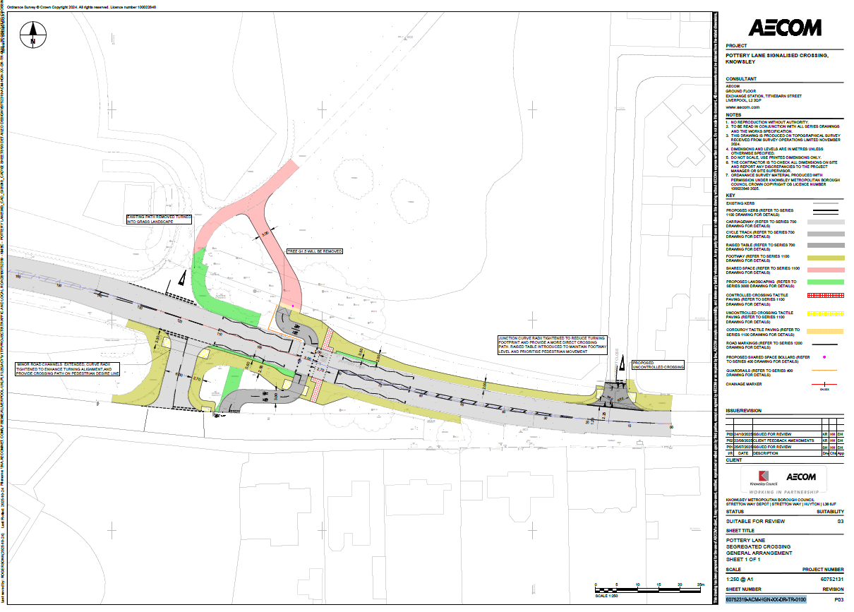

Appendix B – Equality Impact Assessment

Service Area:  Highways and Transportation |  |  | Contact Officer:  Sadi Poudel |  |  | Completed by:  Luke Crilly, Richard Thorpe and Gwen Forkin | Date:  28/10/2025
Title: (Plan/Project/Policy etc.) |  |  | Pottery Lane, Whiston – Traffic Calming & Signalised Crossing
Brief Description: |  |  | To seek approval for the Head of Legal Services to carry out the necessary legal and administrative procedures required to advertise the intention of introducing traffic calming measures in the form of speed tables and signalised crossing on Pottery Lane, Whiston, as shown on the drawings numbered 60752319-ACM-HGN-XX-DR-TR-0 P03
Use the columns below to give details, with evidence, of the impact of the policy/plan/project on each of the protected characteristics in relation to the general duty to:-

- Eliminate discrimination, harassment, and victimisation;
- Advance equality of opportunity between people who share protected characteristics and those who don’t share them; and,
- Foster good relations between people who share a protected characteristic and those who don’t.

Does the proposal have a direct impact on people? |  |  |  |  | YES / NO
If yes, please complete the grid below. If no, consider whether or not an Equality Impact Assessment is necessary - if not, state why not and exit the process.
Have you conducted a consultation? No – however residents & stakeholders will be made aware of the works before they commence.

Who did you consult with?  Local residents, council members and emergency services |  |  |  | How and when did you consult?  Via letter in November/December 2025 |  |  |  | What was the feedback?
 | Is there any potential positive impact? | Is there any potential negative impact? |  | What evidence do you have? (e.g. complaints, statistics, surveys etc disaggregated by equality groups.) | What action will you take to mitigate negative impact? Please state if negative impact is intended due to positive action. |  |  | How will you monitor and review the actions that you have taken to mitigate the impact?
Age | YES The scheme will improve access and safety to all road users. | YES People with limited mobility may suffer short-term inconvenience during the construction works  There are no schools in the vicinity of the changes.  NO in the long term. |  | Over the period 2020 to 2036, the number of people aged 65 and over is expected to increase by 34.4%; by 2036 there will be an additional 6,100 households headed by someone aged 65 or over. | The Highways service will ensure that contractors maintain access during any footway or road closures or provide a suitable alternative route for such users. The Highways service will ensure that contractors maintain access during any footway or road closures or provide a suitable alternative route for people with limited mobility. |  |  | Any issues are to be logged in the daily site diaries which are kept on the scheme folder, amendments to the working practices will be considered where feasible.
Carer Status | YES The scheme will improve access and safety to all road users. | YES Carers who may assist wheelchair users or those on mobility scooters may suffer short-term inconvenience during the construction works. |  | In the 2011 census circa 18,000 people identified as being an unpaid carer providing more than 1hr of care per week. | The Highways service will ensure that contractors maintain access during any footway or road closures or provide a suitable alternative route for such users. |  |  | Any issues are to be logged in the daily site diaries which are kept on the scheme folder, amendments to the working practices will be considered where feasible.
Care  Experience | YES - the works associated with the scheme will improve access and safety to all road users. | No - the works will have a whole community impact with no specific account of care experience.
Disability | YES The scheme will improve access and safety to all road users.  Accessibility of all disabilities will be considered during the design phase and  once the works are completed access will be improved for people with impaired mobility. | YES Wheelchair users or those on mobility scooters may suffer short-term inconvenience during construction. People with impaired visibility may also suffer short-term inconvenience during the construction of the works.  NO impact in the long term. |  | The 2020 Household survey indicates that around 22.4% of the population have a limiting illness or disability.  A projected figure of 10,899 individuals within Knowsley are expected by 2035 to have mobility issues | The Highways service will ensure that contractors maintain access during any footway or road closures or provide a suitable alternative route for such users. Tapping boards will be provided where footways are closed, and traffic management operatives will be advised to look out for people who are visually impaired and offer assistance if necessary. Any letters sent out advising residents of works will be available in other languages or formats as required. The bikeability courses offered as part of the funding are generally for people without disabilities however the Council do operate cycle courses for people with disabilities therefore people will be directed to these courses if that is more suitable. |  |  | Any issues are to be logged in the daily site diaries which are kept on the scheme folder, amendments to the working practices will be considered where feasible.
Gender Identity | YES The scheme will improve access and safety to all road users. | NO The proposals have a whole community impact with no specific account of gender identity.
Offending Past | YES The scheme will improve access and safety to all road users. | NO The proposals have a whole community impact with no specific account of past offending.
Sex | YES The scheme will improve access and safety to all road users. | NO The proposals have a whole community impact with no specific account of sex.
Sexual Orientation | YES The scheme will improve access and safety to all road users. | NO The proposals have a whole community impact with no specific account of sexual orientation.
Race (including Roma and Travellers) | YES The scheme will improve access and safety to all road users. | YES The proposals have a whole community impact with no specific account of race, however any letters advising residents of upcoming works will be sent out in English therefore non-English speakers may not be able to understand them. |  | Around 5.3% of households are estimated to have a Household Reference Person from a Black, Asian, Minority Ethnic background.  2020 records show a population size of 8,757 Black, Asian, Minority Ethnic residents within Knowsley which is approx. 5.81% of the total population | Any letters sent out advising residents of works will be available in other languages or formats as required. |  |  | Any requests for letters or communications in a different format will be logged on the scheme folder.
Religion, Belief and Non-Belief | YES The scheme will improve access and safety to all road users. | NO The proposals have a whole community impact with no specific account of religion or belief. The schemes are not located near places of worship therefore access will not be impacted upon.
Socio-Economic Status and Child Poverty | YES The scheme will improve access and safety to all road users. | YES During construction residents and road users may suffer short-term inconvenience (such as increased journey times). This may impact people who are paid hourly if they are able to complete fewer hours at work.
Armed Forces Personnel, Veterans and their Families | YES The scheme will improve access and safety to all road users. | NO The proposals have a whole community impact with no specific account of armed force status.

