Knowsley Metropolitan Borough Council

Gender Pay Gap Report

2019

Executive Summary

Introduction and purpose
This is Knowsley Council’s Gender Pay information report for the snapshot date of 31st March 2019. In April 2017 section 78 of the Equality Act 2010 was enacted. This requires any organisation that has 250 or more employees to publish and report specific information on the make-up and pay of their workforce. The Gender Pay Gap Report is a valuable resource to help monitor the workforce and provide year on year benchmarking information to assist workforce planning. The Gender Pay Gap Report also supports the Council’s Equality and Diversity Policy Statement and provides intelligence and evidence for the Council’s Workforce Development Strategy.

Background
As a public sector organisation, Knowsley Council has been publishing Workforce Monitoring reports since 2010. These reports cover: -
- The number of part-time and full-time staff;
- Recruitment, promotion and performance review information;
- Access to training;
- Redundancy and leavers information;
- Grievances and dismissals, including reported incidents of harassment;
- The rates of return to work of women following maternity leave;
- Public office holders such as members of boards or committees;
- Gender pay gap information, for part-time and full-time employees;
- Black and minority ethnic (BME) pay gap;
- Disability pay gap;
- Success rates of job applicants; breakdown of applicants; shortlisted and successful; applications for promotion and success rates;
- Leavers details;
- Length of service; and
- An indication of any issues for trans-sexual staff, based on our engagement with trans-sexual staff or voluntary groups.

Data limitations
The data contained in this report is a snapshot of the relevant pay period; that is the pay period that includes 31st March 2019. As detailed in the guidance the data used to make the calculations includes both headcount and salary; not all staff included in the head-count data will have counted as full-pay relevant employees for the pay gap data.

Pay Calculations
These calculations include two types of averages: -

- A mean average involves adding up all of the numbers and dividing the result by how many numbers were in the list;
- A median average involves listing all of the numbers in numerical order. If there is an odd number of results, the median average is the middle number. If there is an even number of results, the median will be the mean of the two central numbers.

What is the Gender Pay Gap?
The Equality and Human Rights Commission defines the difference between equal pay and the gender pay gap as follows: -
- Equal pay means that men and women in the same employment performing equal work must receive equal pay, as set out in the Equality Act 2010;
- The gender pay gap is a measure of the difference between men’s and women’s average earnings across an organisation or the labour market. It is expressed as a percentage of men’s earnings. Men working full-time continue to have higher median hourly and weekly earnings than women. The median full-time gender pay gap is the difference in percentage terms between the median earnings of women and men working full-time.
According to the Office for National Statistics in November 2019, the national median gender pay gap was 17.3%. At the moment there is no published mean. In 2019 all Local Authorities in England reported on their gender pay gaps for March 2018. The average median pay gap across Local Authorities for 2018 was 5%, with a mean gap of 6.8%. Knowsley Council reported a median gender pay gap of 9.61% and a mean gender pay gap of 16.2% for the year 2018.
According to the Office for National Statistics “The median is the preferred measure of average earnings as it is less affected by a relatively small number of very high earners and the skewed distribution of earnings. It therefore gives a better indication of “typical” pay than the mean”.

What do we report on?

Full-Pay Relevant employee | To be included as a full-pay relevant employee, the employee must be paid their full usual pay during the pay period in which the snapshot date falls. If the employee is paid less than their usual rate because of being on leave for that period, they should not be counted as a full-pay relevant employee.
Mean gender pay gap | The difference between the mean hourly rate of pay of male full-pay relevant employees and that of female full-pay relevant employees
Median gender pay gap | The difference between the median hourly rate of pay of male full-pay relevant employees and that of female full-pay relevant employees
Mean Bonus Gap | The difference between the mean bonus pay paid to male relevant employees and that paid to female relevant employees
Median Bonus Gap | The difference between the median bonus pay paid to male relevant employees and that paid to female relevant employees
Bonus Proportions | The proportions of male and female relevant employees who were paid bonus pay during the relevant pay period
Quartile Pay Bands | The proportions of male and female full-pay relevant employees in the lower, lower middle, upper middle and upper quartile pay bands

Gender Workforce Profile
As of 31st March 2019 Knowsley Council’s workforce headcount was 2,607 staff (3,447 including casual staff). The majority of the Council’s workforce at this date was female (72.8%); and the majority of female employees work part-time 51.7%. 93% of the part-time workforce was female, meaning that any policy that affects more part-time staff than full-time staff will have a disproportionate impact on women.

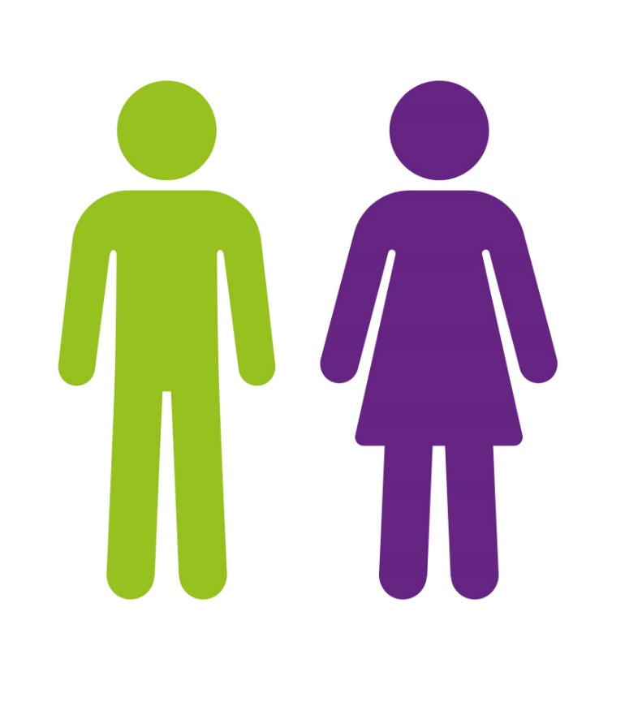
72.8%
27.2%

Total Workforce Demographic
Local Government is unique in that the services Knowsley Council provides cross a number of sectors, including but not limited to, transport, leisure, education, health and social care, business development, community development, communication and finance. This is important to note as each of these different sectors attracts a different workforce. Many of the jobs that women are employed in across the country are low paid and part-time, this is known as occupational segregation.
The graph below shows the number of Council staff by gender and contract status:

Contract Status | Female | Male | No.
Full Time | 921 | 636 | 1553
Part Time | 980 | 74 | 1054
Grand Total | 1897 | 710 | 2607

Gender Pay Gap
On the snapshot date of 31st March 2019 there were 2,895 people employed by the Council, this is based on headcount not full-time equivalent numbers (this figure includes all staff employed regardless of contract status). Out of these, 2,577 counted as full-pay relevant employees; 1,878 were female and 699 were male. For the rest of the report the data solely refers the full-pay relevant employees.

Median Gender Pay Gap
The median gender pay gap is the difference between the median hourly rate of pay of male full-pay relevant employees and that of female full-pay relevant employees. The average median hourly rate across the council is £12.89; for women the rate is £12.31 and for men it is £13.56, meaning there is a median pay gap of 9.22%.
This is a decrease of 0.39% (from 9.61%) on the pay gap reported in the Council’s 2018 report and a reduction of 2.4% since 2017. This is also significantly lower (i.e. better) than the national median gender pay gap of 18.4% and the public administration and defence sector pay gap of 15.4%.
Male | £13.56
Female | £12.31
Difference | £1.25
9.22%

Median full-time gender pay gap
Out of the 1,522 staff who work full-time for Knowsley Council, 898 are female and 624 male. The average median hourly rate for all full-time staff is £15.21. The average median hourly rate for male full-time staff is £14.22 and for female staff it is £15.69, meaning that there is a full-time median gender pay gap of -9.39%, which is interpreted as no pay gap at all.
Median part-time gender pay gap
Out of the 1,023 staff who work part time for Knowsley Council, the vast majority are female (952) with only 71 men working less than full-time hours. The average median hourly rate for all part-time staff is £9.59. The median average hourly rate for male part-time staff is £9.57 and female staff is £9.58 meaning that there is a part-time gender pay gap of -0.1%.

Mean Gender Pay Gap
The mean gender pay gap is the difference between the mean hourly rate of pay of male full-pay relevant employees and that of female full-pay relevant employees. The average mean hourly rate across the council is £14.65, the mean hourly rate for females is £13.96 and the mean hourly rate for men is £16.52. This equates to a mean pay gap of 15.5%, a reduction of 0.71% on the 2018 report.

Males | £16.52
Females | £13.96
Difference | £2.56
15.5%

Mean full-time gender pay gap
Out of the 1,522 staff who work full-time for Knowsley Council, 898 are female and 624 male. The average hourly rate for all full time staff is £17.01, for male full-time staff it is £17.12 and for female full time staff it is £16.94, meaning that there is a full-time mean, gender pay gap of 1.1%.
Mean part-time gender pay gap
Out of the 1023 staff who work part time for Knowsley Council, the vast majority are female (952) with only 71 men working less than full-time hours. The average hourly rate for part-time staff is £11.30, male part-time staff is £11.66 and for female staff it is £11.27, meaning that there is a part-time mean, gender pay gap of 3.3%.

Proportion of Men and Women Receiving Bonuses
Knowsley Council does not operate any performance related pay or bonus scheme and therefore there is no bonus gender pay gap.

Sex (Gender) – Quartile Distribution
The Gender Pay Gap reporting legislation requires that the Council publishes the number of full-pay relevant men and women in each quartile of the pay structure.
Lower Quartile Lower Middle Quartile
 | Number | %
Female | 560 | 87
Male | 84 | 13
Grand Total | 644 | 100.0
 | Number | %
Female | 445 | 69
Male | 200 | 31
Grand Total | 645 | 100

Upper Middle Quartile Upper Quartile

 | Number | %
Female | 463 | 72
Male | 181 | 28
Grand Total | 644 | 100
 | Number | %
Female | 410 | 64
Male | 234 | 36
Grand Total | 644 | 100

The data shows there are substantially more female employees in the lower quartiles than male employees. 21.8% of the Council’s female employees are in the upper quartile pay band; whereas 33.4% of the Council’s male employees are in the upper quartile pay band.

The graph below shows the distribution of full-pay relevant staff by gender across the quartiles. It clearly illustrates how women make up the majority of the workforce, yet the numbers of women in each of the quartiles reduces as pay increases, the opposite occurs with the men in the workforce.

Sex (Gender) – Pay Gap by Quartile Distribution

The graph below shows the pay gap by quartiles. The graph highlights that there is a negative or neutral pay gap for both the mean and median pay gaps in the lower, lower middle and upper middle quartiles, this amounts to no pay gap at all. However, the upper middle quartile shows a pay gap for both mean 9.83 and median 7.30%. This a slight increase of 0.26% on the mean from 2018 and a reduction of 1.88% from the median upper pay quartile gap in 2018.

Reported by the Office for National Statistics as of March 2018
Letter from Government Equalities Office 18th July 2019

